# Team Portfolio Documentation

Cleckhudderfax Online Megastore

**Team Name: Team A**

**Project Manager: Rohit Raj Pandey**

***Team Members***

Dikson Rajbanshi (Team Leader)

Prasansa Dahal

Surya Shrestha

Susan Khatri

Alok Raj

# Overview

Cleckhudderfax Online Megastore is an online grocery store, which is being developed as a solution to the competition given by the national chains to the small local independent businesses at Cleckhudderfax. Given the fact that currently we are living in the information age where technologies are blooming, online markets are growing widely due to ease of use and better accessibility. Cleckhudderfax Online Megastore aims to be the solution for tackling the current issue at hand and provide the local shops with wider range of usage along with providing the customers with better shopping experience.

Table of Contents

Team Portfolio Documentation 1

Overview 2

Product Initiation 7

Project Charter 7

Project Charter (v1.1) 10

Team Contract 13

Project Planning 17

Belbin Analysis (Team) 17

Belbin Analysis (Individual) 25

Skill Audit (Team) 27

Skill Audit (Individual) 28

Microsoft Project 29

Task Sheet 29

Gantt Chart 34

Calendar 38

Network Diagram 40

Resource Sheet 43

Timeline 44

Team Meetings 45

Team Meetings (Virtual) 48

Communication and Collaboration Tools Used 52

Trello 52

Slack 52

GitHub 53

Project Execution 54

Requirements 54

Entity Relationship Diagram (ERD) 58

Extended Entity Relationship Diagram (EERD) 59

Composite ERD 60

Logical Design 61

Use Case 62

Wireframes 64

Home 64

About Us 65

Our Clients 66

FAQs 66

Our Blog 67

Shop 68

Single Product Page 69

Search 70

Basket 70

Login 71

Manage Account 71

Add Product 72

Product Details 73

Risk Register 74

Risk Register (Team) 74

Risk Profile (Team) 74

Risk Register (Individual) 75

Risk Profile (Individual) 75

Web Application 76

Homepage 76

About Us 77

Shop 78

Products 78

Filter 79

Product 81

Product Search 81

Product Search Result 82

Product Information 83

Basket 84

Basket Empty 84

Add to Basket 85

Product Added 86

Collection slot 87

Order 87

Order Details 87

Order Confirmation Receipt 88

PayPal Payment 89

Payment Method 89

Confirm Payment 89

Payment Success 90

Registration 91

Registration Form 91

Account Creation 92

Confirmation Email 93

Form Validation 94

Login 95

Login Form 95

Form Validation 96

Login Success 101

Forgot Password 102

Account Management 104

Profile 104

Edit/Update Profile 104

Profile Update Notification Email 106

Admin (PHP) 107

Trader Details 107

Trader Status Update 107

Trader Type Details 108

Trader Type Status Update 108

Collection Slot Details 109

Collection Slot 110

Collection Slot Added 110

Trader (PHP) 111

Add Product 111

Product Added 112

Product Details 113

Add Trader Type 114

Trader Type Details 114

Add Shop 115

Shop Added 115

Shop Details 116

Update Profile 116

Profile Update Success 117

Admin (Oracle) 117

Login 117

Dashboard 118

Products 119

Trader Details 120

Customer Information 121

Sales Report 122

Trader (Oracle) 124

Dashboard 124

Shop/Product Details 125

Product/Product Comment 126

Product Type Details 127

Order Details 128

Monthly Sales Report 129

Monthly Sales Report Chart 130

# Product Initiation

## Project Charter

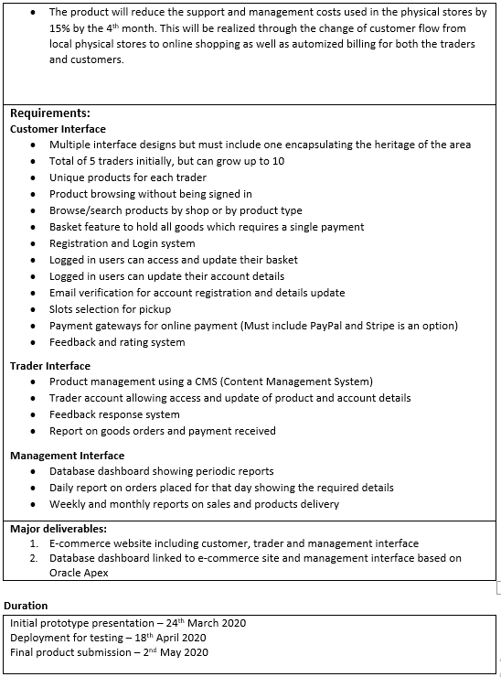

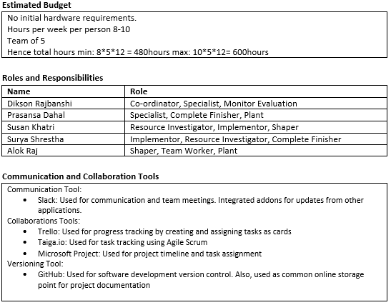

This is our initial version of project charter. It provides with the details of project justification, project scope, requirements, estimated budget, roles and responsibilities, and collaboration, communication tools.

## Project Charter (v1.1)

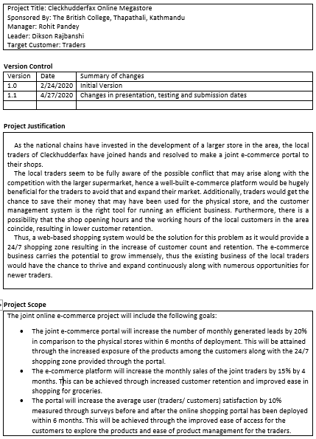

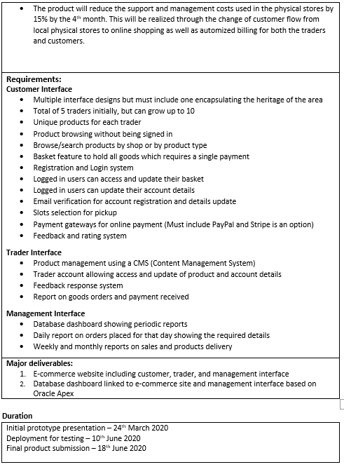

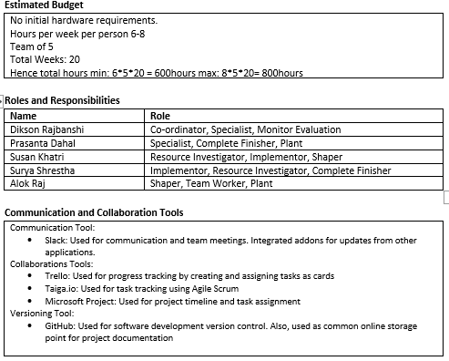

This is our second version of project charter with changes in presentation, testing and submission dates. It provides with the details of project justification, project scope, requirements, estimated budget, roles and responsibilities, and collaboration, communication tools.

## Team Contract

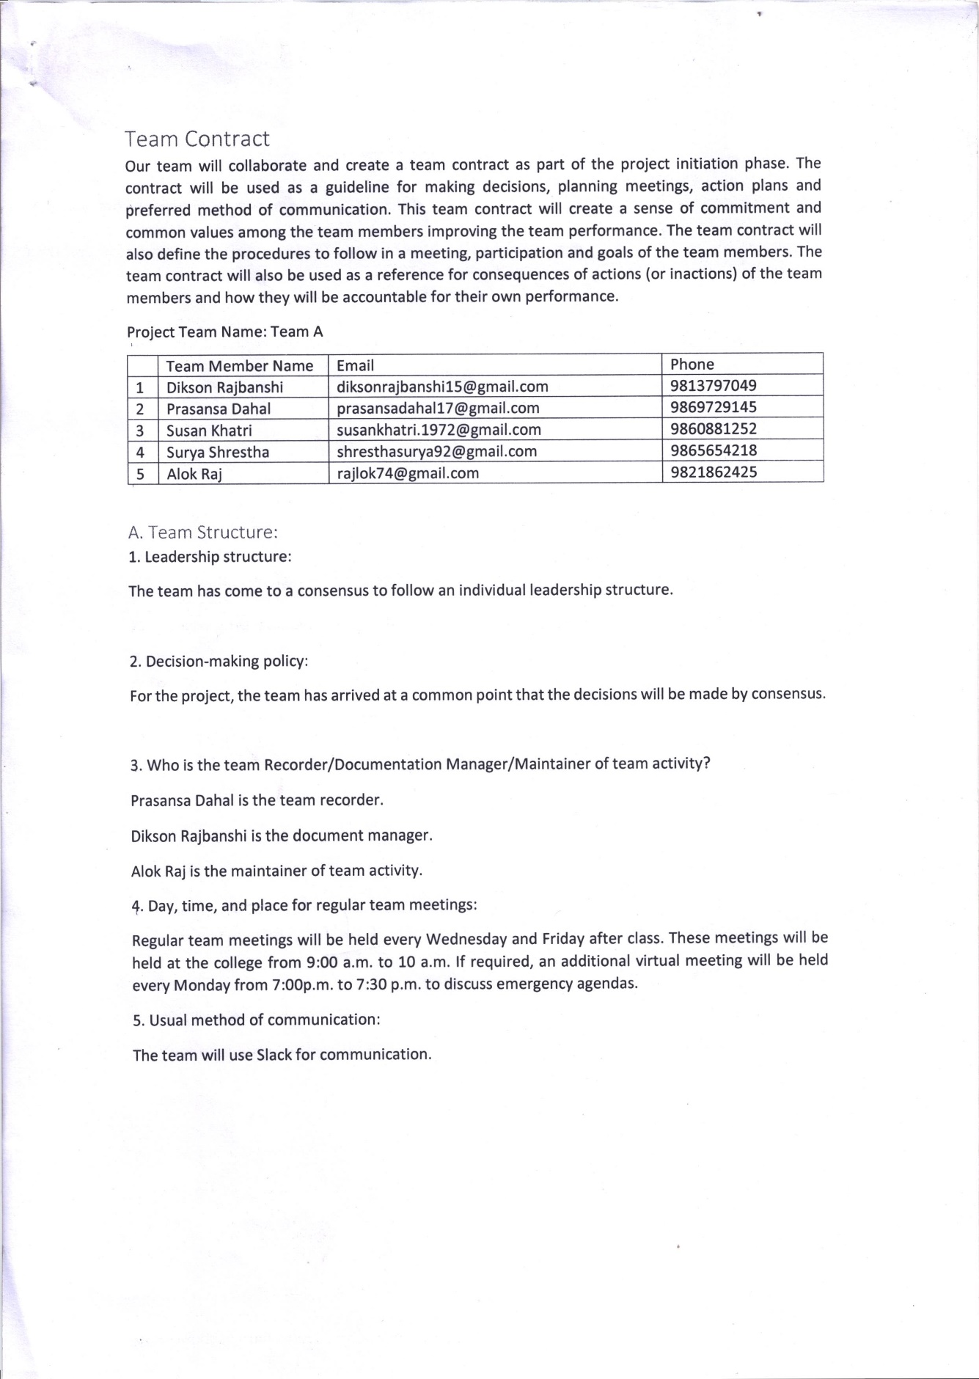

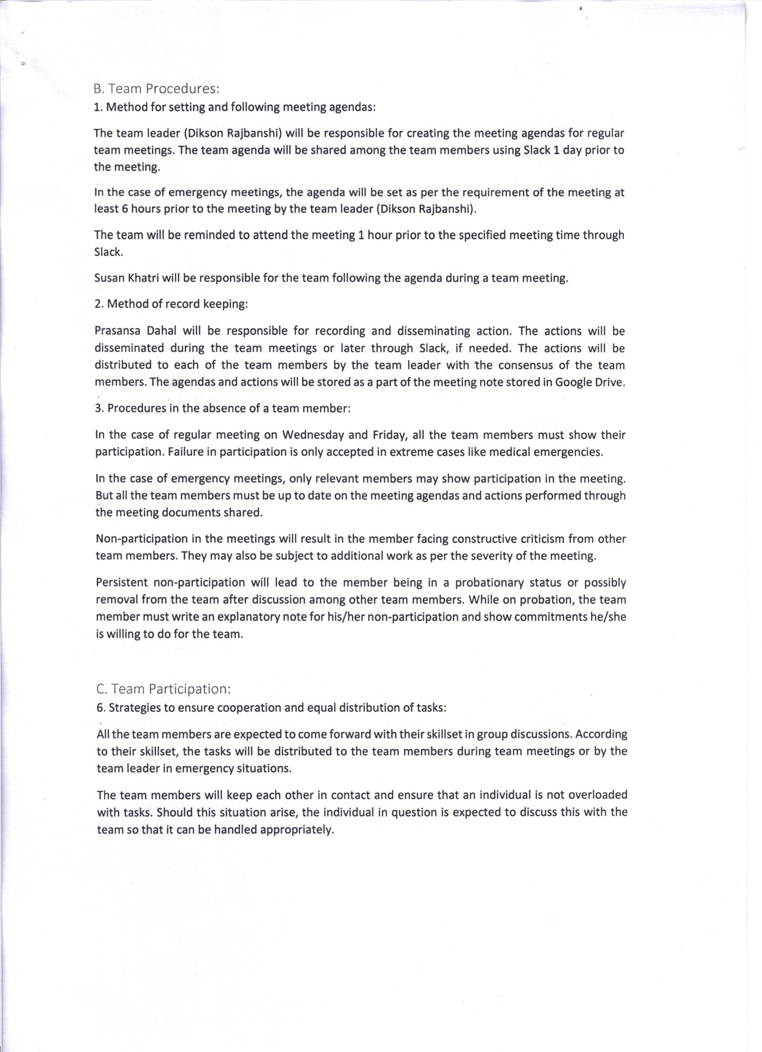

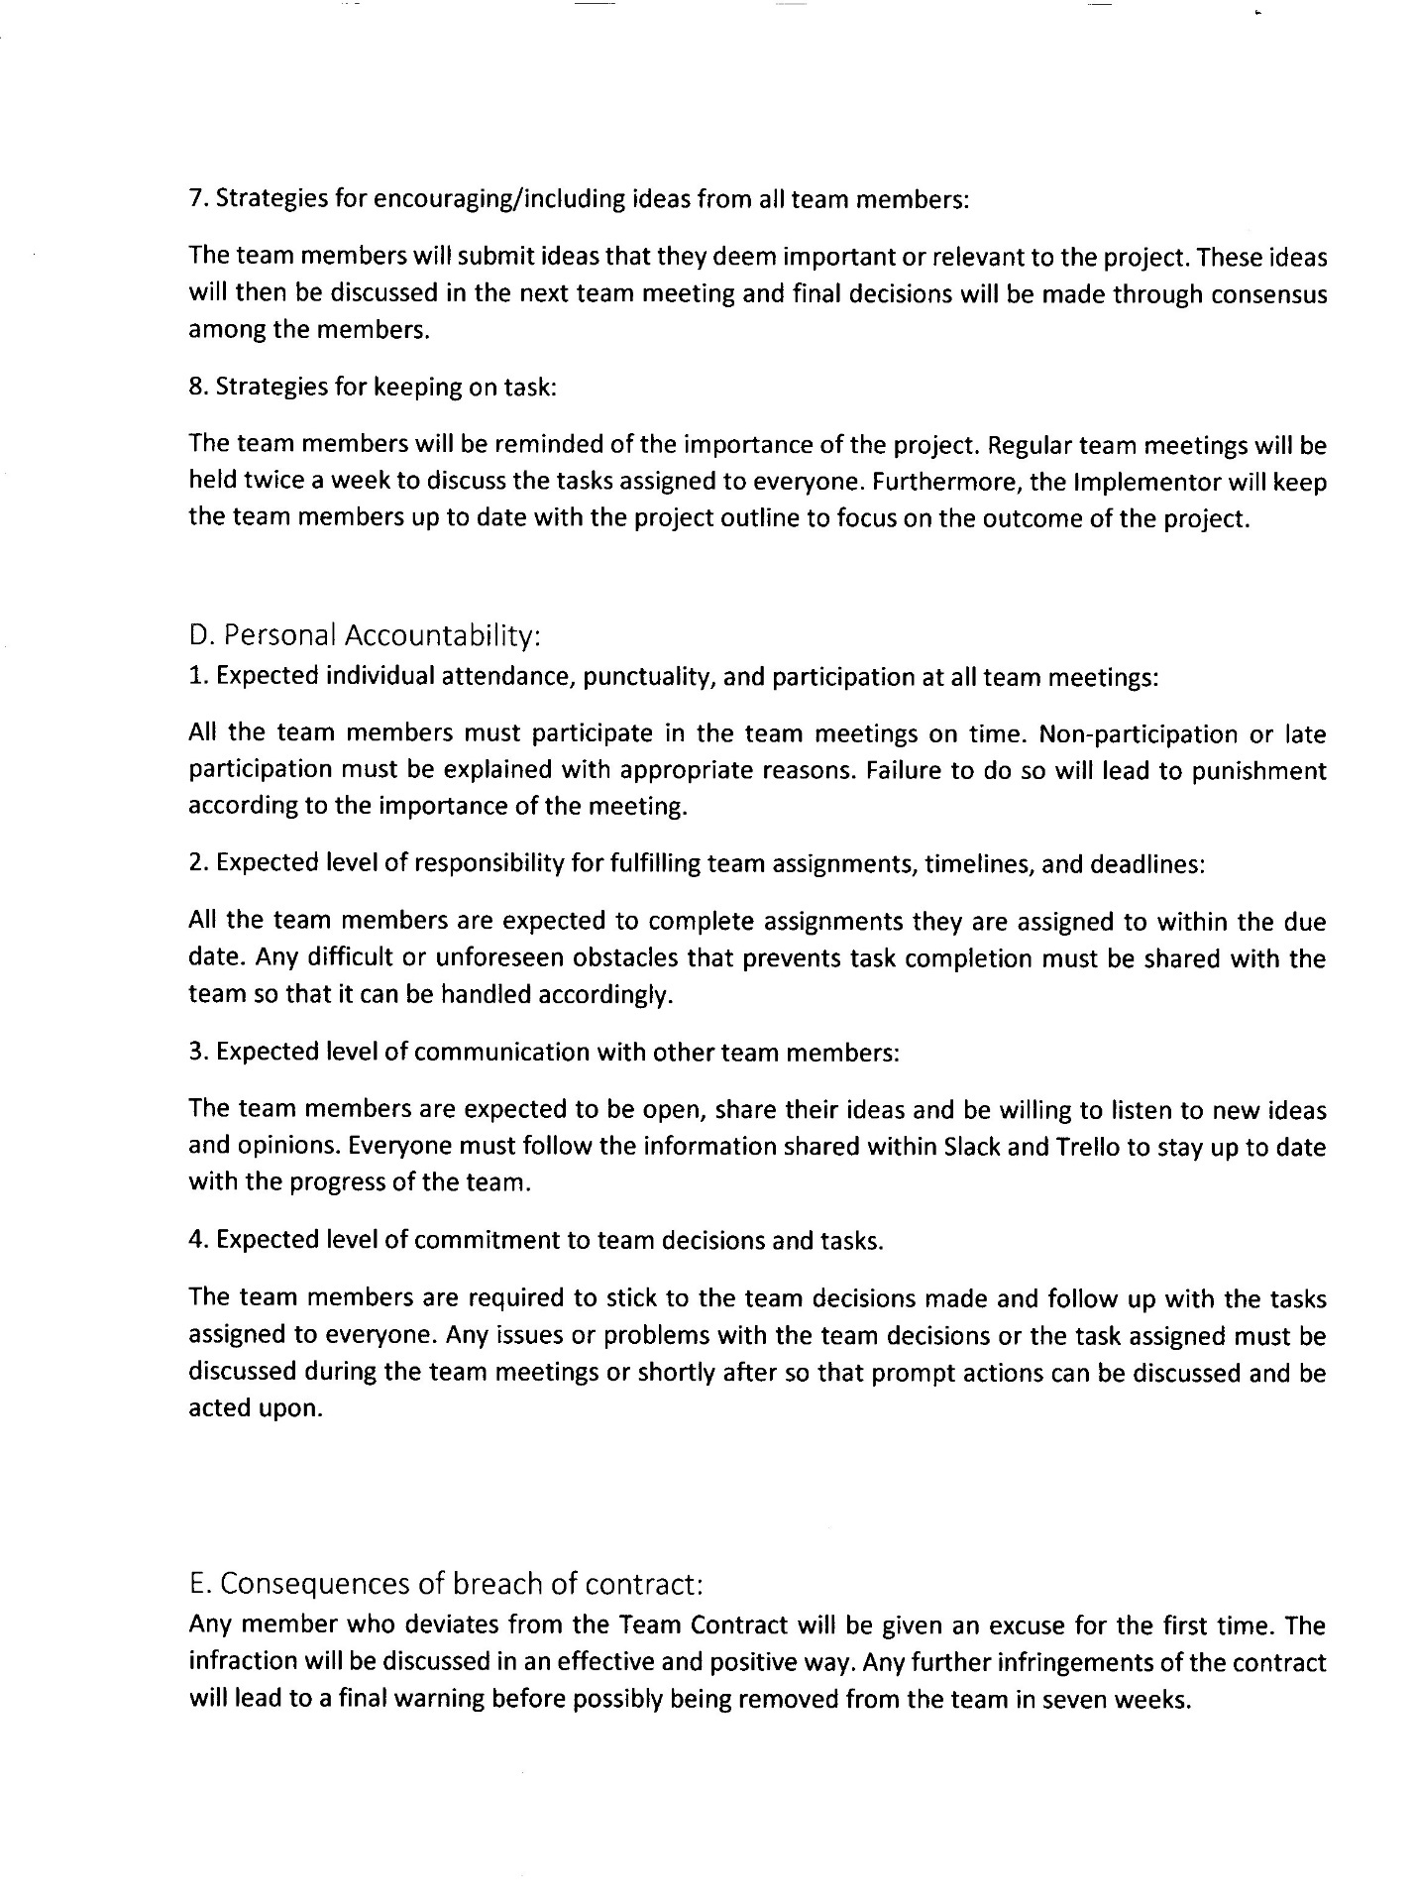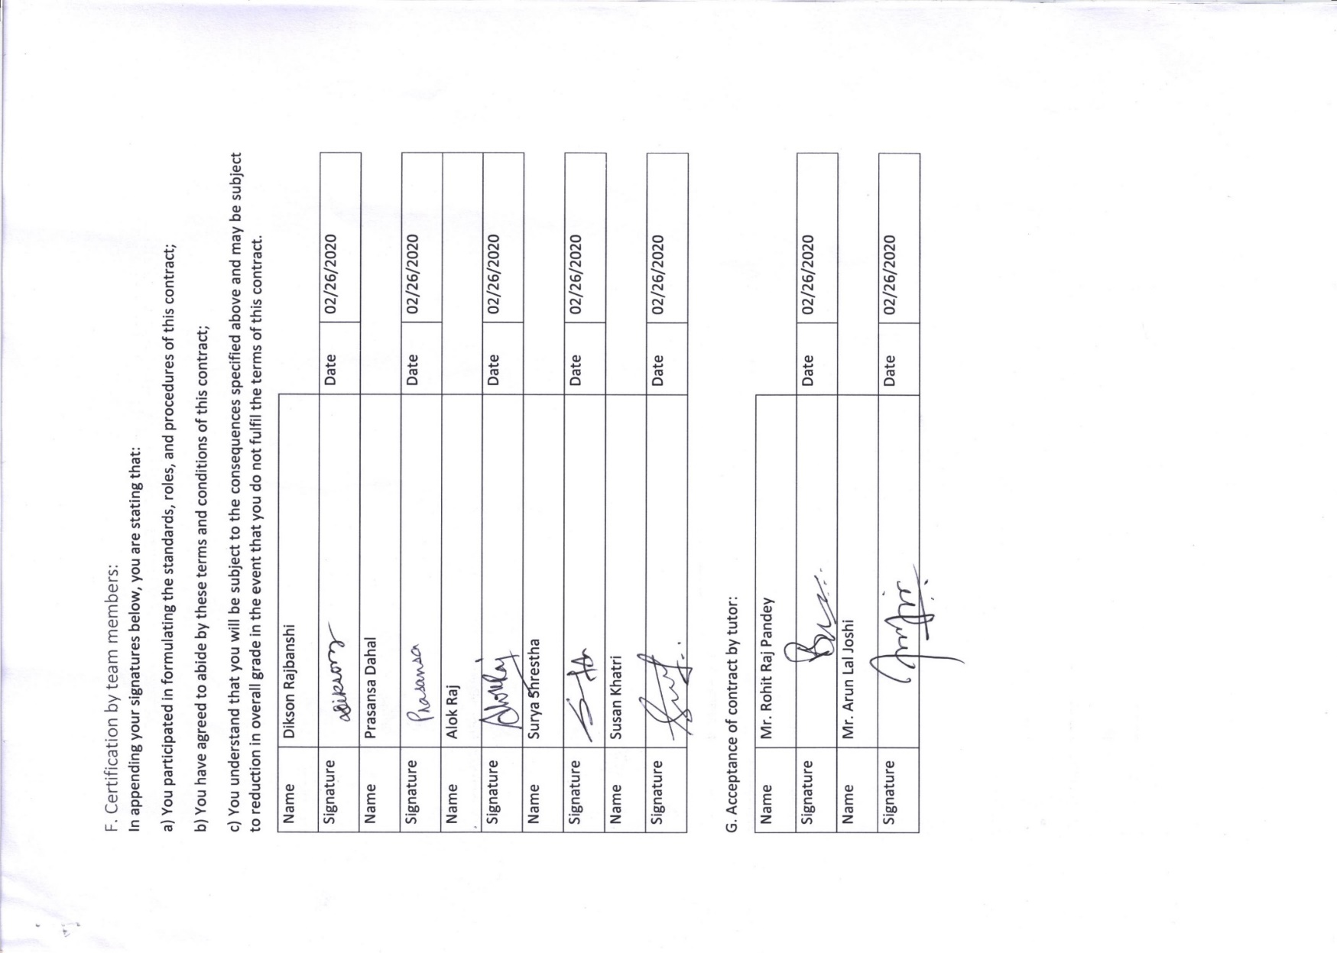

This is our team contract. It consists of team member names and terms and conditions of working in the project. It also includes the consequences of contract breach and has been approved and signed by all the team members along with the acceptance of our tutors.

# Project Planning

## Belbin Analysis (Team)

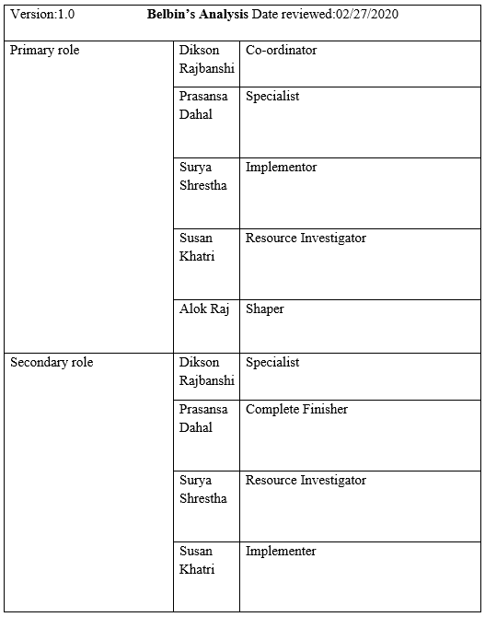

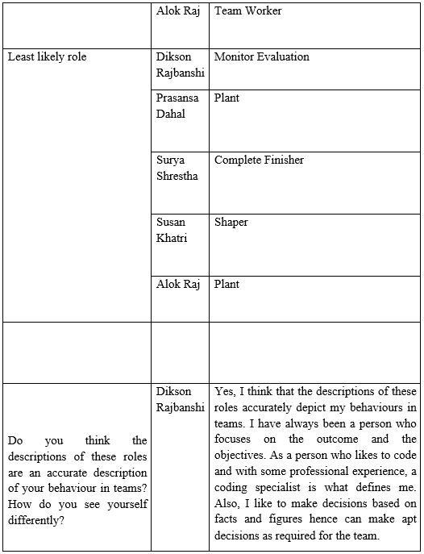

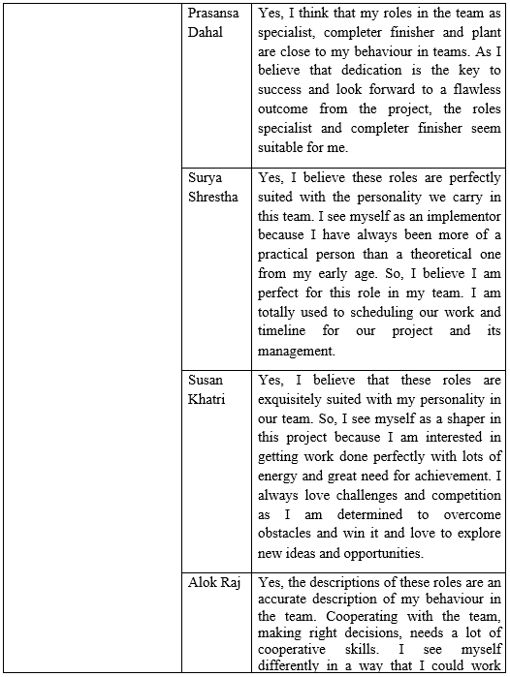

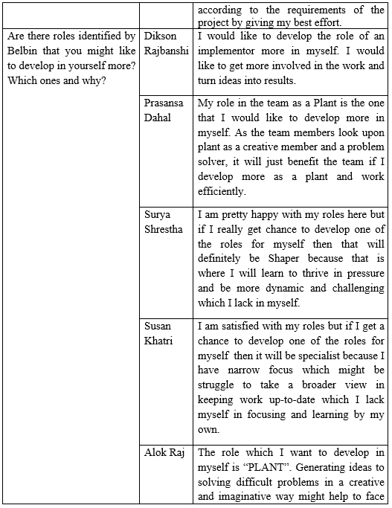

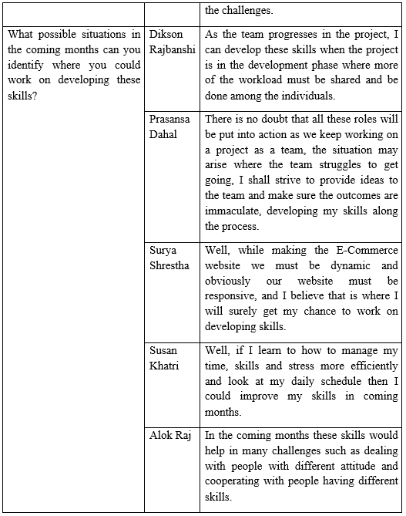

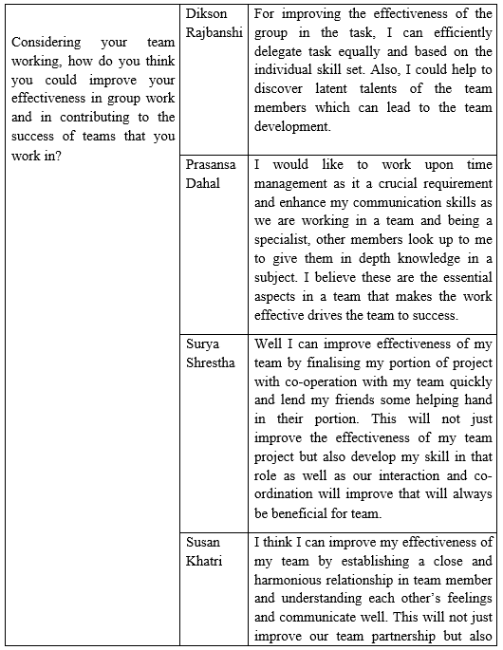

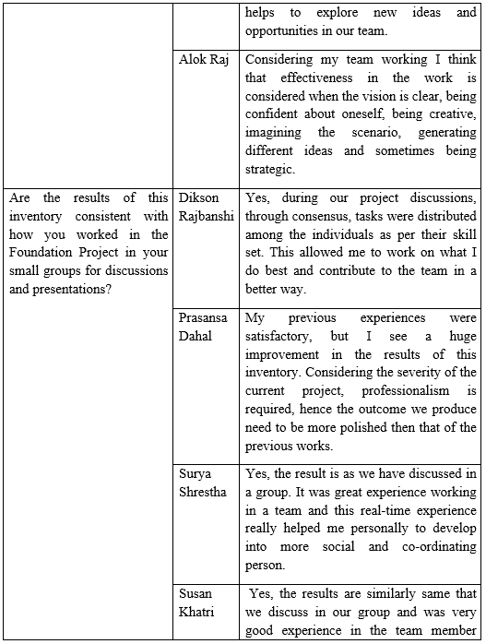

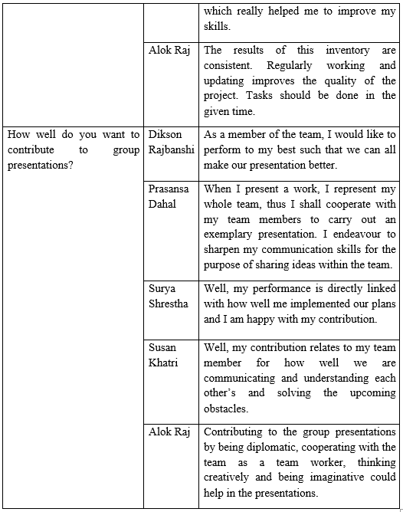

This is our team Belbin analysis. It consists of the distributed roles and responsibilities of the all the team members and their views on them. It contains explanation on why they chose the role and what they’ve achieved from it.

## Belbin Analysis (Individual)

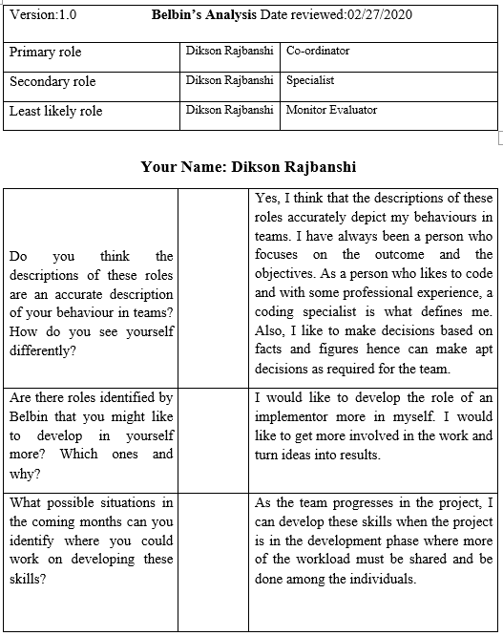

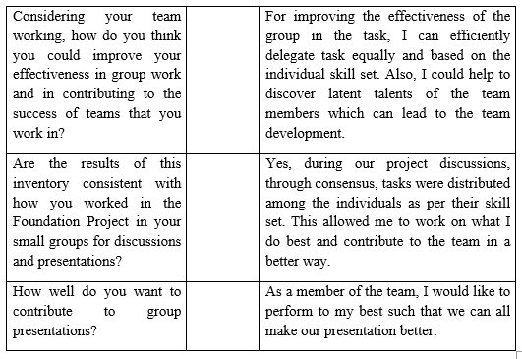

This is the individual Belbin analysis. It consists of each member’s roles and responsibilities and their views on them. It contains explanation on why we chose the roles and what we’ve achieved from it.

## Skill Audit (Team)



This is the team skills audit, it contains a compiled list of all the skills required for the project and the skill levels of the team members, It contains the training objective and action for the required skills if a member lacks in any.

## Skill Audit (Individual)



This is the team members individual skills audit. It consists of the skills required for the project and each members’ skill level on them. I have mentioned the required training action and its objective.

## Microsoft Project

### Task Sheet

|  |  |  |  |  |  |
| --- | --- | --- | --- | --- | --- |
| Task Name | Duration | Start | Finish | Predecessors | Resource Names |
| **Team A** | **87 days** | **Tue 2/18/20** | **Thu 6/18/20** |  |  |
| **Initial Phase** | **3 days** | **Tue 2/18/20** | **Thu 2/20/20** |  |  |
| Team Formation | 1 day | Tue 2/18/20 | Tue 2/18/20 |  | Rohit Raj Pandey |
| Start Case Study | 1 day | Wed 2/19/20 | Wed 2/19/20 | 3 | Alok Raj, Dikson Rajbanshi, Prasansa Dahal, Surya Shrestha, Susan Khatri |
| **Project Charter** | **2 days** | **Wed 2/19/20** | **Thu 2/20/20** |  |  |
| Finalize Project Name | 0.1 hrs. | Wed 2/19/20 | Wed 2/19/20 |  | Alok Raj, Dikson Rajbanshi, Prasansa Dahal, Surya Shrestha, Susan Khatri |
| Version Control | 0.1 hrs. | Wed 2/19/20 | Wed 2/19/20 | 6 |  |
| Finalize Team Name | 0.1 hrs. | Wed 2/19/20 | Wed 2/19/20 |  | Alok Raj, Dikson Rajbanshi, Prasansa Dahal, Surya Shrestha, Susan Khatri |
| Roles and Responsibilities Distribution | 1 hr. | Wed 2/19/20 | Wed 2/19/20 |  | Dikson Rajbanshi |
| Project Justification Draft | 0.75 days | Wed 2/19/20 | Wed 2/19/20 |  | Prasansa Dahal |
| Project Scope | 0.25 days | Thu 2/20/20 | Thu 2/20/20 | 9 | Alok Raj |
| Set Project Goals | 0.25 days | Thu 2/20/20 | Thu 2/20/20 | 11 | Surya Shrestha, Susan Khatri |
| Project Charter Documentation | 0.25 days | Thu 2/20/20 | Thu 2/20/20 |  | Dikson Rajbanshi |
| **Planning Phase** | **8 days** | **Fri 2/21/20** | **Tue 3/3/20** | **2** |  |
| **Create Team Contract** | **1 day** | **Fri 2/21/20** | **Fri 2/21/20** |  |  |
| Contract Description | 0.25 days | Fri 2/21/20 | Fri 2/21/20 |  | Dikson Rajbanshi |
| Team Structure | 0.25 days | Fri 2/21/20 | Fri 2/21/20 | 16SS | Alok Raj, Surya Shrestha |
| Team Procedures | 0.25 days | Fri 2/21/20 | Fri 2/21/20 | 17SS | Prasansa Dahal, Susan Khatri |
| Team Participation | 0.25 days | Fri 2/21/20 | Fri 2/21/20 | 18SS | Dikson Rajbanshi, Susan Khatri |
| Personal Accountability | 0.25 days | Fri 2/21/20 | Fri 2/21/20 |  | Alok Raj, Dikson Rajbanshi, Prasansa Dahal, Surya Shrestha, Susan Khatri |
| Contract Breach Consequences | 0.25 days | Fri 2/21/20 | Fri 2/21/20 | 20,19 | Alok Raj, Surya Shrestha |
| Certification by Team Members | 0.25 days | Fri 2/21/20 | Fri 2/21/20 | 21 | Alok Raj, Dikson Rajbanshi, Prasansa Dahal, Surya Shrestha, Susan Khatri |
| Finalize Contract | 0.25 days | Fri 2/21/20 | Fri 2/21/20 | 22FF | Alok Raj, Dikson Rajbanshi, Prasansa Dahal, Surya Shrestha, Susan Khatri |
| **Belbin Analysis** | **2 days** | **Mon 2/24/20** | **Tue 2/25/20** |  |  |
| Individual Belbin | 1 day | Mon 2/24/20 | Mon 2/24/20 |  | Alok Raj, Dikson Rajbanshi, Prasansa Dahal, Surya Shrestha, Susan Khatri |
| Team Belbin | 0.5 days | Tue 2/25/20 | Tue 2/25/20 | 25 | Dikson Rajbanshi |
| Documentation for Submission | 0.5 days | Tue 2/25/20 | Tue 2/25/20 | 25 | Dikson Rajbanshi |
| **Skills Audit** | **2 days** | **Wed 2/26/20** | **Thu 2/27/20** |  |  |
| Individual Skills Audit | 1 day | Wed 2/26/20 | Wed 2/26/20 |  | Alok Raj, Dikson Rajbanshi, Prasansa Dahal, Surya Shrestha, Susan Khatri |
| Team Skills Audit | 0.5 days | Thu 2/27/20 | Thu 2/27/20 | 29 | Susan Khatri |
| Documentation for Submission | 0.5 days | Thu 2/27/20 | Thu 2/27/20 | 29 | Dikson Rajbanshi |
| **Website Outline** | **1 day** | **Fri 2/28/20** | **Fri 2/28/20** |  |  |
| Create Website Outline | 0.5 days | Fri 2/28/20 | Fri 2/28/20 |  | Alok Raj, Dikson Rajbanshi, Prasansa Dahal, Surya Shrestha, Susan Khatri |
| Finalize Website Outline | 0.5 days | Fri 2/28/20 | Fri 2/28/20 | 33 | Alok Raj, Dikson Rajbanshi, Surya Shrestha, Susan Khatri, Prasansa Dahal |
| **Organize MS Project** | **2 days** | **Mon 3/2/20** | **Tue 3/3/20** | **32** |  |
| Training | 0.5 days | Mon 3/2/20 | Mon 3/2/20 |  | Prasansa Dahal |
| Set Tasks | 1 day | Mon 3/2/20 | Mon 3/2/20 | 36SS | Prasansa Dahal, Dikson Rajbanshi |
| Create Team Calendar | 0.1 hrs. | Tue 3/3/20 | Tue 3/3/20 | 36 | Prasansa Dahal |
| Change Working Time | 0.1 hrs. | Tue 3/3/20 | Tue 3/3/20 | 36 | Prasansa Dahal |
| Create Timeline | 0.1 hrs. | Tue 3/3/20 | Tue 3/3/20 | 36 | Prasansa Dahal |
| Edit Work Breakdown Structure | 0.1 hrs. | Tue 3/3/20 | Tue 3/3/20 | 36 | Prasansa Dahal, Dikson Rajbanshi |
| Manage Gantt Chart | 0.1 hrs. | Tue 3/3/20 | Tue 3/3/20 | 36 | Prasansa Dahal |
| Set Resources | 0.1 hrs. | Tue 3/3/20 | Tue 3/3/20 | 36 | Prasansa Dahal |
| **Execution Phase** | **57 days** | **Wed 3/4/20** | **Fri 5/22/20** |  |  |
| **Requirement Catalogue** | **1 day** | **Wed 3/4/20** | **Wed 3/4/20** |  |  |
| Functional Requirement | 0.5 days | Wed 3/4/20 | Wed 3/4/20 |  | Alok Raj, Prasansa Dahal |
| Non-functional Requirement | 0.5 days | Wed 3/4/20 | Wed 3/4/20 | 46 | Alok Raj, Prasansa Dahal |
| **Entity Relationship Diagram** | **2 days** | **Thu 3/5/20** | **Fri 3/6/20** | **45** |  |
| Create Entity Relationship Diagram | 1 day | Thu 3/5/20 | Thu 3/5/20 |  | Dikson Rajbanshi, Susan Khatri |
| Create Composite ERD | 0.5 days | Fri 3/6/20 | Fri 3/6/20 | 49SS | Alok Raj |
| Create Extended Entity Relationship Diagram | 0.25 days | Fri 3/6/20 | Fri 3/6/20 | 49SS | Surya Shrestha, Dikson Rajbanshi |
| Create Logical Design | 0.25 days | Fri 3/6/20 | Fri 3/6/20 | 50 | Prasansa Dahal |
| **Use Case Diagram** | **2 days** | **Fri 3/6/20** | **Tue 3/10/20** |  |  |
| Overview | 0.5 days | Fri 3/6/20 | Fri 3/6/20 |  | Dikson Rajbanshi |
| Admin Access | 1 day | Fri 3/6/20 | Fri 3/6/20 | 54SS | Alok Raj, Prasansa Dahal |
| Trader Access | 1 day | Fri 3/6/20 | Fri 3/6/20 | 55SS | Surya Shrestha |
| Customer Access | 1 day | Mon 3/9/20 | Mon 3/9/20 | 56 | Susan Khatri |
| Finalize Use Case Diagram | 0.5 days | Tue 3/10/20 | Tue 3/10/20 | 57 | Alok Raj, Dikson Rajbanshi, Prasansa Dahal, Surya Shrestha, Susan Khatri |
| **Logo Design** | **1 day** | **Tue 3/10/20** | **Tue 3/10/20** |  |  |
| Research Designs | 0.5 days | Tue 3/10/20 | Tue 3/10/20 |  | Susan Khatri |
| Create Sample Logo | 0.5 days | Tue 3/10/20 | Tue 3/10/20 | 60SS | Dikson Rajbanshi |
| **Wireframe Design** | **3 days** | **Wed 3/11/20** | **Fri 3/13/20** |  |  |
| Create Wireframe | 2 days | Wed 3/11/20 | Thu 3/12/20 |  | Alok Raj |
| Frontend Training | 1 day | Fri 3/13/20 | Fri 3/13/20 |  | Alok Raj, Dikson Rajbanshi, Prasansa Dahal, Surya Shrestha, Susan Khatri |
| Website Coding Frontend | 4 days | Mon 3/16/20 | Thu 3/19/20 | 64SS | Surya Shrestha, Prasansa Dahal |
| **Work in Progress** | **4 days** | **Thu 3/19/20** | **Tue 3/24/20** |  |  |
| Documentation | 2 days | Thu 3/19/20 | Fri 3/20/20 |  | Dikson Rajbanshi |
| Create Presentation | 1 day | Mon 3/23/20 | Mon 3/23/20 | 67 | Surya Shrestha |
| Presentation Submission | 1 day | Tue 3/24/20 | Tue 3/24/20 | 68 | Alok Raj, Dikson Rajbanshi, Prasansa Dahal, Surya Shrestha, Susan Khatri |
| Finalize Website Frontend | 8 days | Wed 3/25/20 | Fri 4/3/20 | 65 | Dikson Rajbanshi, Surya Shrestha, Prasansa Dahal |
| **Website Backend** | **36 days** | **Fri 4/3/20** | **Fri 5/22/20** | **70** |  |
| Backend Training | 2 days | Fri 4/3/20 | Mon 4/6/20 |  | Alok Raj, Dikson Rajbanshi, Prasansa Dahal, Surya Shrestha, Susan Khatri |
| Initiate Coding | 15 days | Tue 4/7/20 | Mon 4/27/20 | 72SS | Dikson Rajbanshi, Alok Raj |
| Coding Continue | 15 days | Tue 4/28/20 | Thu 5/21/20 | 73 | Alok Raj, Susan Khatri, Dikson Rajbanshi |
| **Monitoring and Controlling Phase** | **7 days** | **Mon 5/25/20** | **Tue 6/2/20** |  |  |
| **Testing and Evaluation** | **6 days** | **Mon 5/25/20** | **Mon 6/1/20** |  |  |
| Test Website | 1 day | Mon 5/25/20 | Mon 5/25/20 |  | Alok Raj, Dikson Rajbanshi, Prasansa Dahal, Surya Shrestha, Susan Khatri |
| Edit Website | 3 days | Tue 5/26/20 | Thu 5/28/20 | 77 | Dikson Rajbanshi, Prasansa Dahal |
| Finalize Website | 2 days | Fri 5/29/20 | Mon 6/1/20 | 78 | Alok Raj, Dikson Rajbanshi, Prasansa Dahal, Surya Shrestha, Susan Khatri |
| **Set Up User Installation Manual** | **1 day** | **Tue 6/2/20** | **Tue 6/2/20** |  |  |
| Register and Login | 0.25 days | Tue 6/2/20 | Tue 6/2/20 |  | Prasansa Dahal |
| Admin Manual | 0.25 days | Tue 6/2/20 | Tue 6/2/20 | 81 | Alok Raj |
| Trader Manual | 0.25 days | Tue 6/2/20 | Tue 6/2/20 | 82 | Dikson Rajbanshi |
| Customer Manual | 0.25 days | Tue 6/2/20 | Tue 6/2/20 | 83 | Surya Shrestha |
| **Closing Phase** | **12 days** | **Wed 6/3/20** | **Thu 6/18/20** |  |  |
| Set Up User Installation Manual | 1 day | Wed 6/3/20 | Wed 6/3/20 |  | Susan Khatri |
| Create Presentation Plan | 1 day | Thu 6/4/20 | Thu 6/4/20 | 86 | Surya Shrestha |
| Create Final Presentation | 1 day | Fri 6/5/20 | Fri 6/5/20 | 87 | Susan Khatri |
| Start Team Portfolio Documentation | 5 days | Mon 6/8/20 | Fri 6/12/20 | 88 | Dikson Rajbanshi, Alok Raj |
| Final Presentation Submission | 1 day | Mon 6/15/20 | Mon 6/15/20 | 89 | Alok Raj, Dikson Rajbanshi, Prasansa Dahal, Susan Khatri, Surya Shrestha |
| Finish Team Portfolio Documentation | 2 days | Tue 6/16/20 | Wed 6/17/20 | 90 | Susan Khatri, Surya Shrestha |
| Team Portfolio Submission | 1 day | Thu 6/18/20 | Thu 6/18/20 | 88,89,91 | Alok Raj, Dikson Rajbanshi, Prasansa Dahal, Surya Shrestha, Susan Khatri |

The task sheet shows the work breakdown structure of our team, it includes all the task names with the name of the resources assigned along with their predecessors.

### Gantt Chart

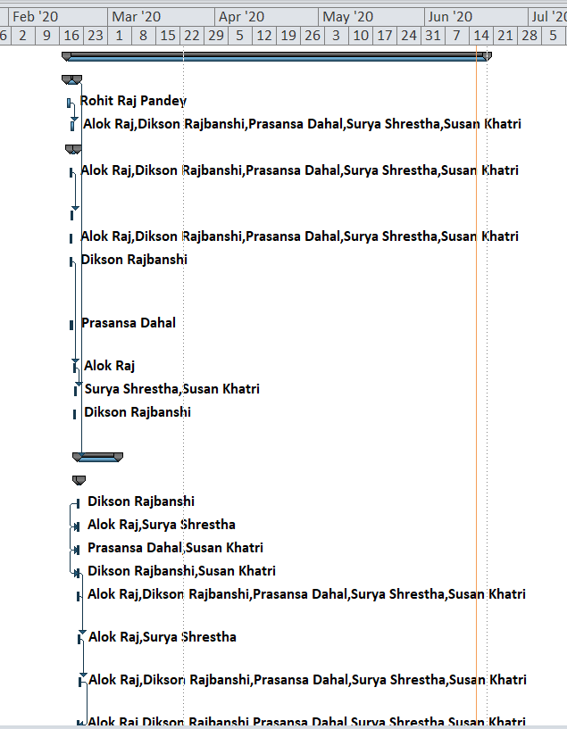

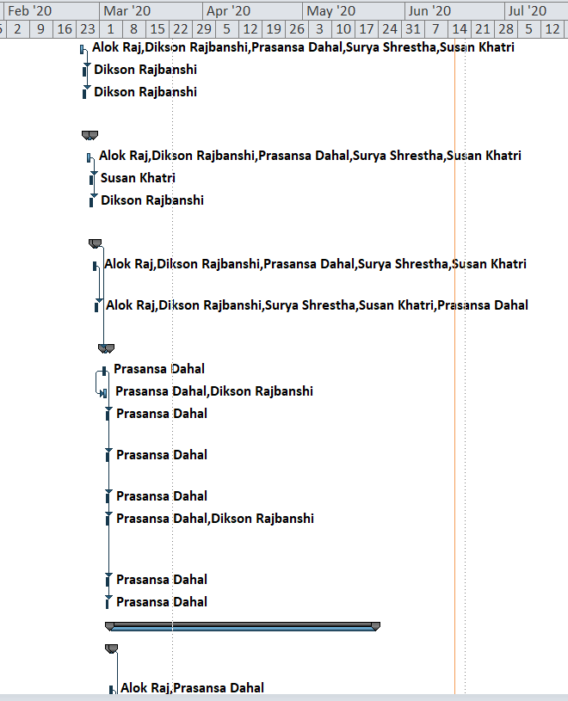

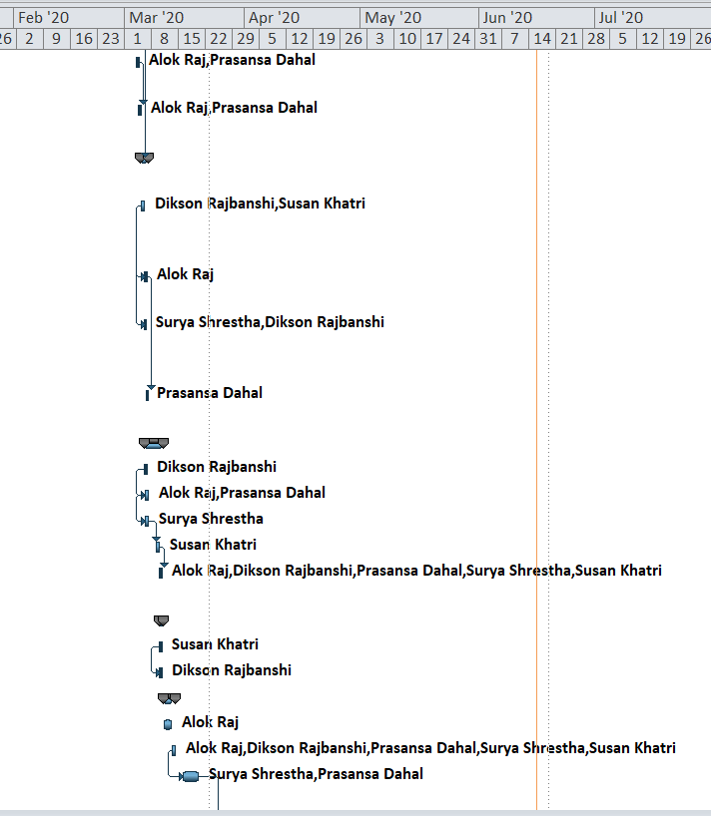

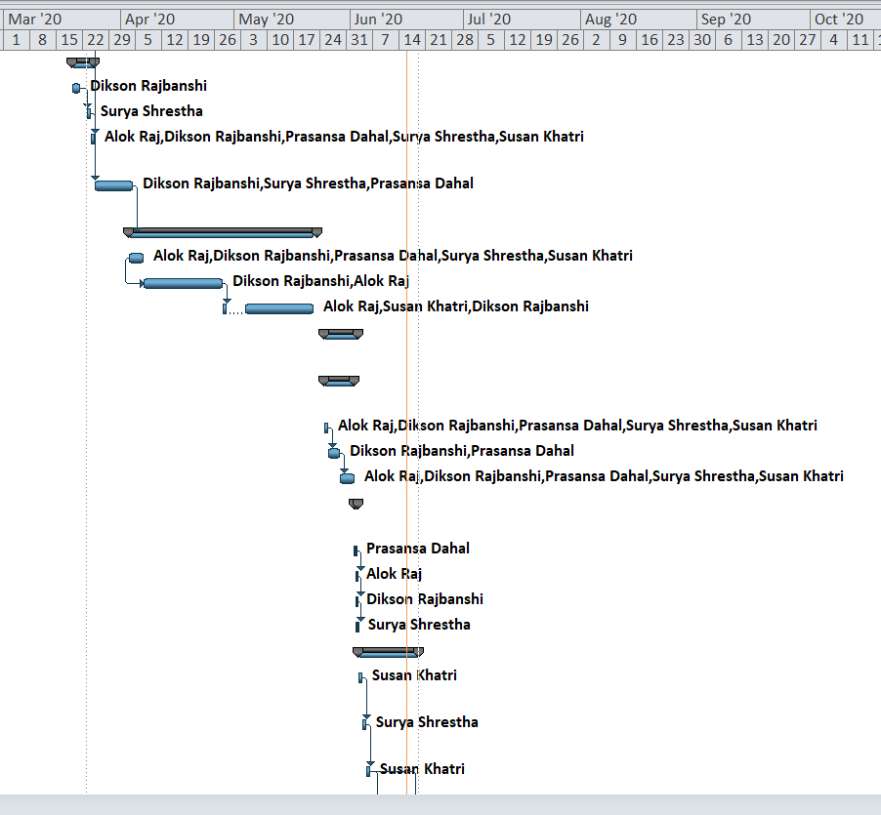

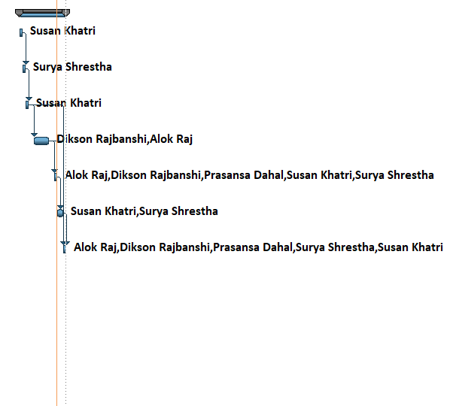

This is our Gantt chart. The chart shows the timeline of the project, it has start to finish date of the project along with the duration of the scheduled tasks and the names of the resources.

### Calendar

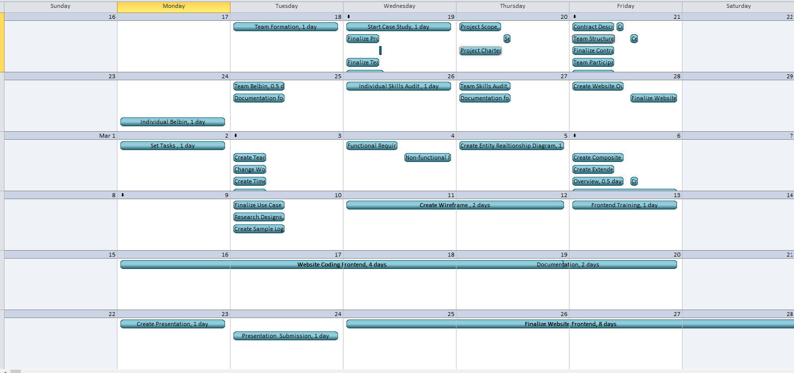

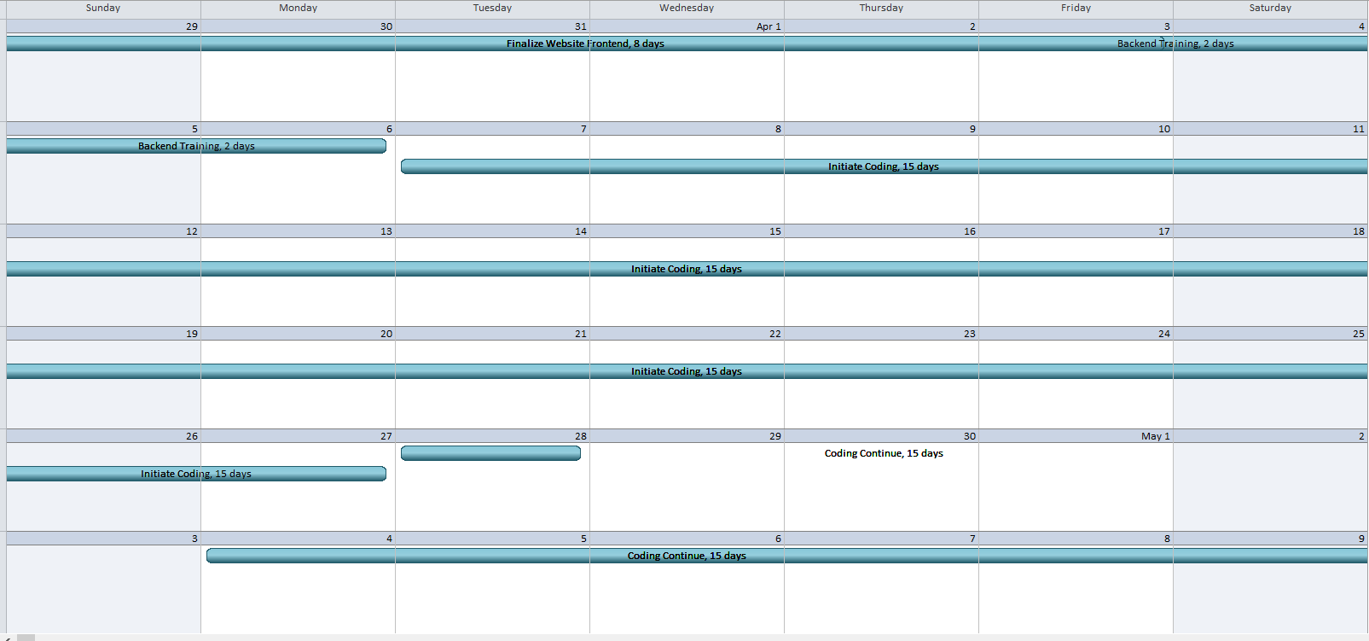

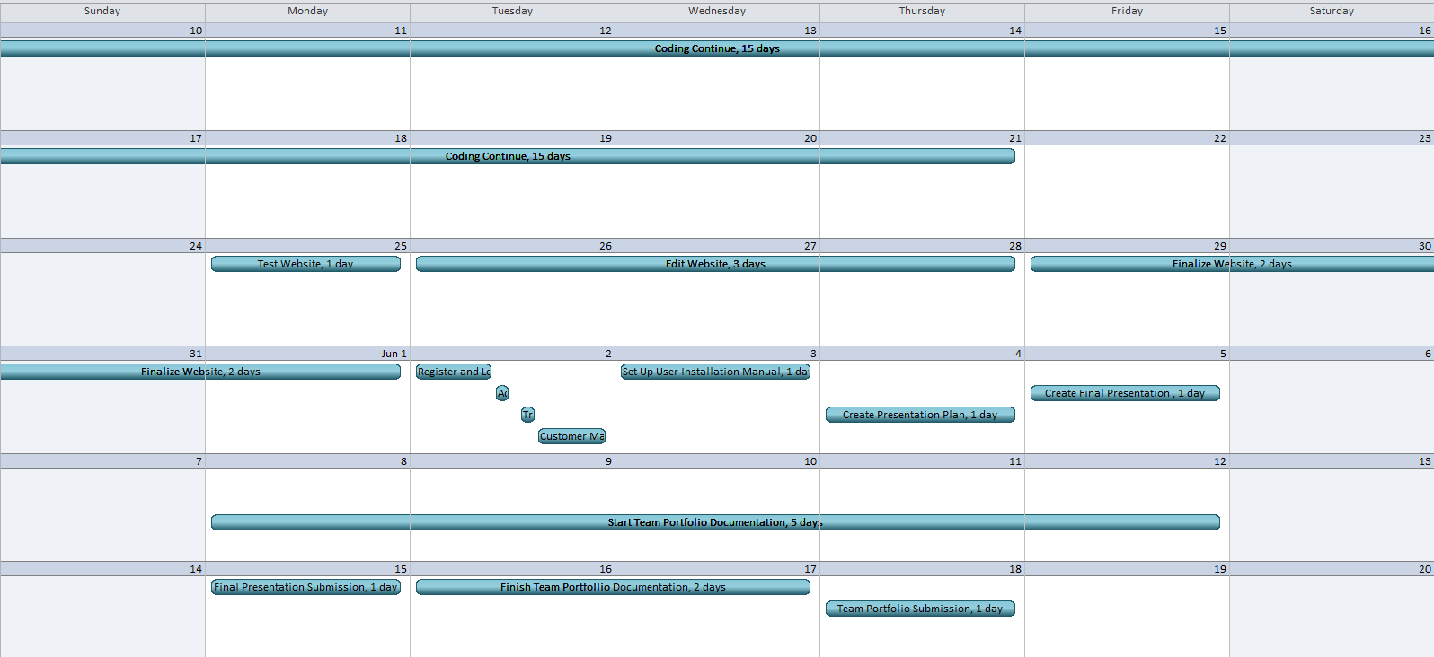

This is our calendar. The calendar shows the organization of all the scheduled tasks during the specific working time. It shows the tasks for each working day and their duration.

### Network Diagram

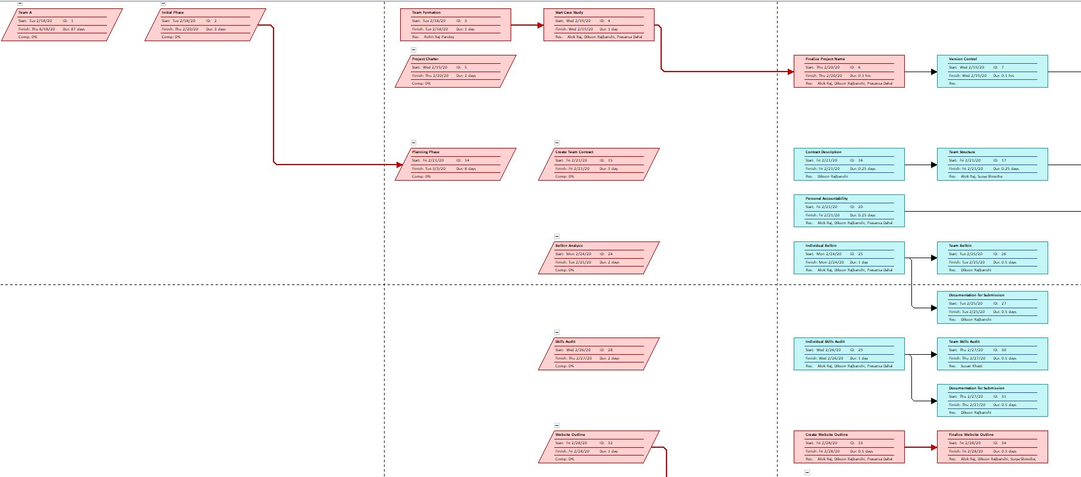

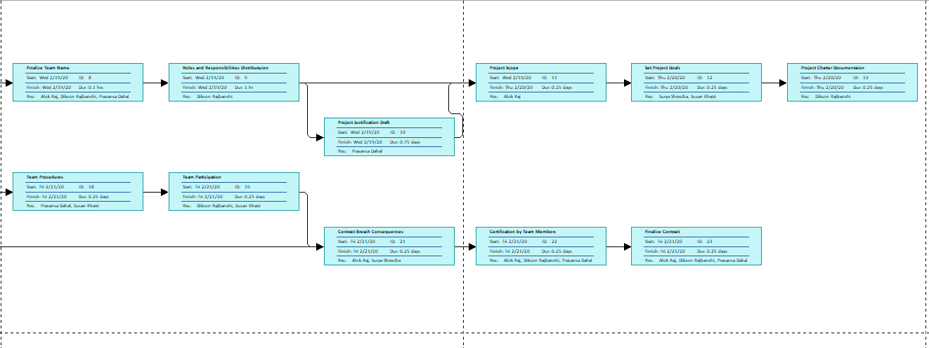

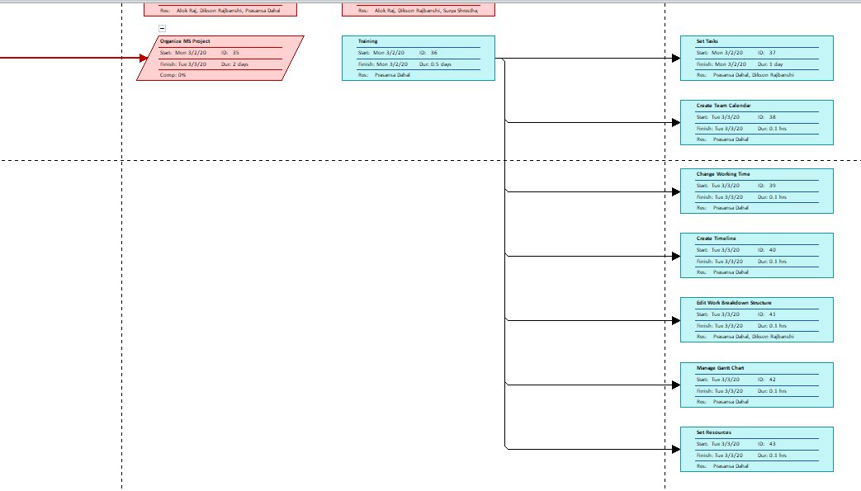

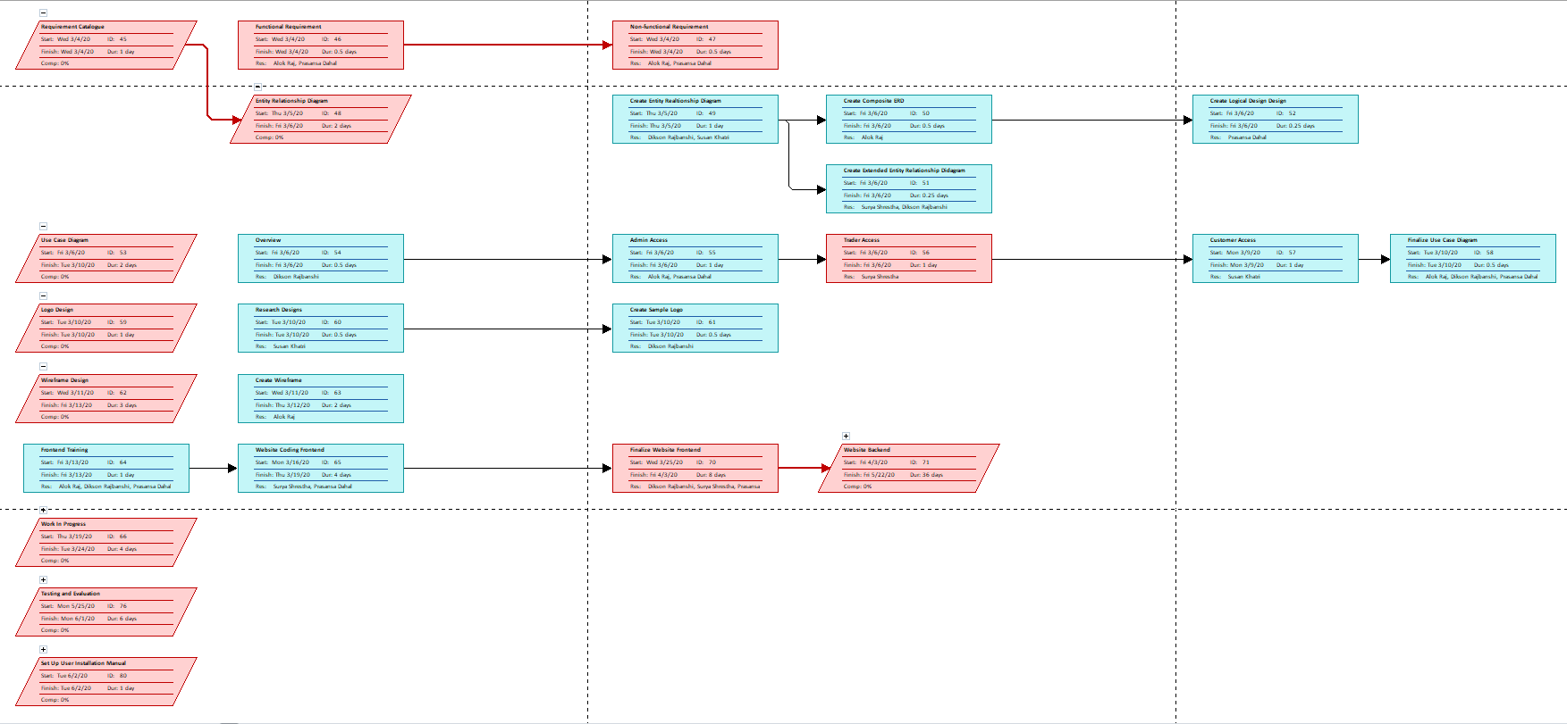

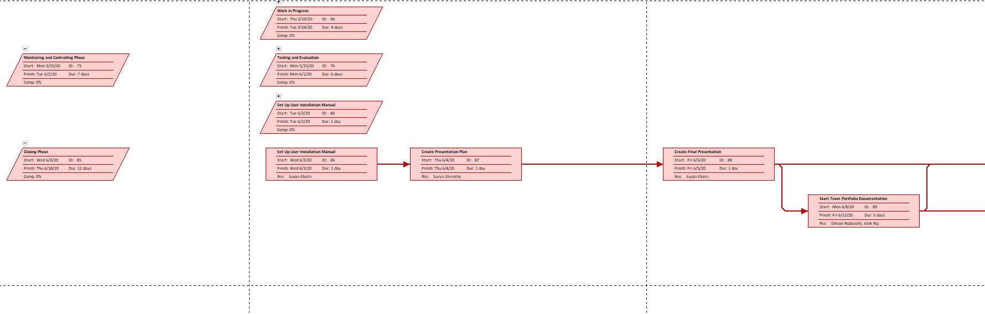

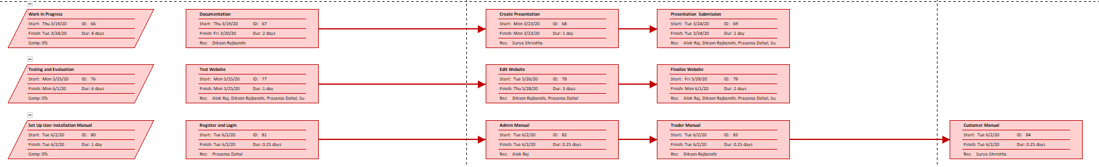

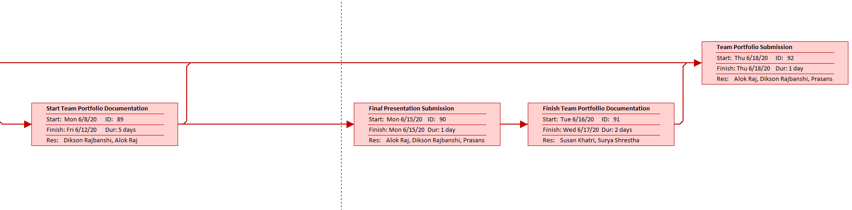

This is our network diagram. The diagram is a visual representation of the project, it includes all the tasks and the relationship between them. It shows whether a task is already finished or not.

### Resource Sheet

|  |  |  |  |  |  |  |  |  |  |  |
| --- | --- | --- | --- | --- | --- | --- | --- | --- | --- | --- |
| Resource Name | Type | Material Label | Initials | Group | Max. Units | Std. Rate | Ovt. Rate | Cost/Use | Accrue At | Base Calendar |
| Writer | Work |  | W |  | 100% | $0.00/hr | $0.00/hr | $0.00 | Prorated | Team A |
| Editor | Work |  | E |  | 100% | $0.00/hr | $0.00/hr | $0.00 | Prorated | Team A |
| Arun Joshi | Work |  | A |  | 100% | $0.00/hr | $0.00/hr | $0.00 | Prorated | Team A |
| Rohit Raj Pandey | Work |  | R |  | 100% | $0.00/hr | $0.00/hr | $0.00 | Prorated | Team A |
| Dikson Rajbanshi | Work |  | D |  | 100% | $0.00/hr | $0.00/hr | $0.00 | Prorated | Team A |
| Prasansa Dahal | Work |  | P |  | 100% | $0.00/hr | $0.00/hr | $0.00 | Prorated | Team A |
| Surya Shrestha | Work |  | S |  | 100% | $0.00/hr | $0.00/hr | $0.00 | Prorated | Team A |
| Susan Khatri | Work |  | S |  | 100% | $0.00/hr | $0.00/hr | $0.00 | Prorated | Team A |
| Alok Raj | Work |  | A |  | 100% | $0.00/hr | $0.00/hr | $0.00 | Prorated | Team A |
| Glossy Paper | Material | Xerox | G |  |  | $0.00 |  | $0.00 | Prorated | Team A |
| Printer | Work |  | P |  | 100% | $0.00/hr | $0.00/hr | $0.00 | Prorated | Team A |
| Pen | Material | Cello | P |  |  | $0.00 |  | $0.00 | Prorated |  |
| Laptop | Work |  | L |  | 100% | $0.00/hr | $0.00/hr | $0.00 | Prorated | Team A |
| QSEE | Material | QSEE Technologies | Q |  |  | $0.00 |  | $0.00 | Prorated | Team A |
| MS Project Professional | Material | Microsoft | M |  |  | $0.00 |  | $0.00 | Prorated | Team A |
| MS Word | Material | Microsoft | M |  |  | $0.00 |  | $0.00 | Prorated | Team A |
| Oracle Database | Material | Oracle | O |  |  | $0.00 |  | $0.00 | Prorated | Team A |

This is our resource sheet. The sheet shows the resource names i.e. the names of the people required during the project, material used and their type.

### Timeline

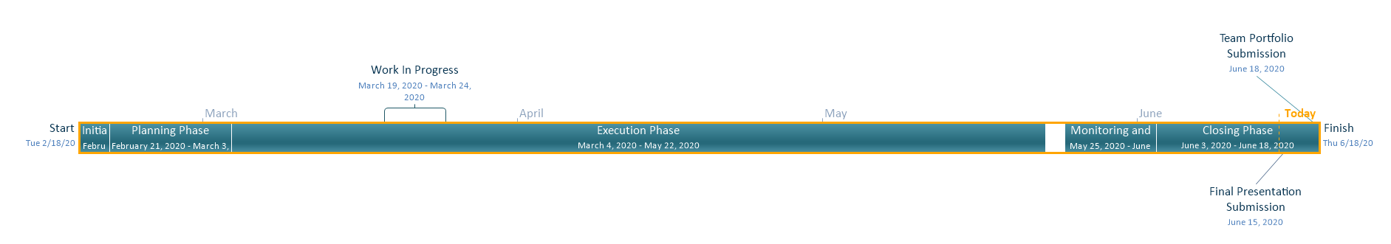

This is our timeline. The timeline shows the line of events with their respective dates, along with start and finish date of the project.

## Team Meetings

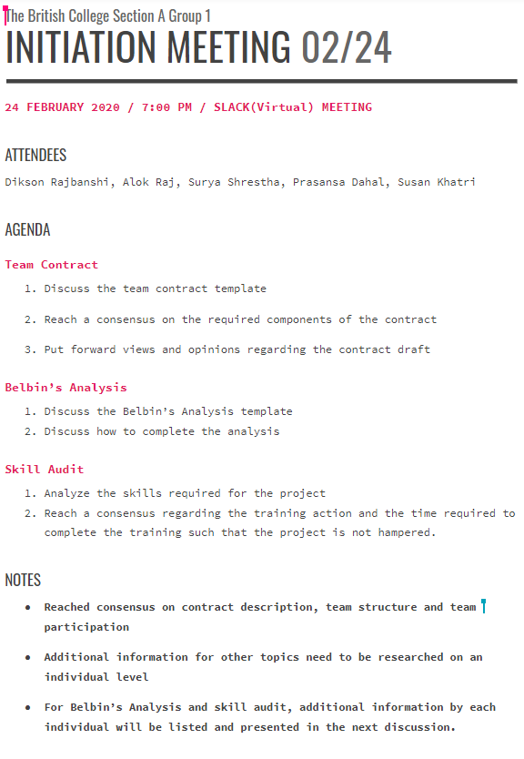

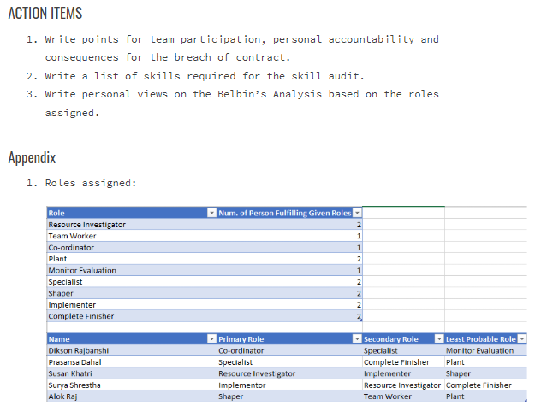

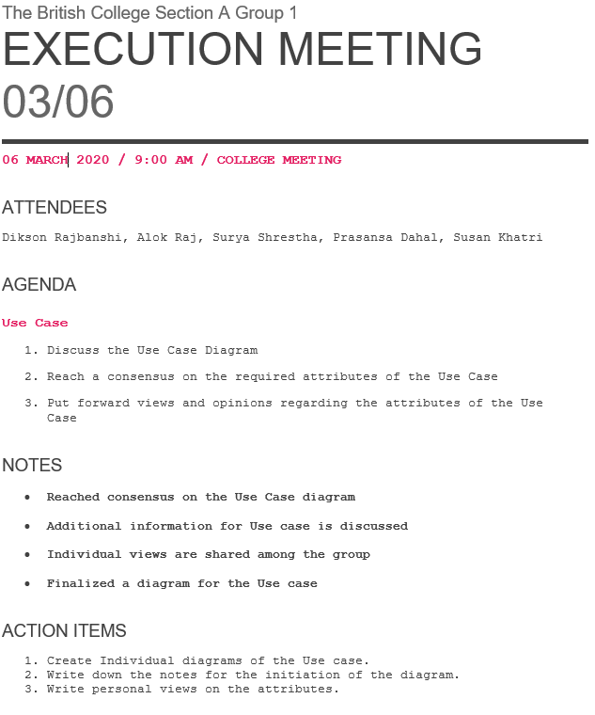

## Team Meetings (Virtual)

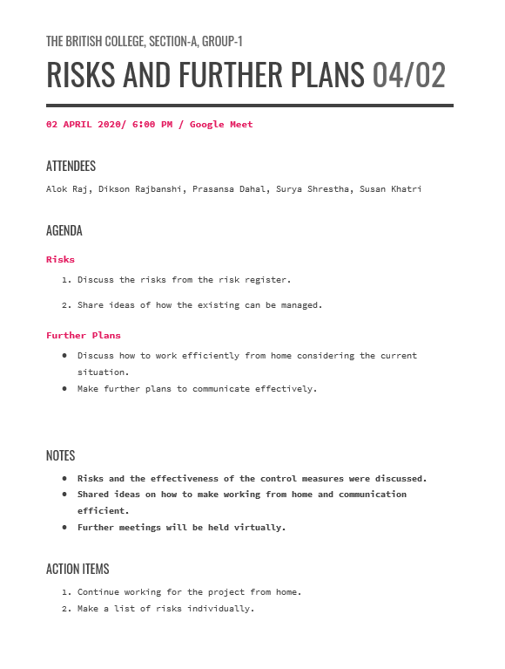

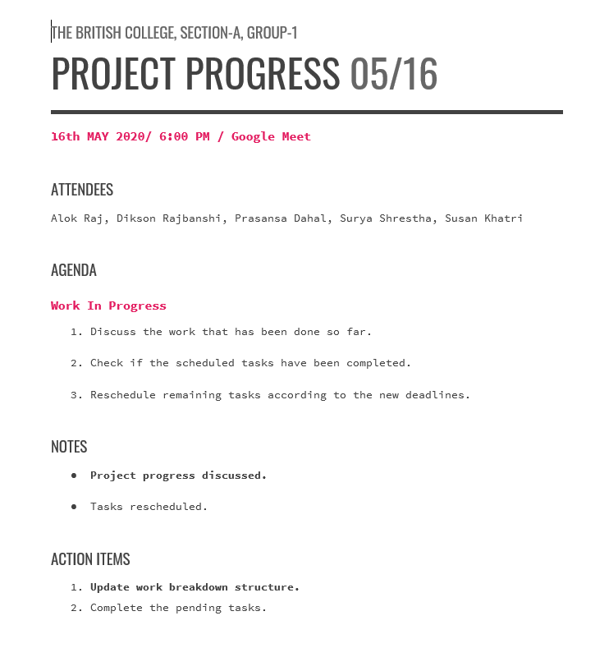

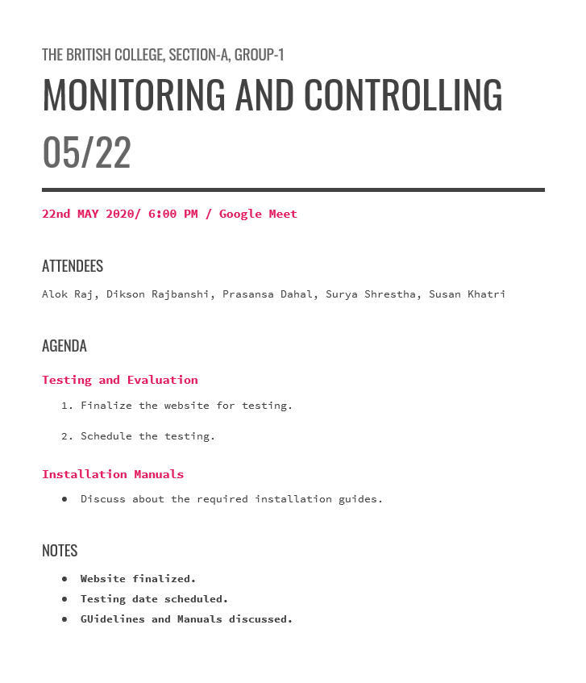

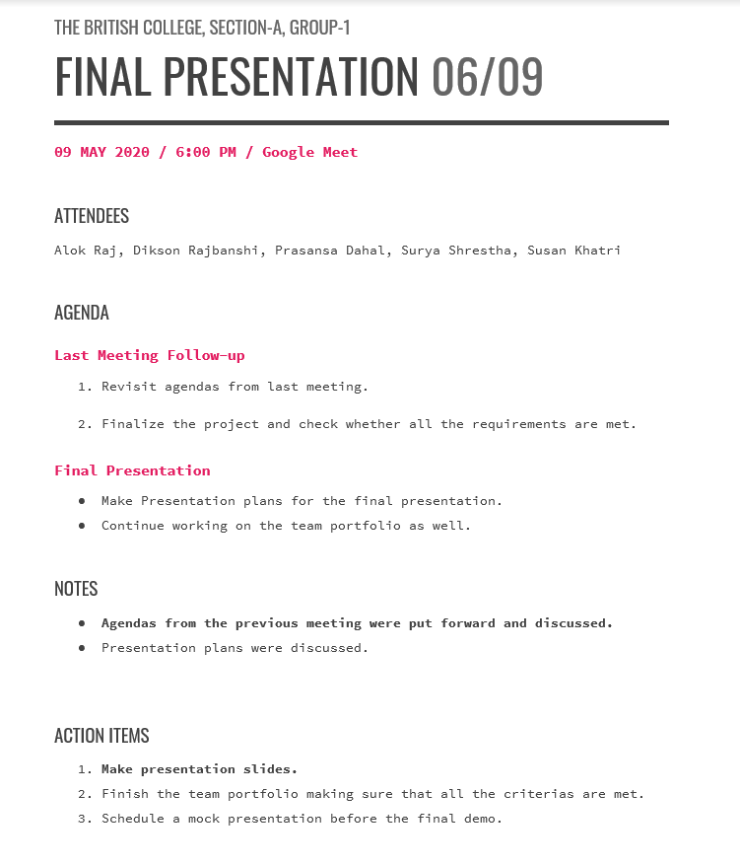

This is the team meeting minutes. Team Meetings contain the attendees, agendas, and notes from the meetings. It contains the minutes of the face-to-face as well as the virtual meetings.

## Communication and Collaboration Tools Used

### Trello

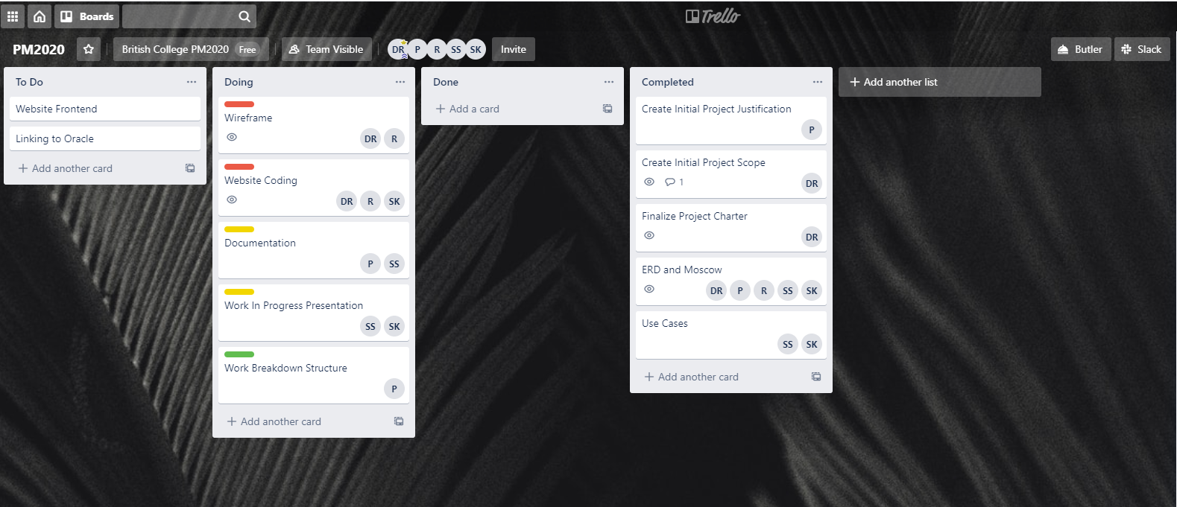

### Slack

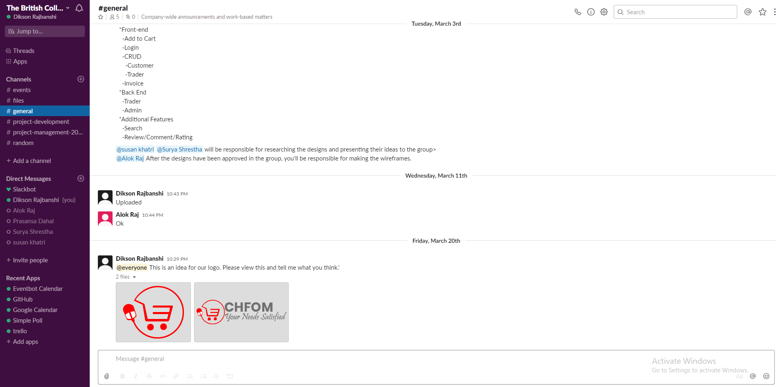

### GitHub

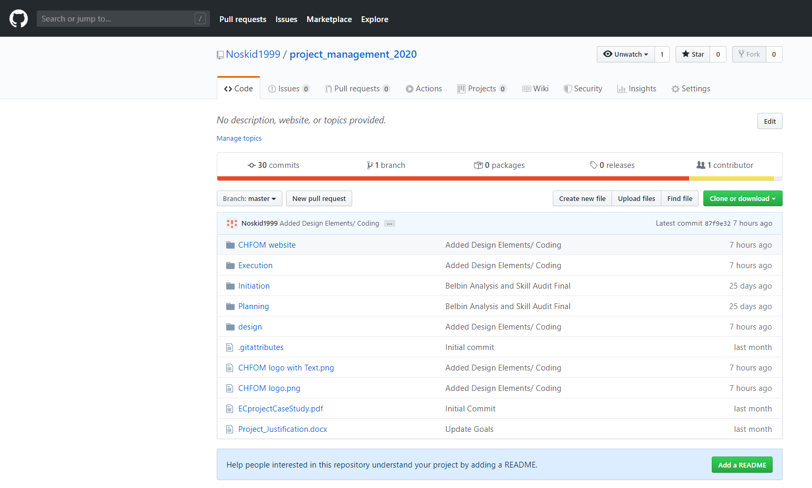

* The collaboration tools used show the details of the online tools used among the team members to regularly communicate. Tools like Trello, Slack and GitHub were used to organize tasks and share files with each other.

# Project Execution

## Requirements

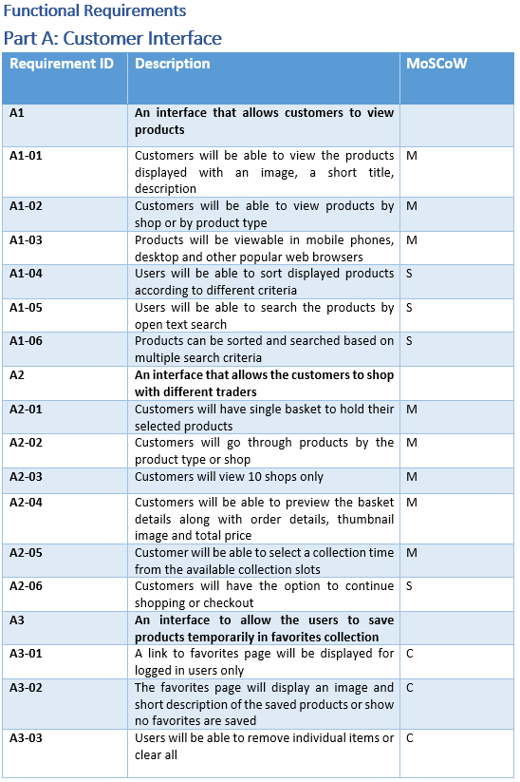

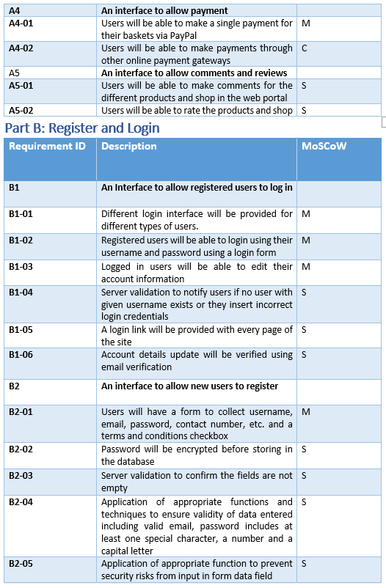

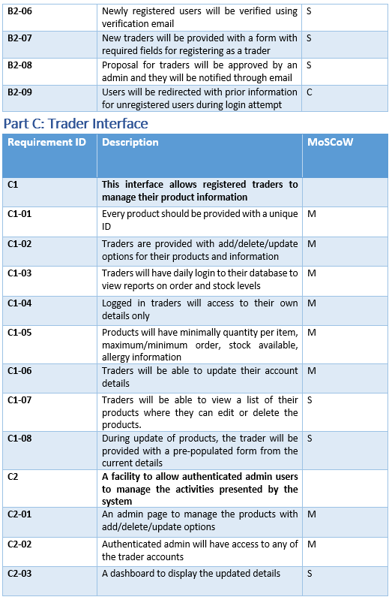

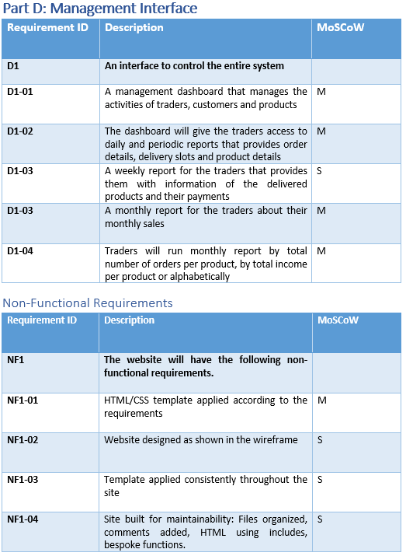

The requirement catalogue shows both the functional and non-functional requirements of the project along with the MoSCoW rule. It contains requirement id and description of Customer, Trader and Management interfaces.

## Entity Relationship Diagram (ERD)

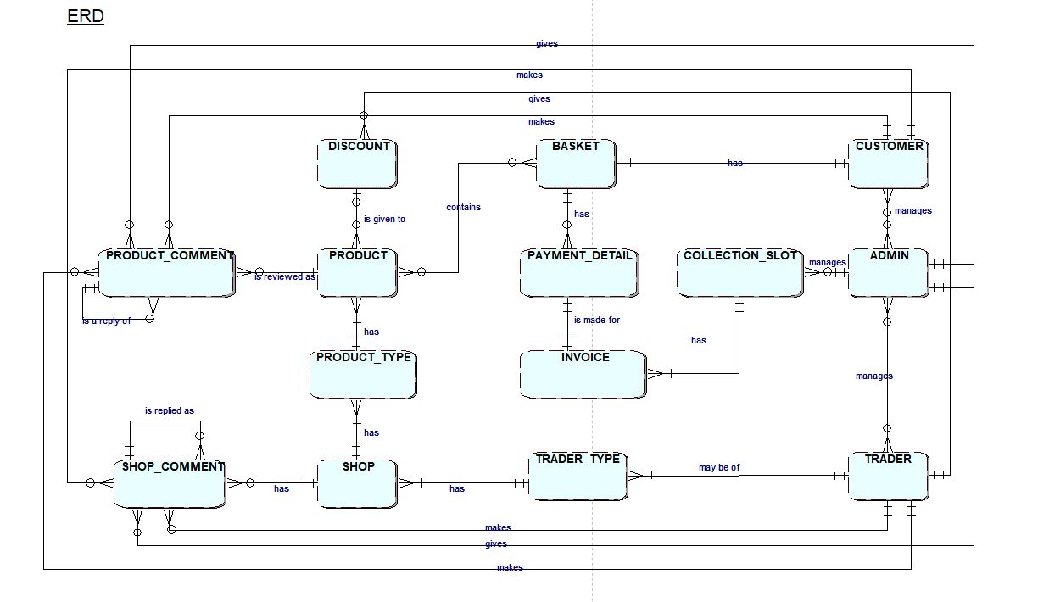

This is our ERD for the project. The Entity Relationship Diagram shows the relationship between the entity tables of the database. It shows all the entities required for the project and their relationship with one another.

## Extended Entity Relationship Diagram (EERD)

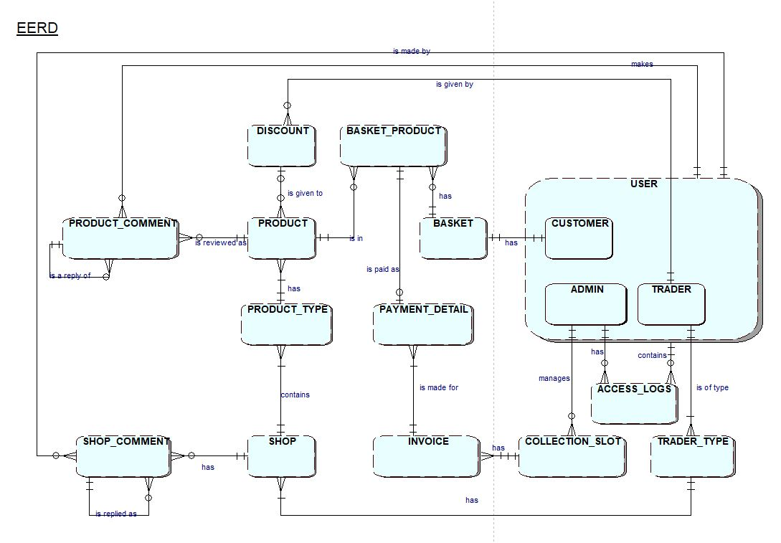

The Extended Entity Relationship diagram shows the expanded and more clear vision of all the entities and their relationship.

## Composite ERD

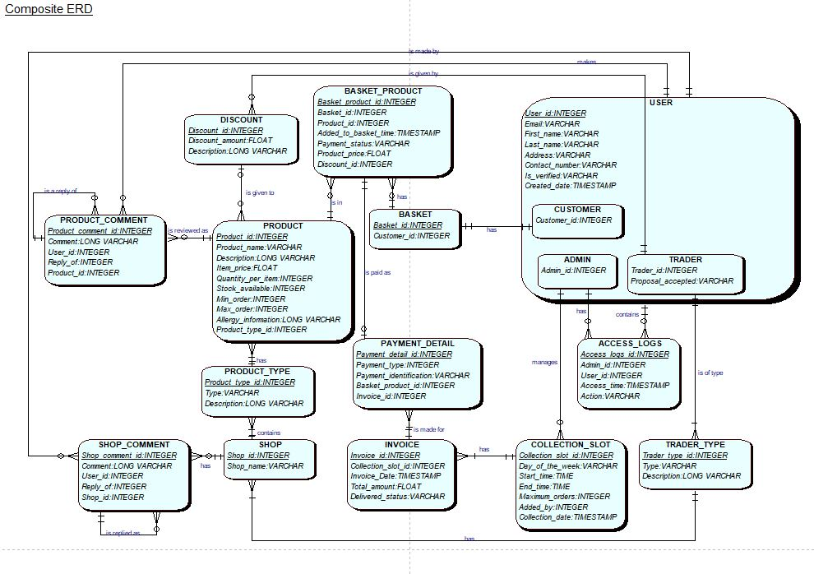

This is the composite ERD, it contains all the entities along with the attirbutes.

## Logical Design

* USER (User_id, Email, First_name, Last_name, Address, Contact_number, Is_verified, Created_date)
* CUSTOMER (Customer_id, *User_id*)
* ADMIN (Admin_id, *User_id)*
* TRADER (Trader_id, Proposal_accepted, *User_id)*
* PRODUCT (Product_id, Product_name, Description, Item_price, Quantity_per_item, Stock_available, Min_order, Max_order, Allergy_information, *Product_type_id, Discount_id*)
* BASKET (Basket_id, *Customer_id*)
* BASKET_PRODUCT (Basket_product_id, *Basket_id, Product_id*, Added_to_basket_time, Payment_status, Product_price, *Discount_id*)
* PAYMENT_DETAIL (Payment_detail_id, Payment_type, Payment_identification, *Basket_product_id, Invoice_id*)
* INVOICE (Invoice_id, *Collection_slot_id,* Invoice_date, Total_amount, Delivered_status)
* COLLECTION_SLOT (Collection_slot_id, Day_of_the_week, Start_time, End_time, Maximum_orders, *Added_by*, Collection_date)
* ACCESS_LOGS (Access_logs_id, *Admin_id, User_id,* Access_time, Action)
* TRADER_TYPE (Trader_type_id, Type, Description)
* SHOP (Shop_id, Shop_name)
* PRODUCT_TYPE (Product_type_id, Type, Description, *Shop_id*)
* DISCOUNT (Discount_id, Discount_amount, Description)
* SHOP_COMMENT (Shop_comment_id, Comment, *User_id, Reply_of, Product_id*)
* PRODUCT_COMMENT (Product_comment_id, Comment, *User_id, Reply_of, Shop_id*)

This is the logical design. It contains the attributes of the entities along defining their primary and foreign keys.

## Use Case

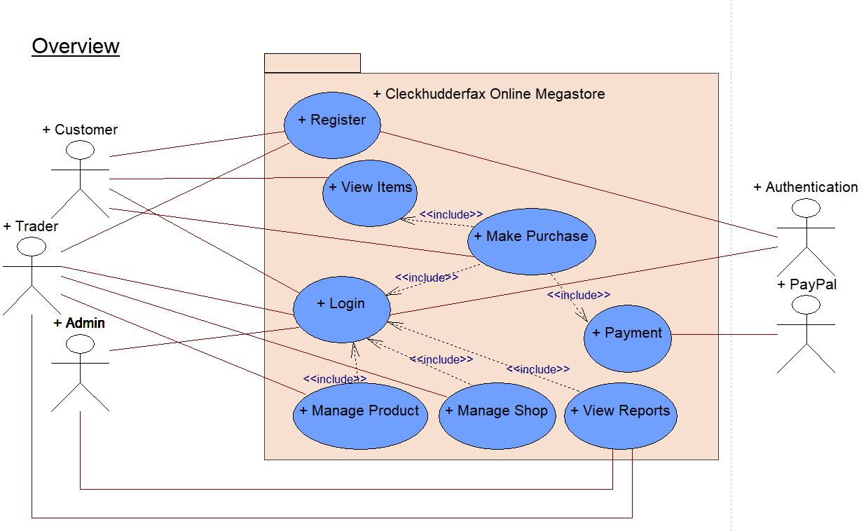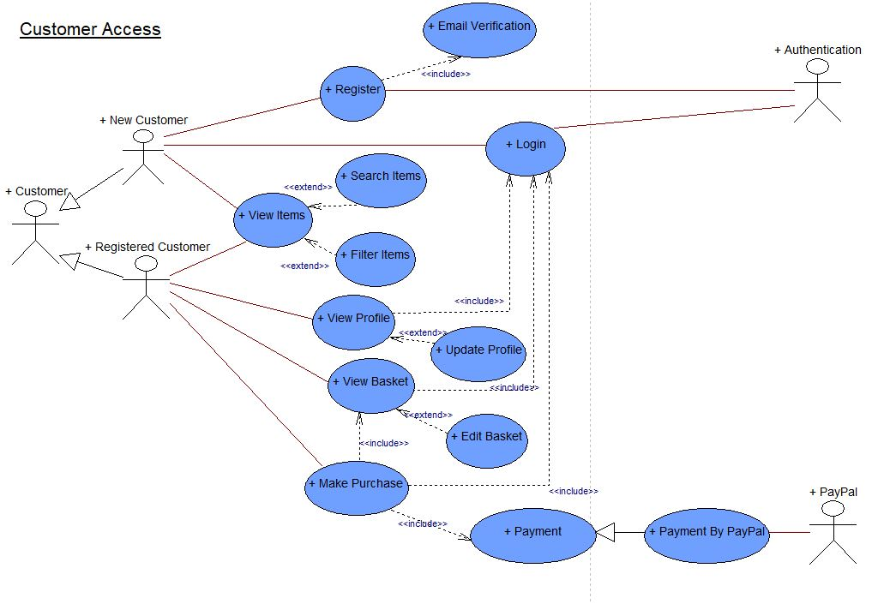

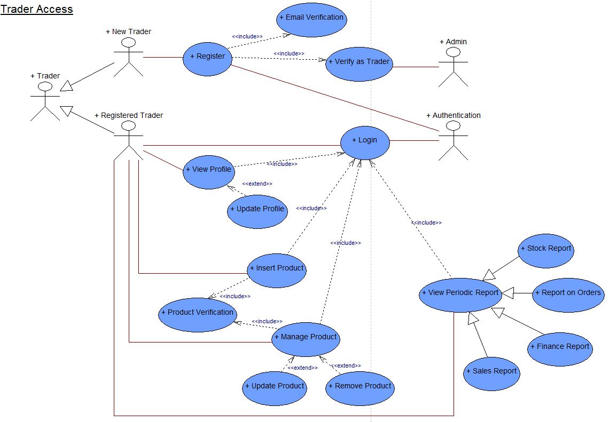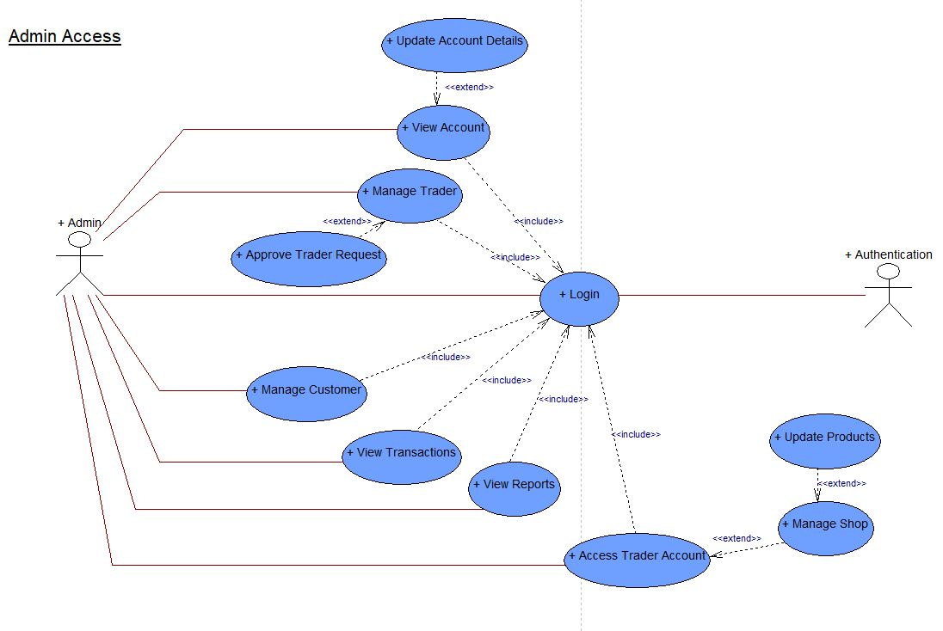

These are the use case designs for customer access, trader access and admin access and one overall use case. It shows the functionality of the system.

## Wireframes

### Home

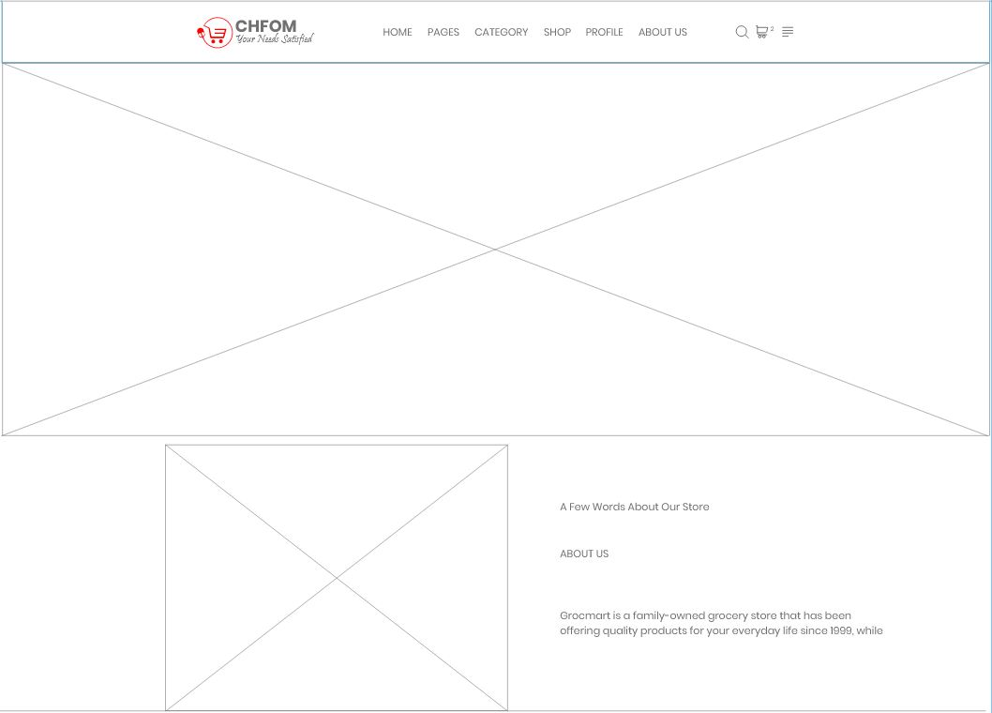

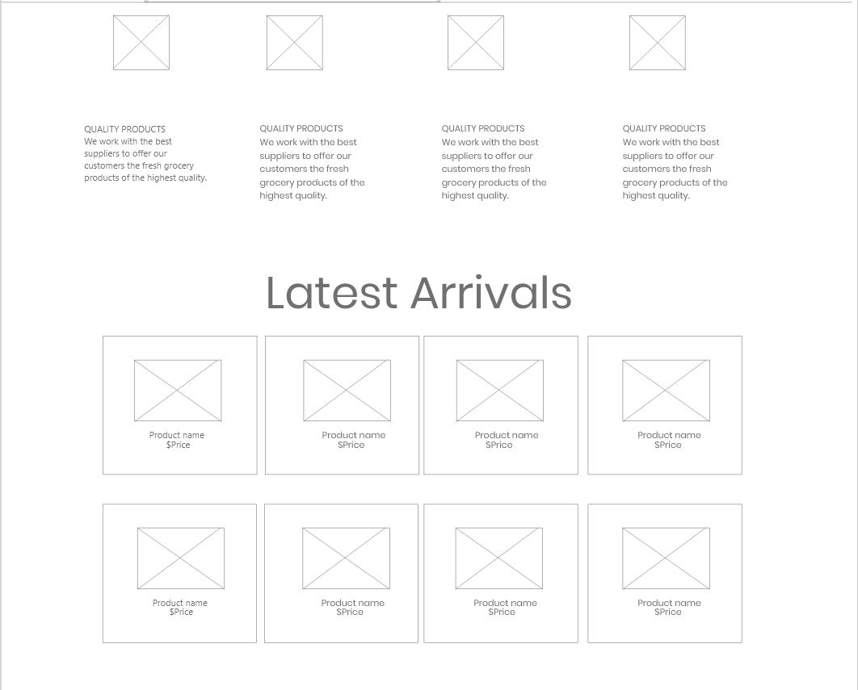

These are the wireframes for our homepage. They represent how the actual homepage looks like with the product images, logo, navigation etc.

### About Us

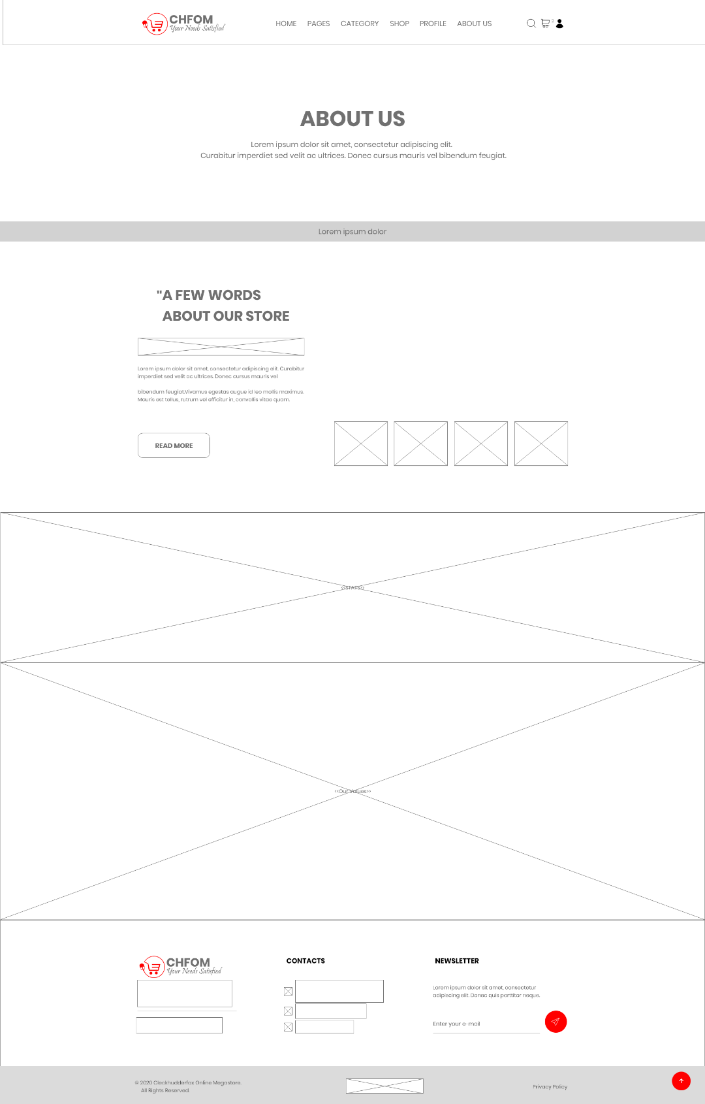

This wireframe represents out about us page, it contains navigation menu, store information, images contact information etc.

### Our Clients

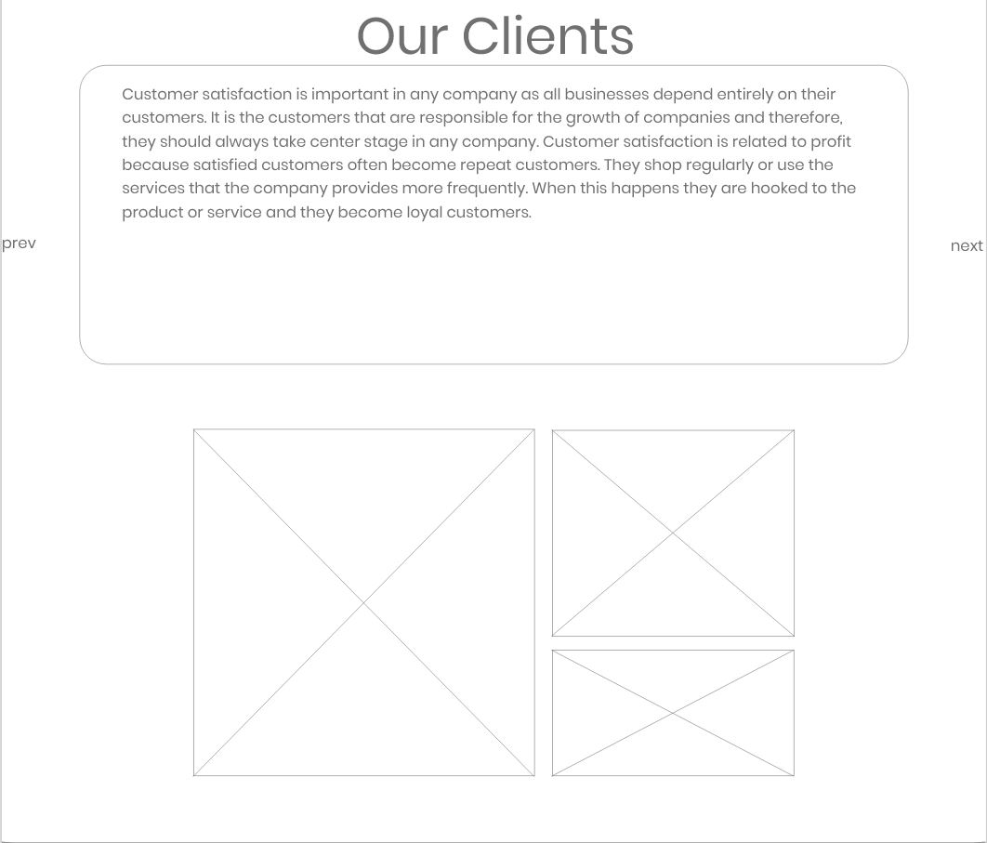

This wireframe represents the our view towards our clients and few words from us.

### FAQs

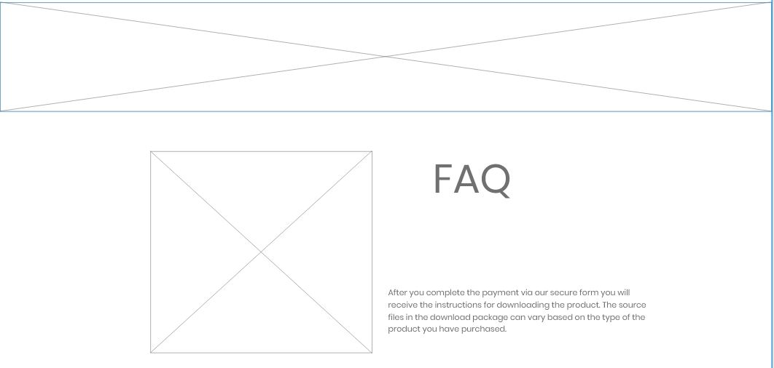

This wireframe represents the frequently asked questions page. This page displays the questions the users ask.

### Our Blog

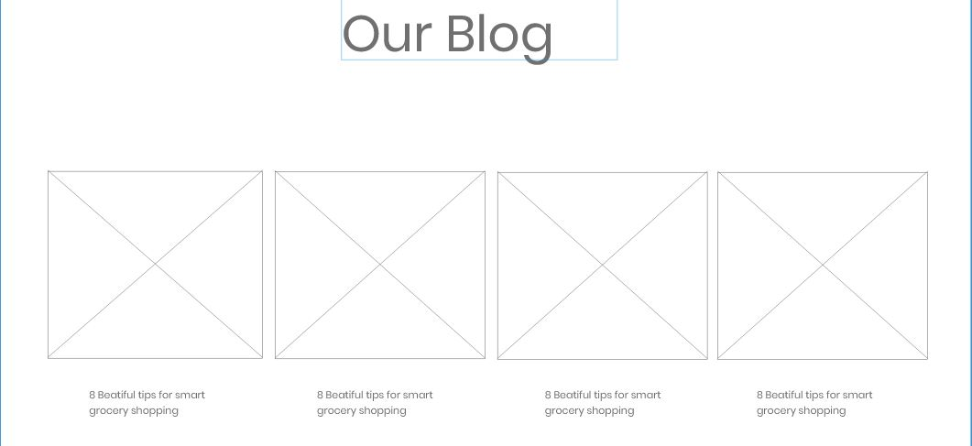

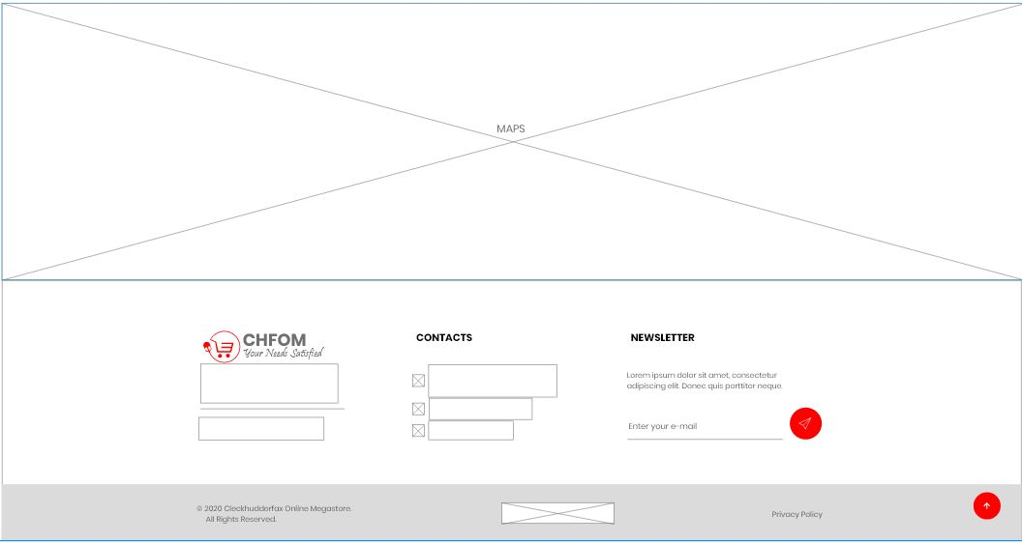

Our Blog represents the blog page where updates of the shop and website are available.

### Shop

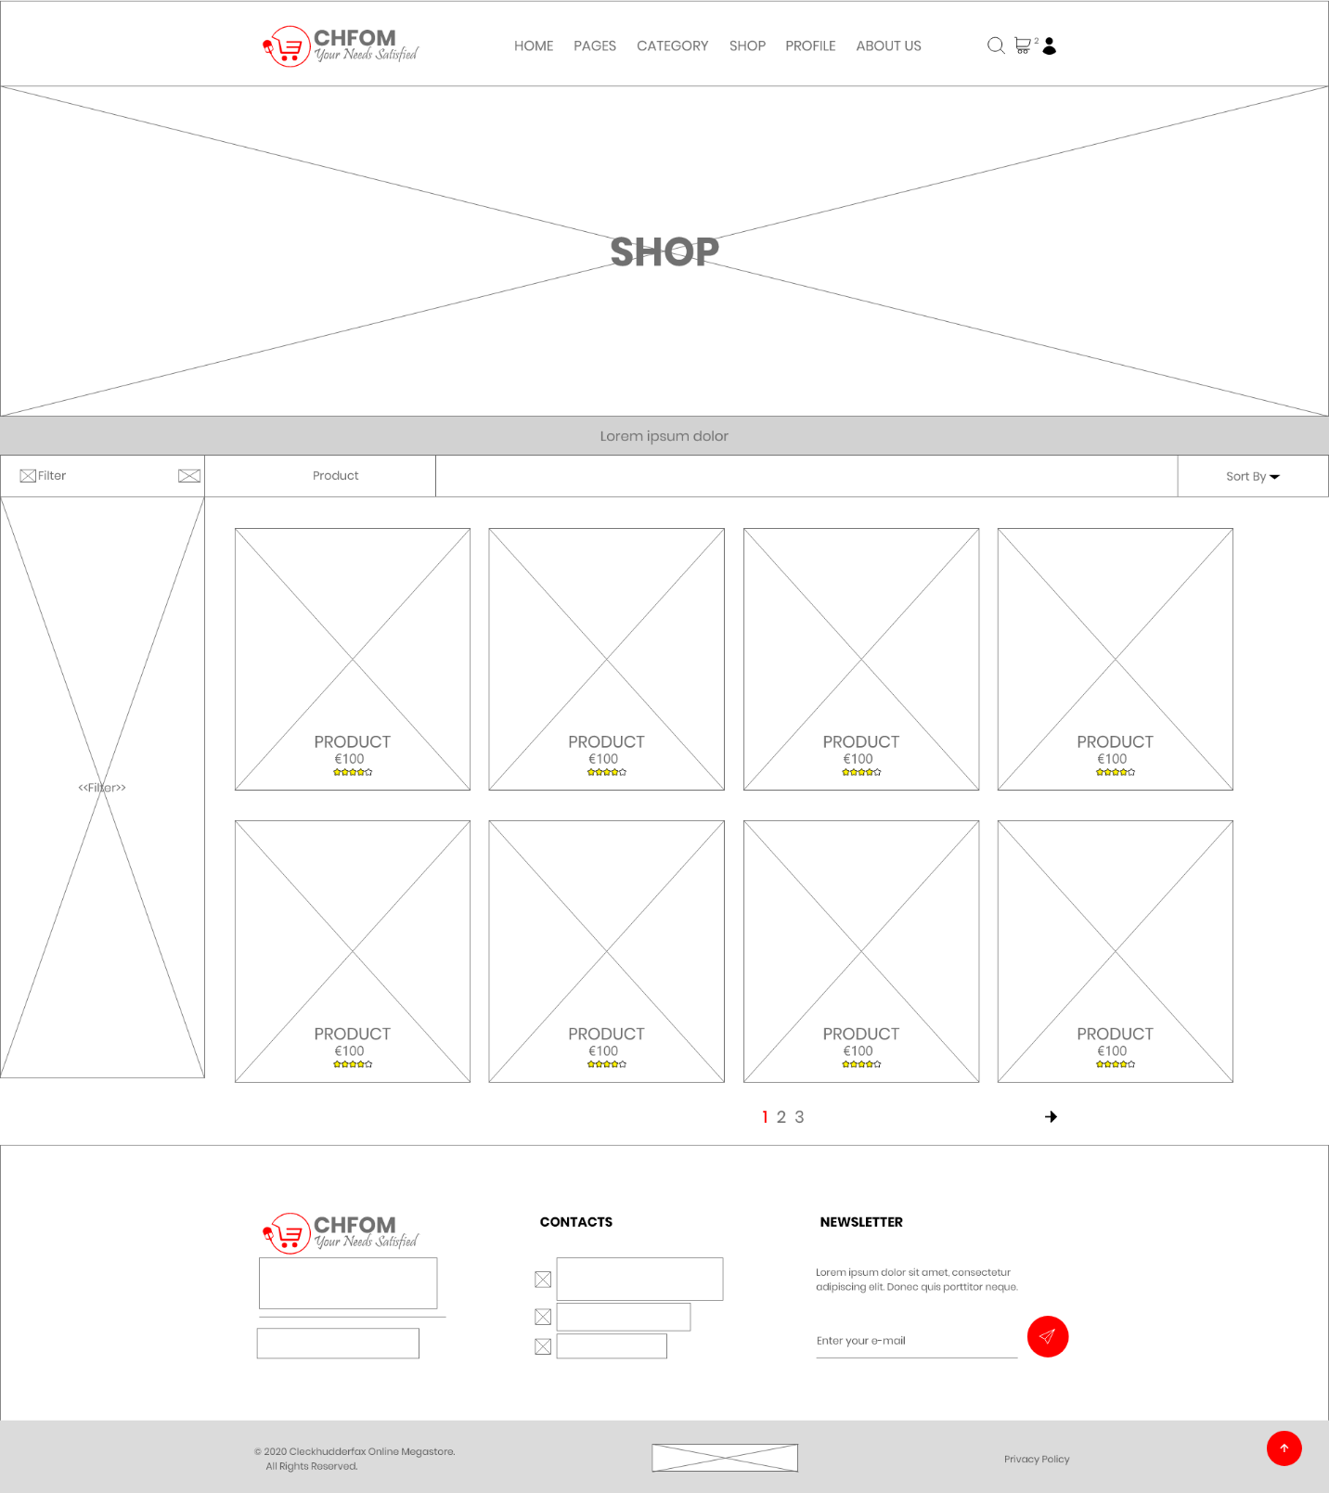

The wireframe represents the shop of our actual site. It contains the images and details of products.

### Single Product Page

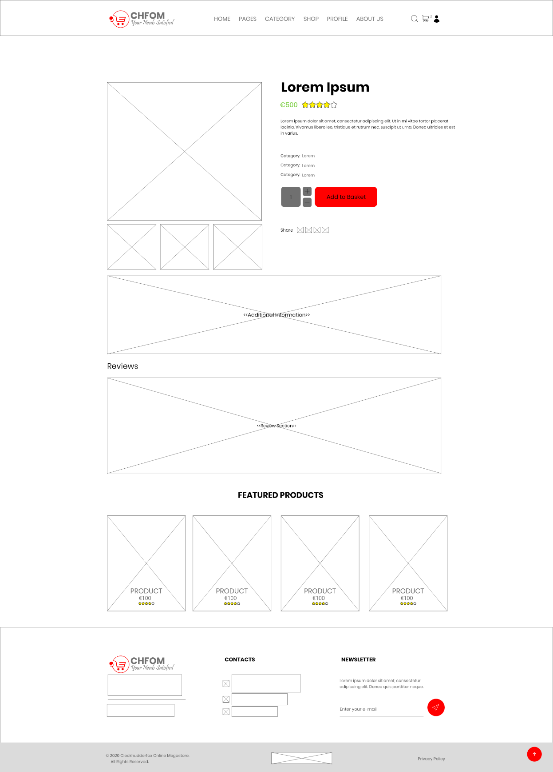

The single product page shows all the details about a product along with the suggestion of the featured product.

### Search

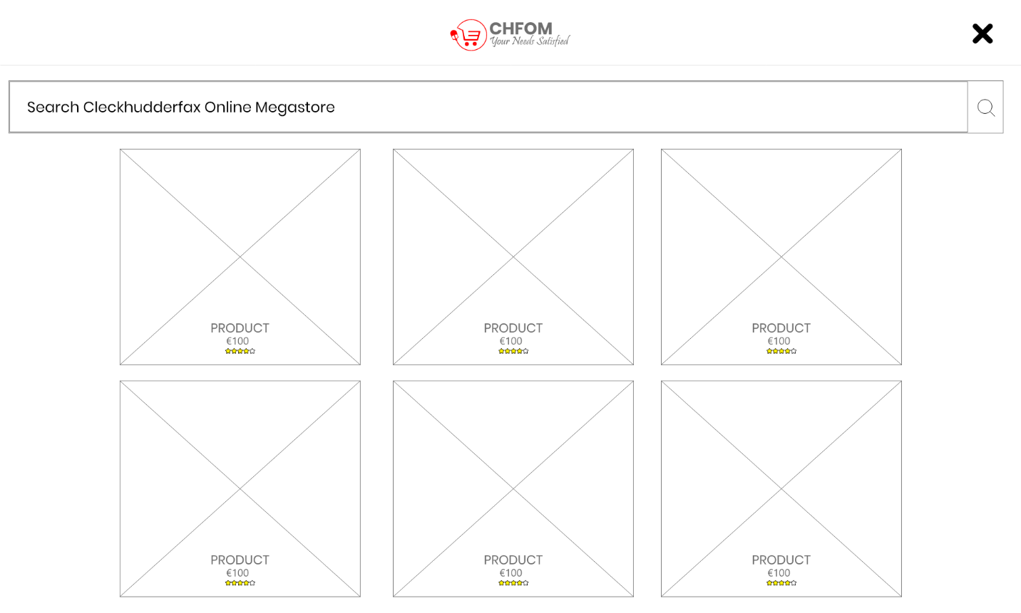

Search bar to perform live search for the product of interest.

### Basket

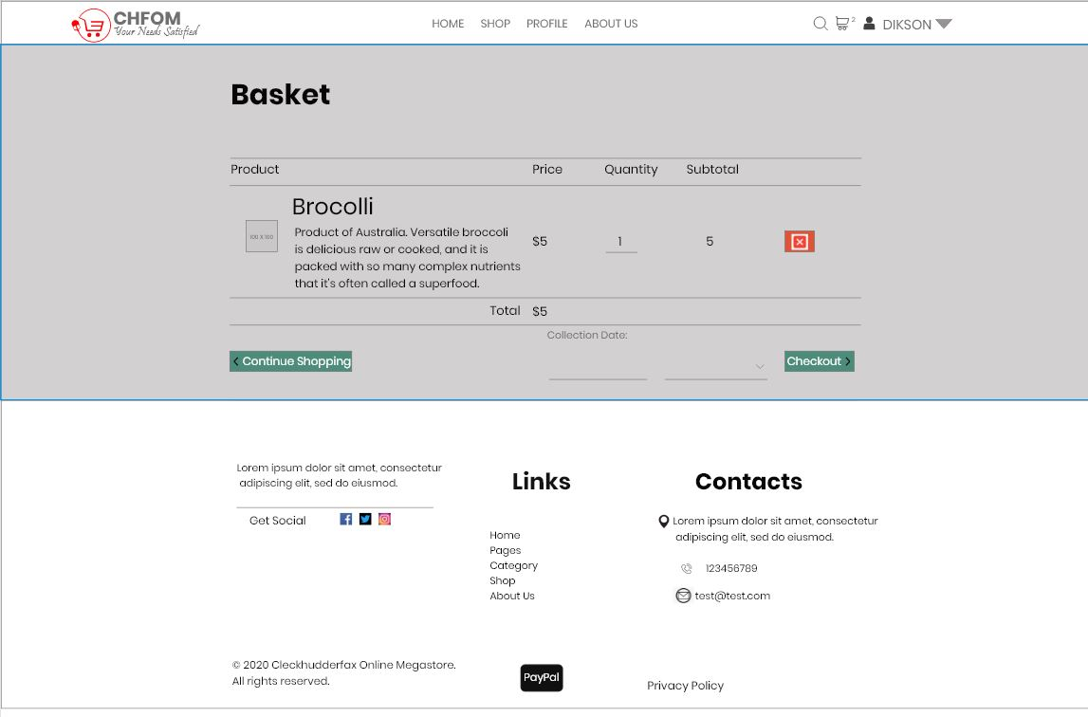

Basket page to add products of interest before buying.

### Login

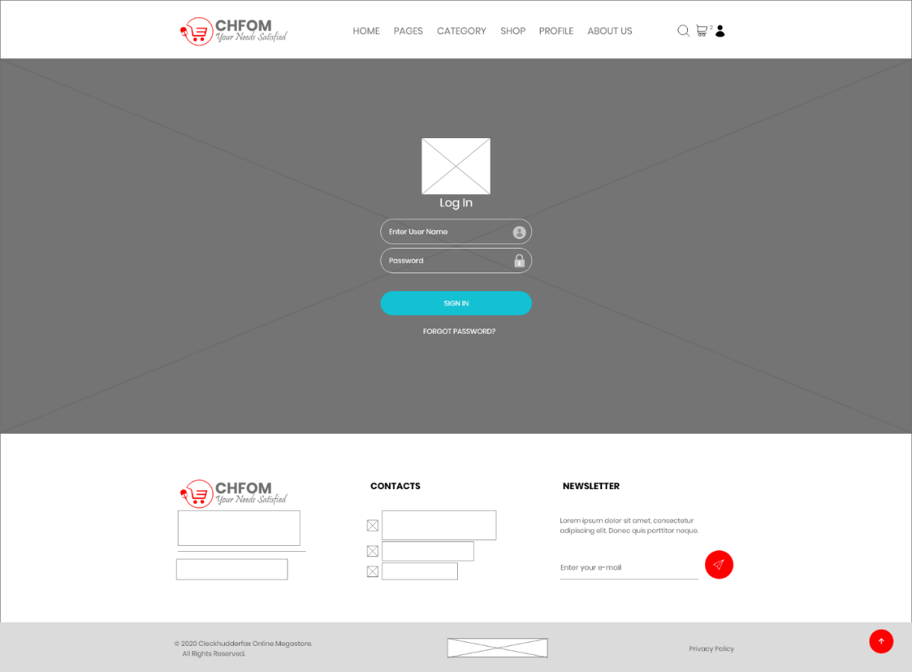

Login form representation for customer, trader or admin.

### Manage Account

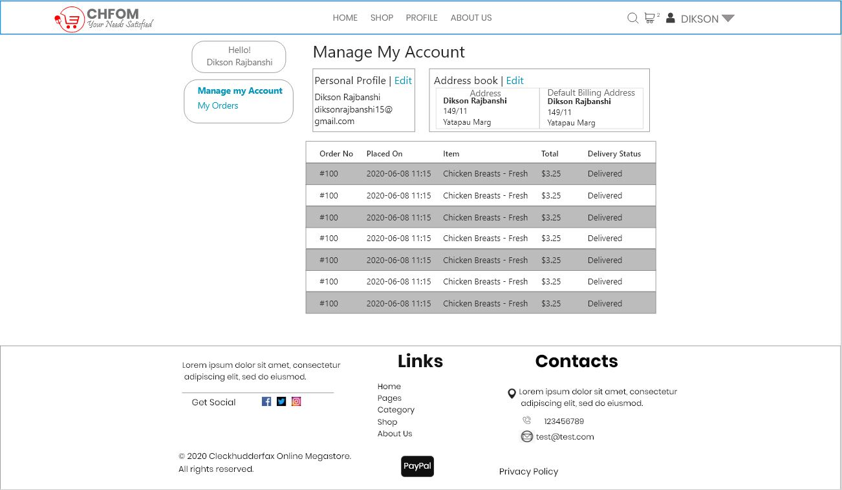

This is manage my account page where users can update and manage their account.

### Add Product

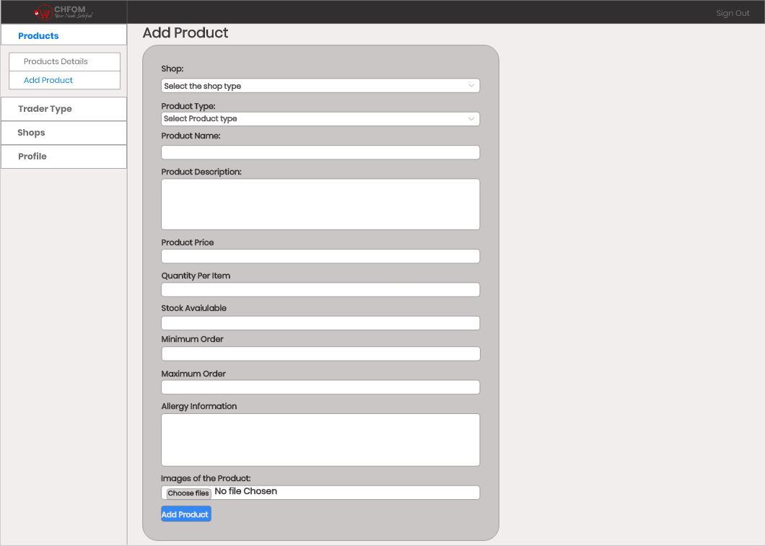

This wireframe represents add product facility for trader and admin.

### Product Details

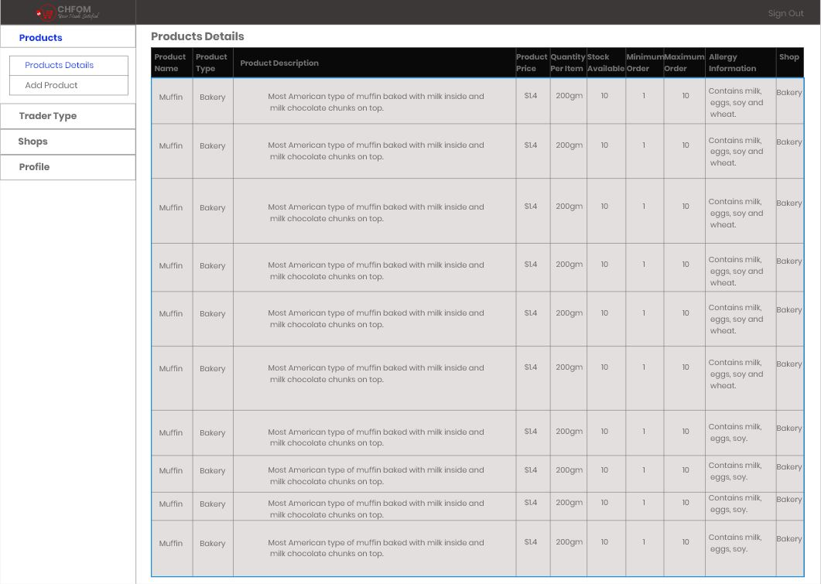

This wireframe represents update product details for admin facility.

## Risk Register

### Risk Register (Team)

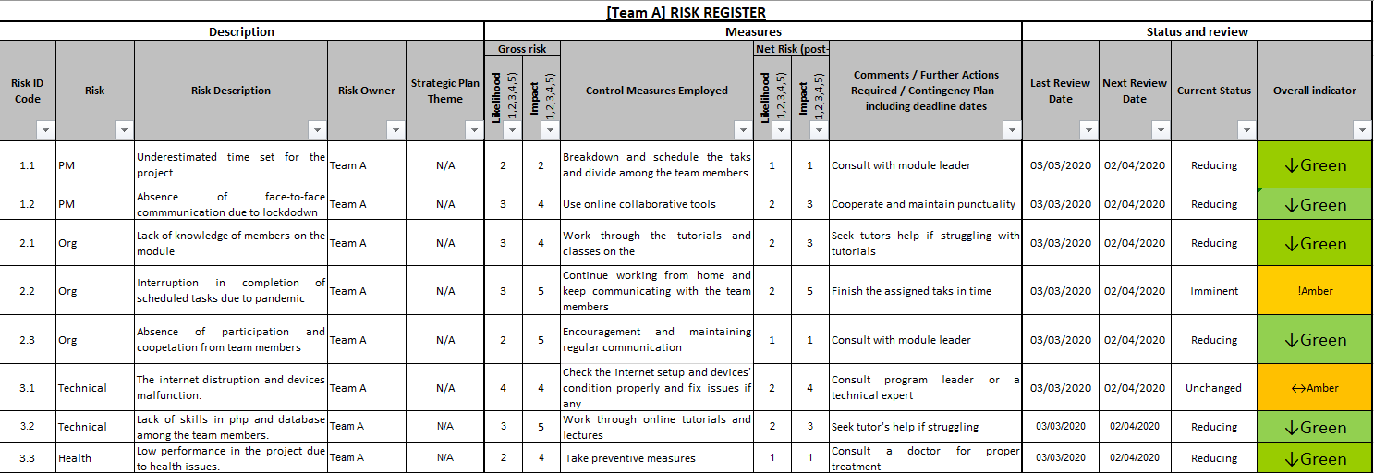

### Risk Profile (Team)

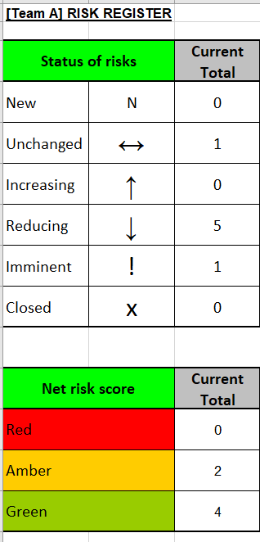

* Risk Register (team) shows the list of overall possible risks of the team for the project and their control measures. It contains required further actions as well and the status of the impact. Risk Profile contains the total count of risk status and net risk score.

### Risk Register (Individual)



### Risk Profile (Individual)



* Risk Register (individual) shows the list of overall possible risks of the team for the project and their control measures. It contains required further actions as well and the status of the impact. Risk Profile(individual) contains the total count of risk status and net risk score.

# Web Application

## Homepage

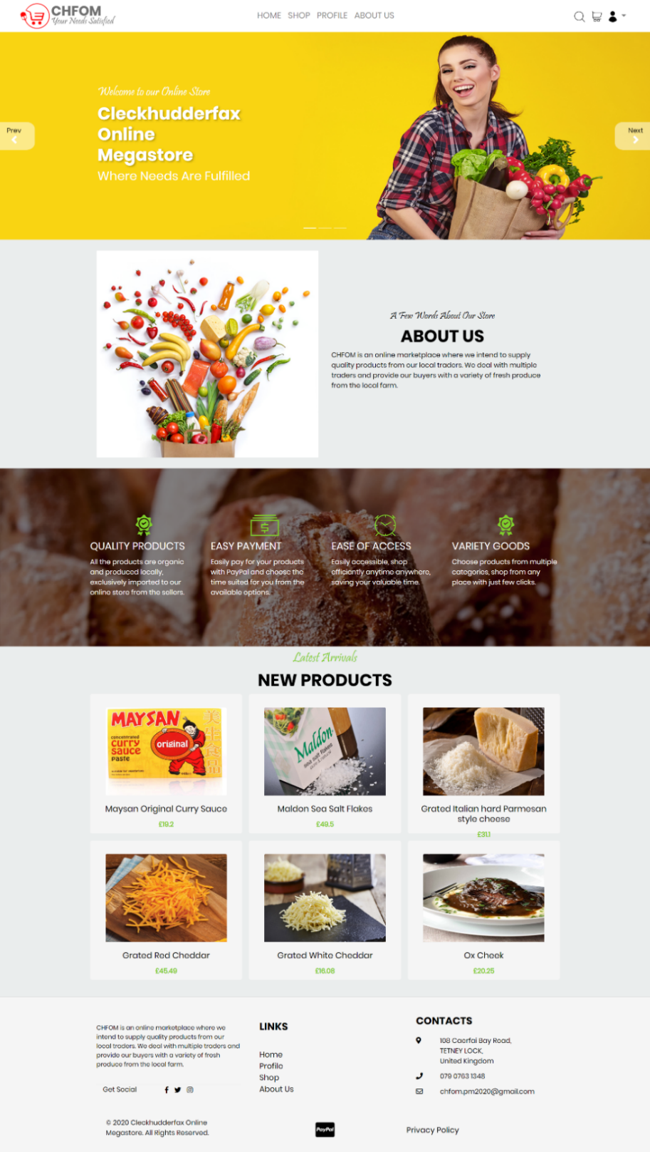

This is our homepage. This page of the website shows the logo and name of the online store the project is based on, along with navigation links. Additionally, it has a short description of the store, features, and latest products. The footer displays the links to other pages, out contact details etc.

## About Us

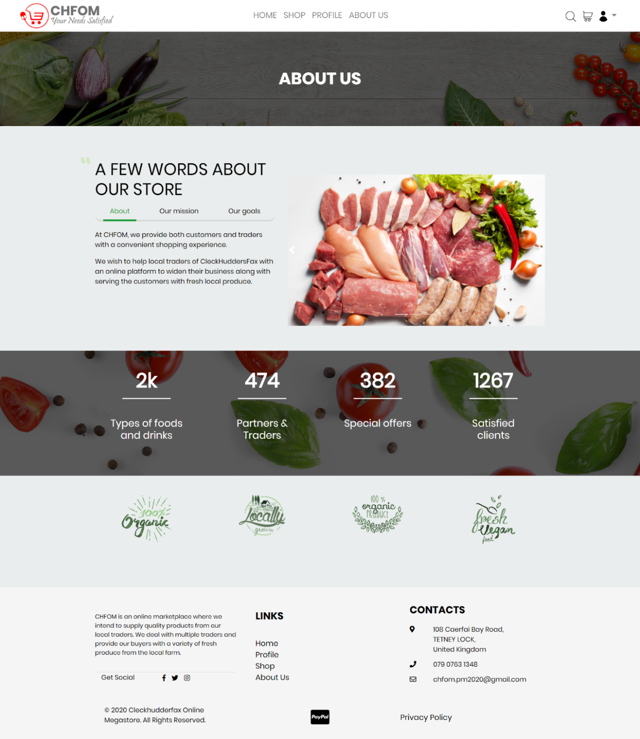

This is our about us page. This page provides more information of the project along with our mission and goals. It displays the total counts of food, partners, special counts, and clients followed by the footer.

## Shop

### Products

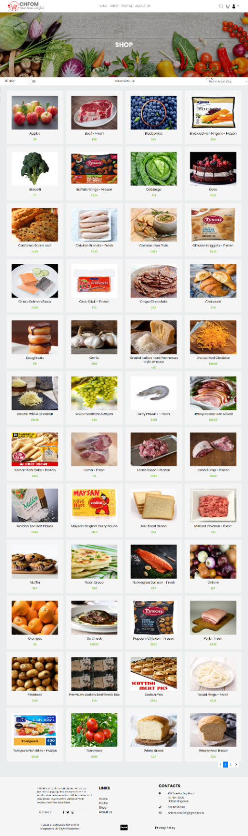

This is our shop page. This page features a display of the products available along with their names and price. The pagination allows users to go to other pages and view all products.

### Filter

#### Filter: Product type

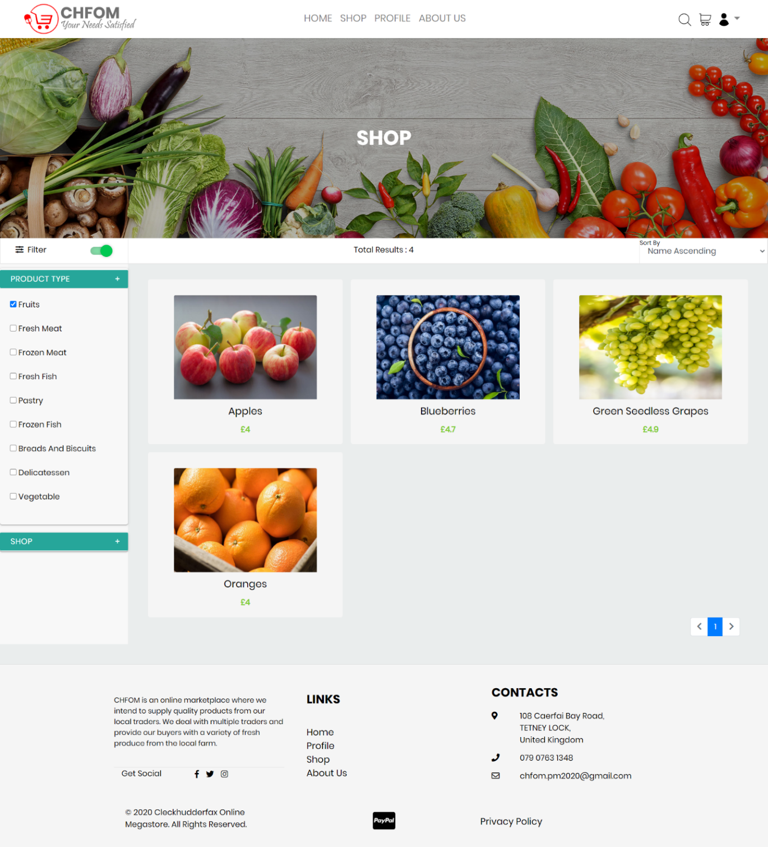

This is the product type filter. The available products can be filtered according to their type with the product type filter. Users can choose the product of their choice and have them filtered and displayed.

#### Filter: Shop

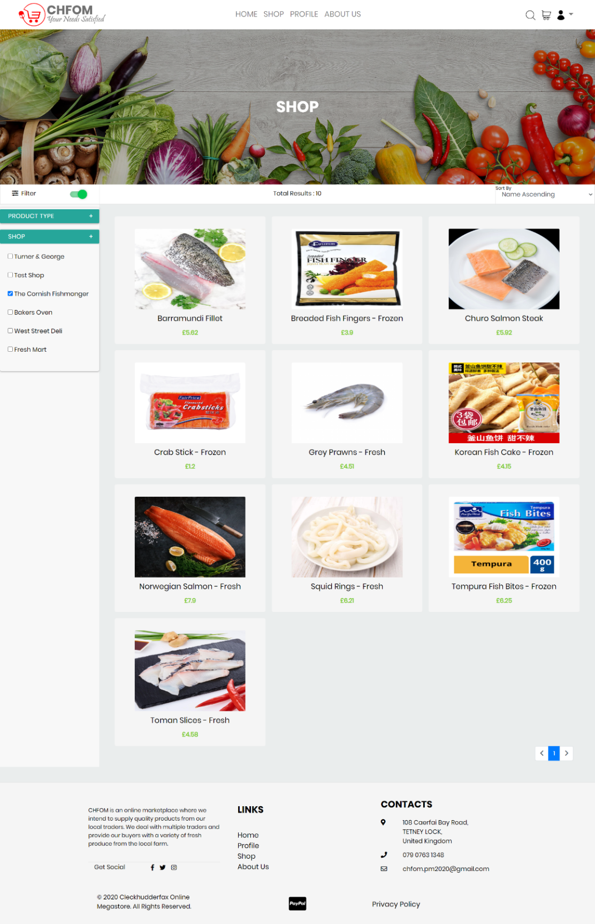

The shop page provides with another filter where users can filter the products by their shops. Users can choose the shop of their choice with the shop filter and have them products displayed accordingly.

## Product

### Product Search

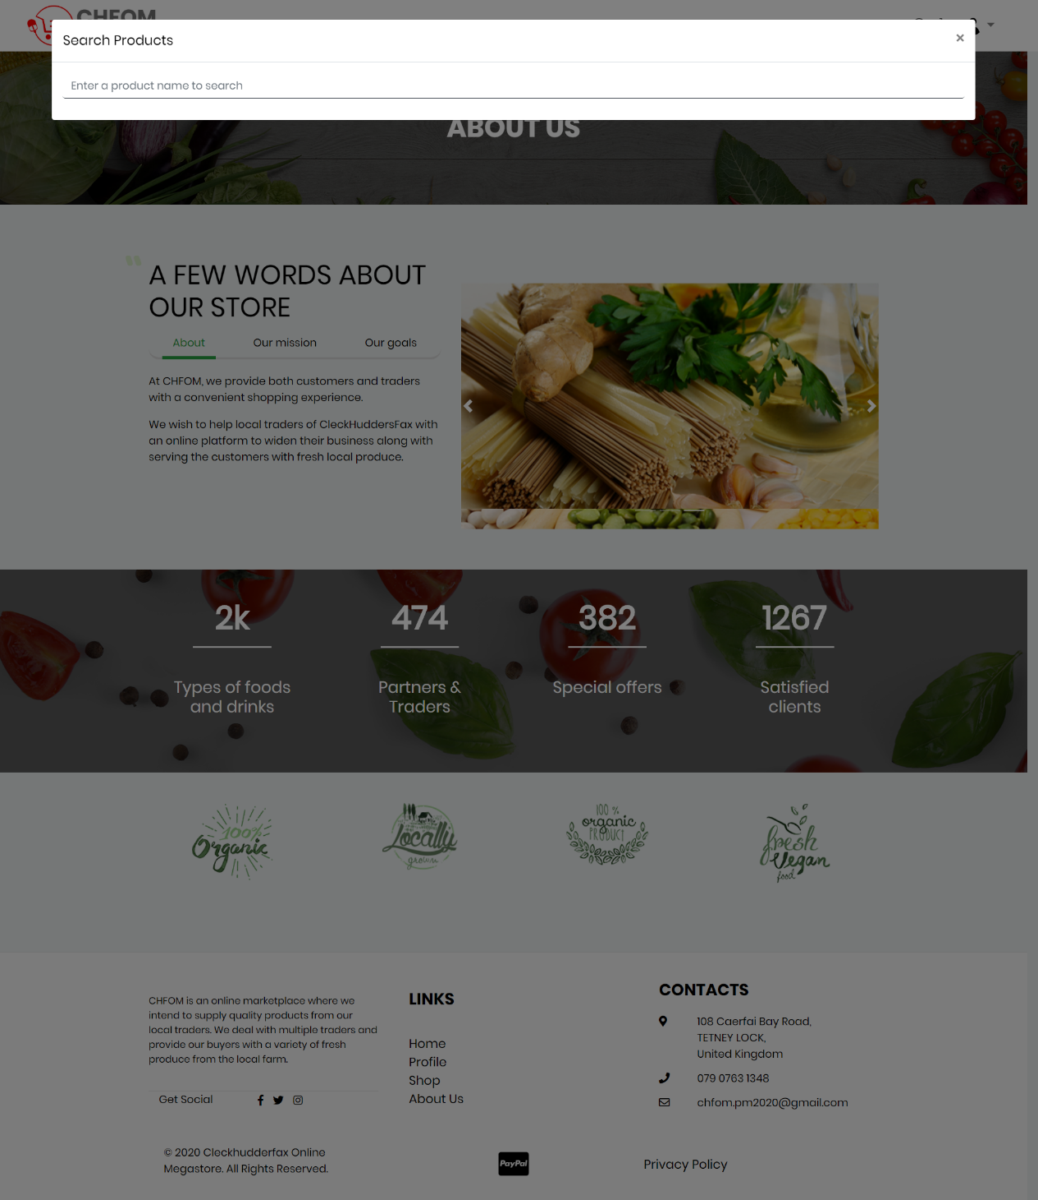

The Search feature allows the user to type and search products that they are interested to in buying.

### Product Search Result

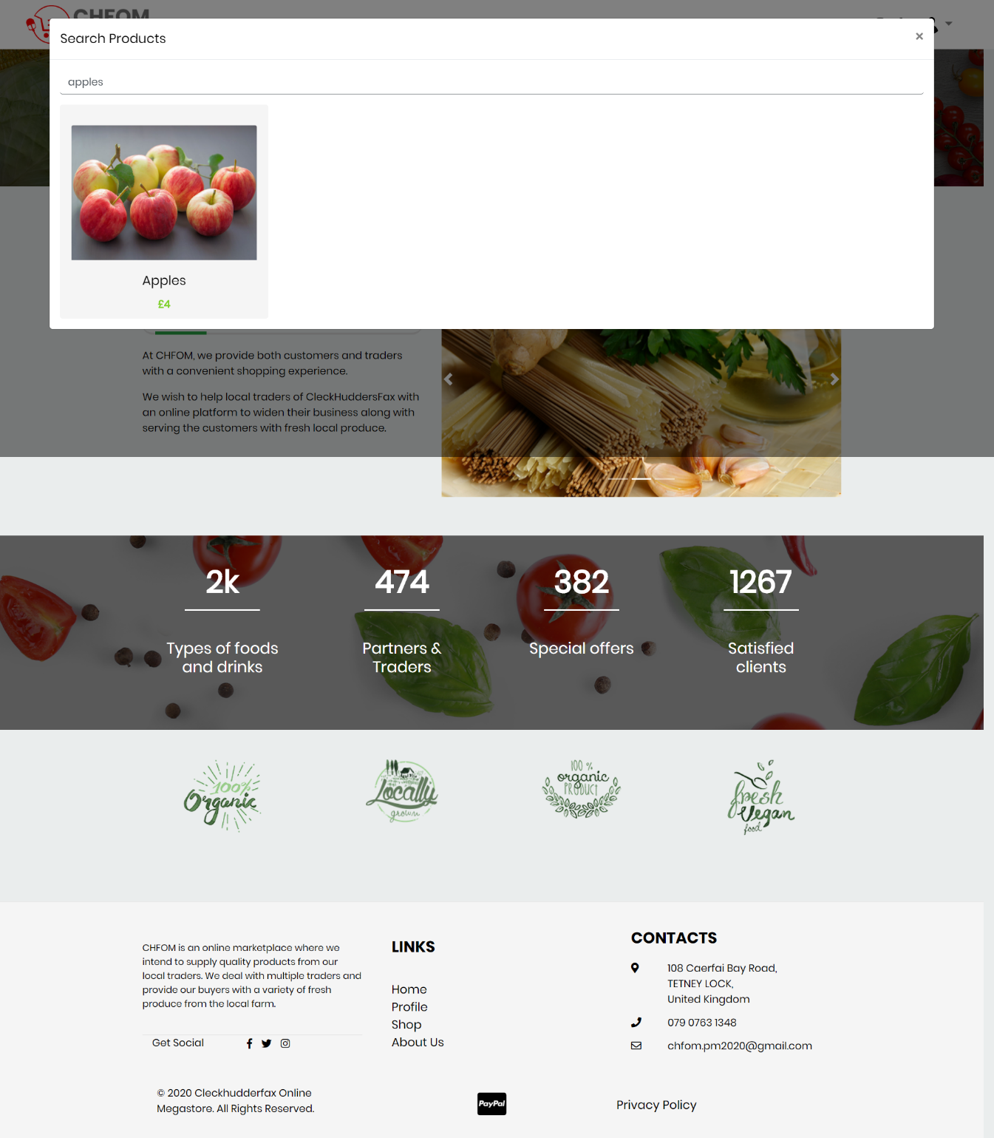

As a result of live search, the available products are displayed along with their price as you type the product name.

### Product Information

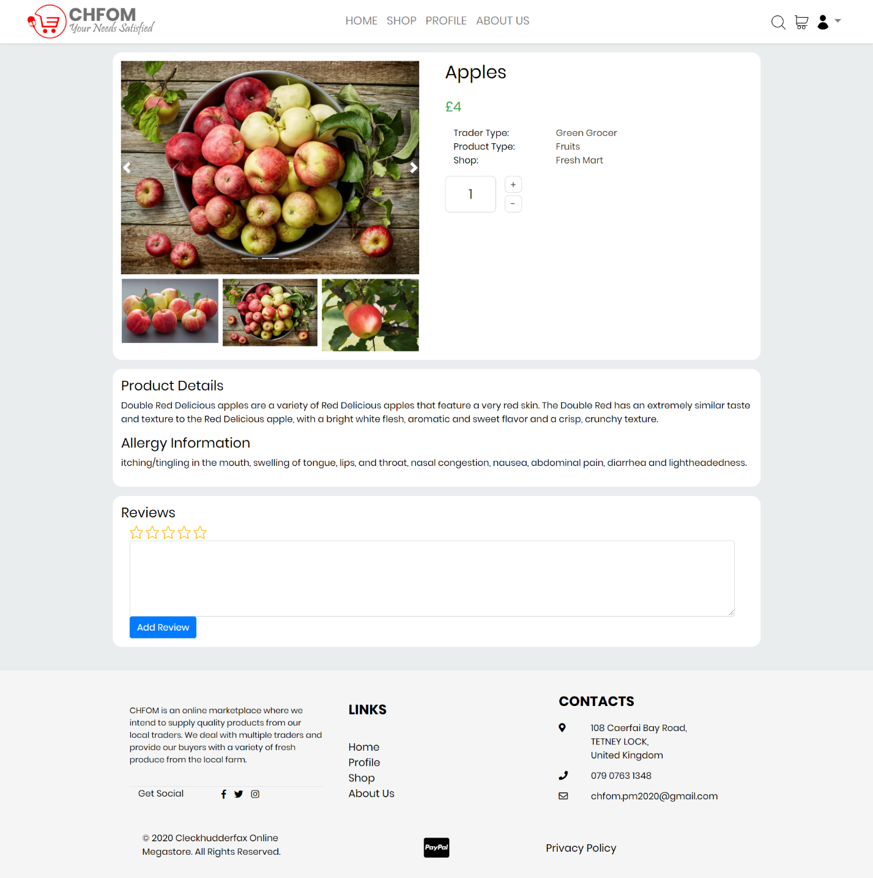

The page displays product details.Products Details displays all the information of the product i.e. product name, type, description, allergy information and a field to leave reviews and rating.

## Basket

### Basket Empty

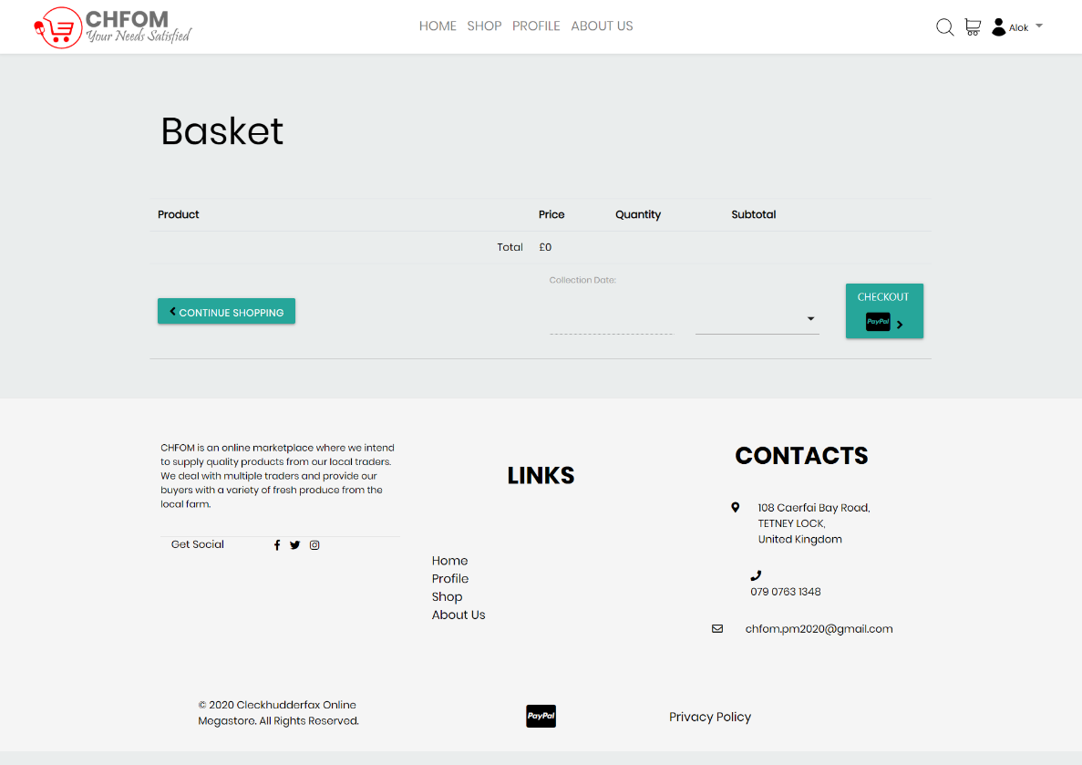

The Basket allows a customer to store products before checkout. Users are able to make a single payment for the whole basket.

### Add to Basket

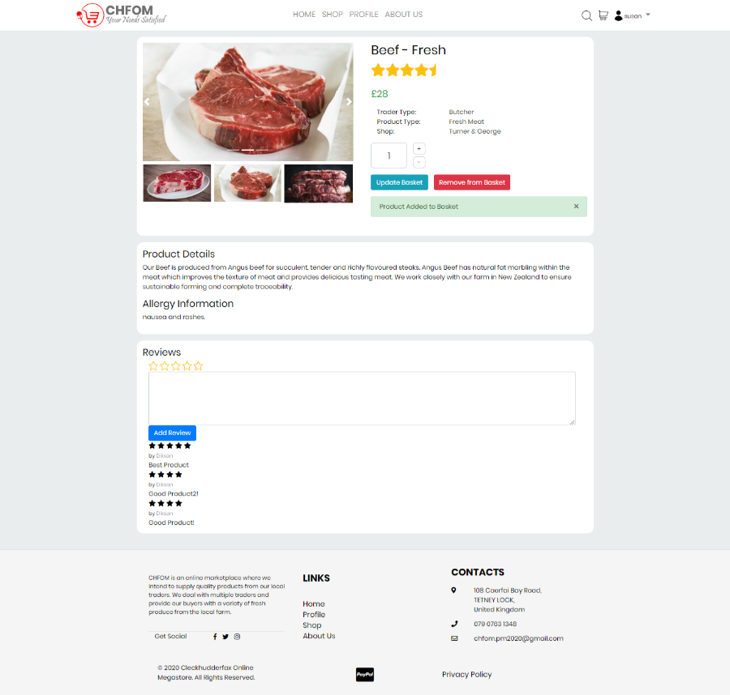

The page displays after a product is added to the basket, it shows the details of the selected product and the reviews and rating provided by the clients, it also provides with the options of update or removal of products from the basket.

### Product Added

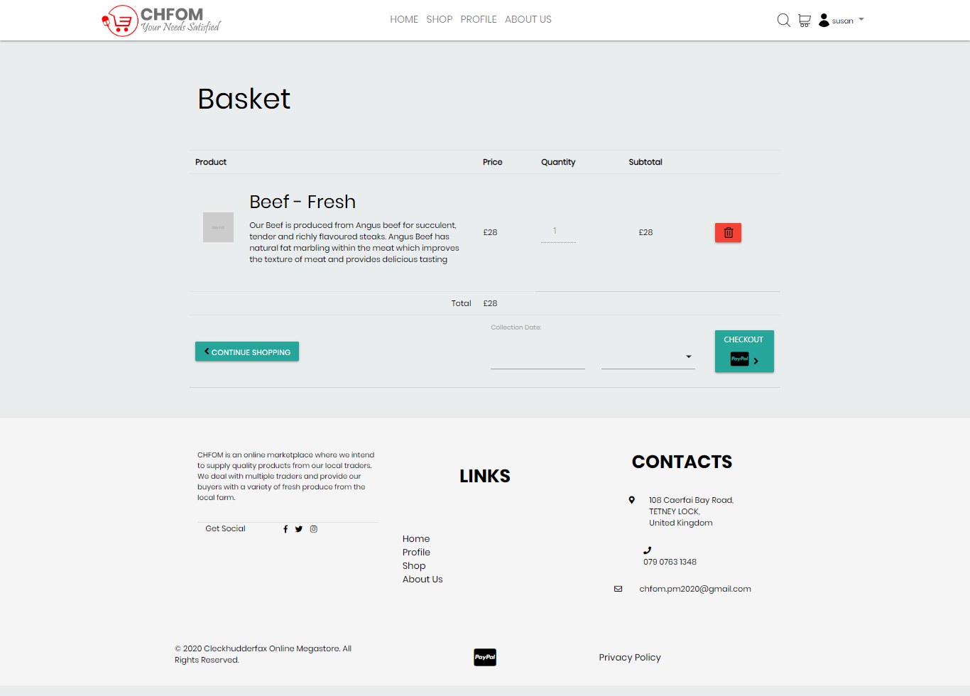

Basket displayed after a product is added to the basket showing the price, quantity, and total amount. Users can choose to continue shopping or checkout.

### Collection slot

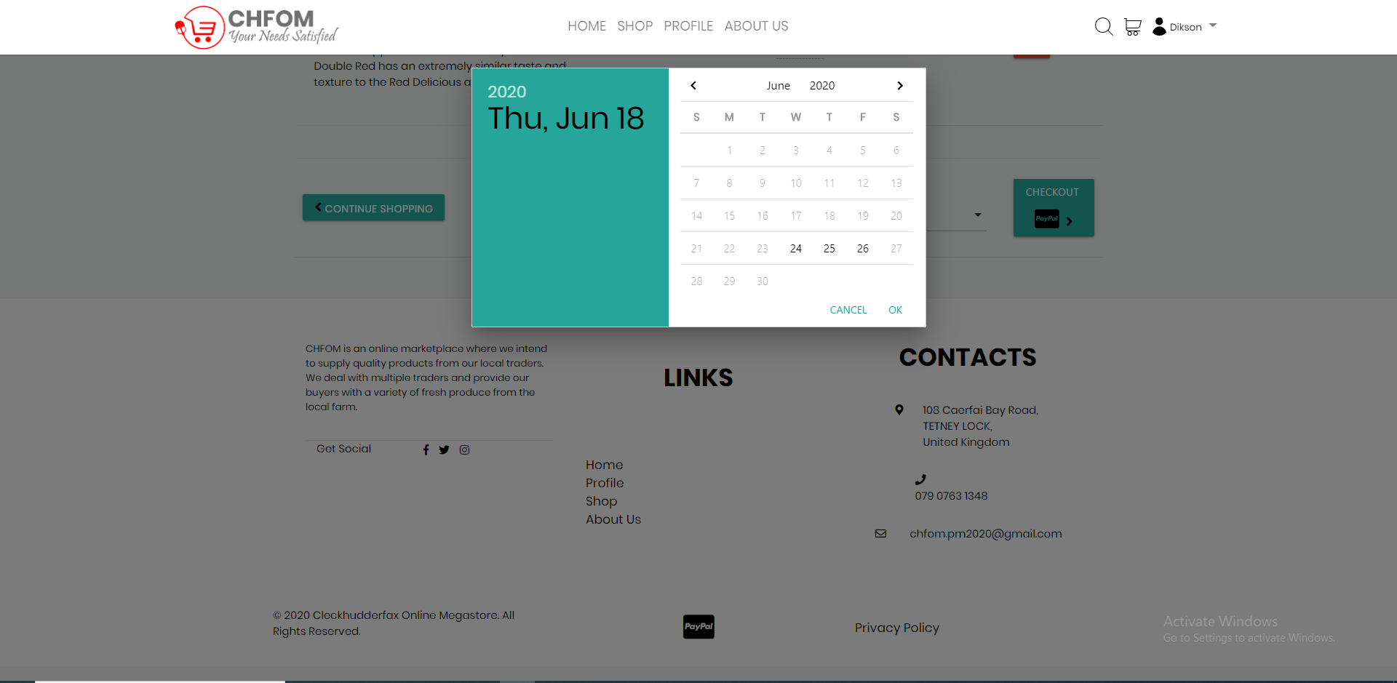

Customers can choose a collection slot from among the list which currently consists of three times a week and after 24 hours of order placement.

## Order

### Order Details

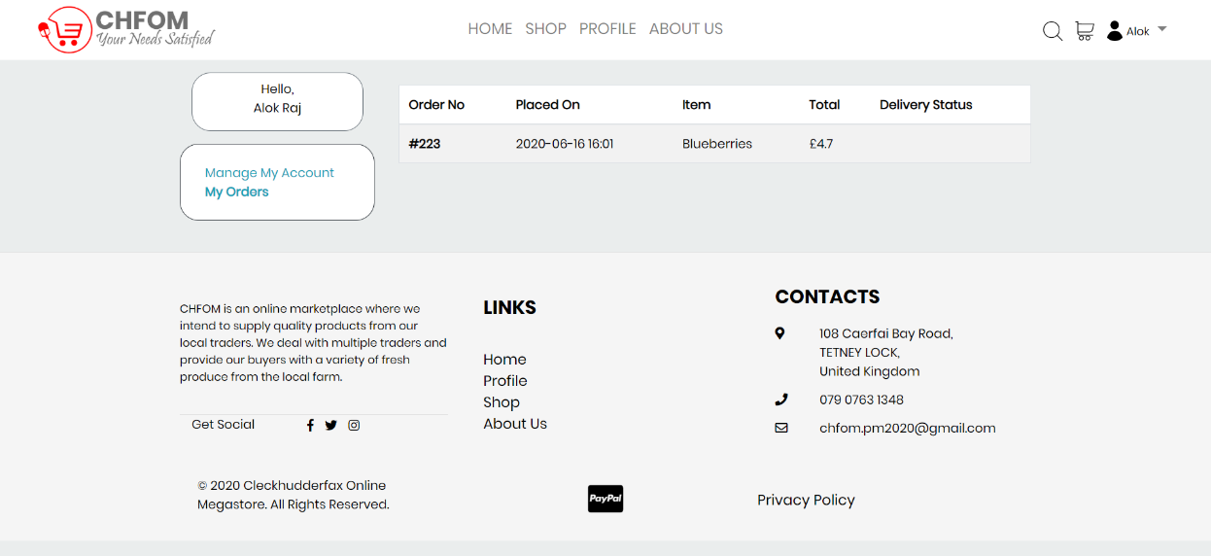

Order Details display the order information like order number, date, item name, total price, and status.

### Order Confirmation Receipt

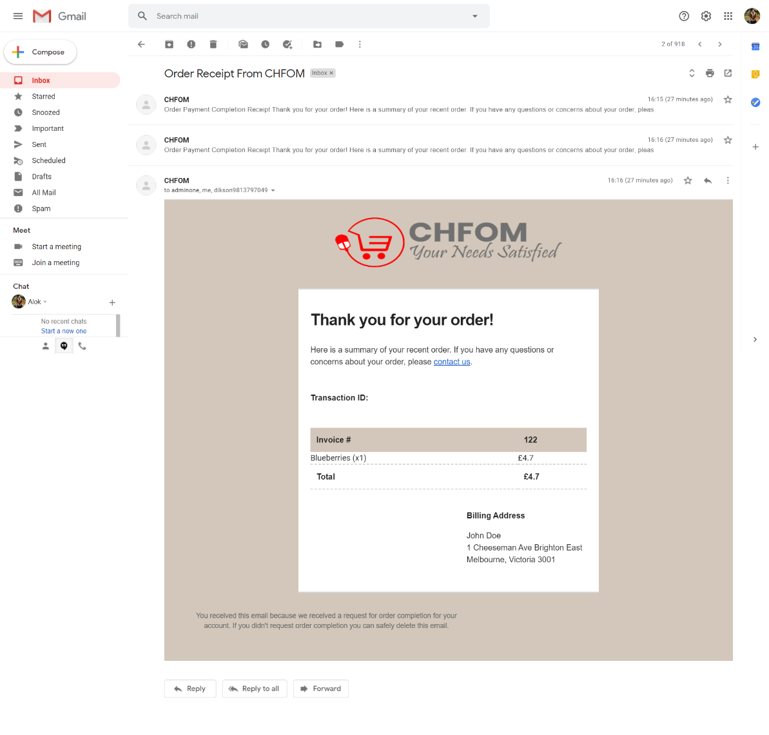

A confirmation email is sent after the order is placed providing the Invoice details and billing address.

## PayPal Payment

### Payment Method

#### 

PayPal virtual payment method provides with the multiple paying options as per the convenience of the customers.

### Confirm Payment

#### 

Confirm payment method with the pay now button.

### Payment Success

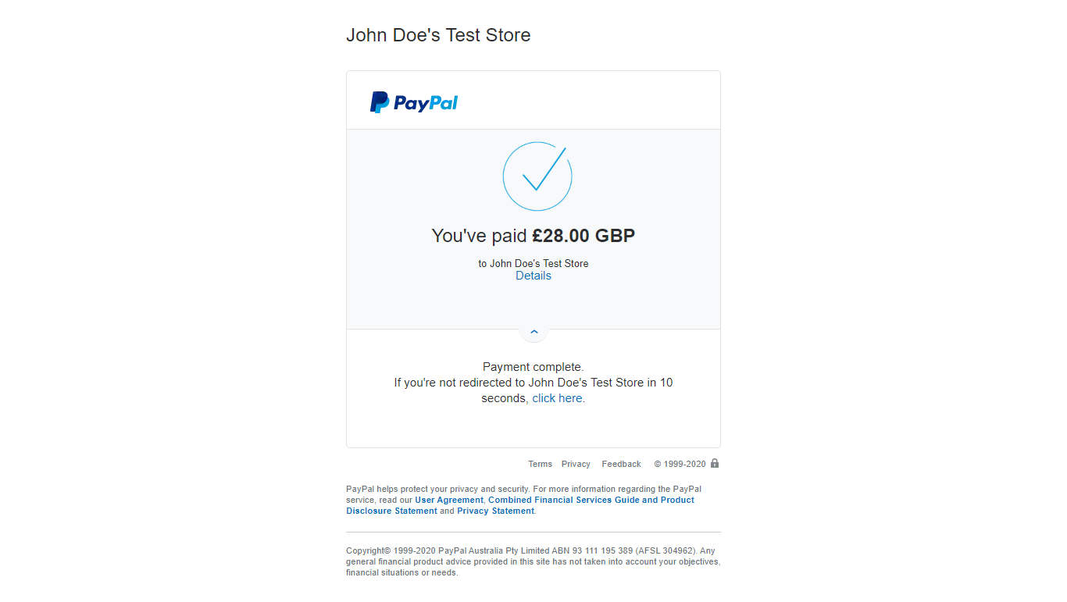

Payment Completion along with the payment details is displayed after successful payment.

## Registration

### Registration Form

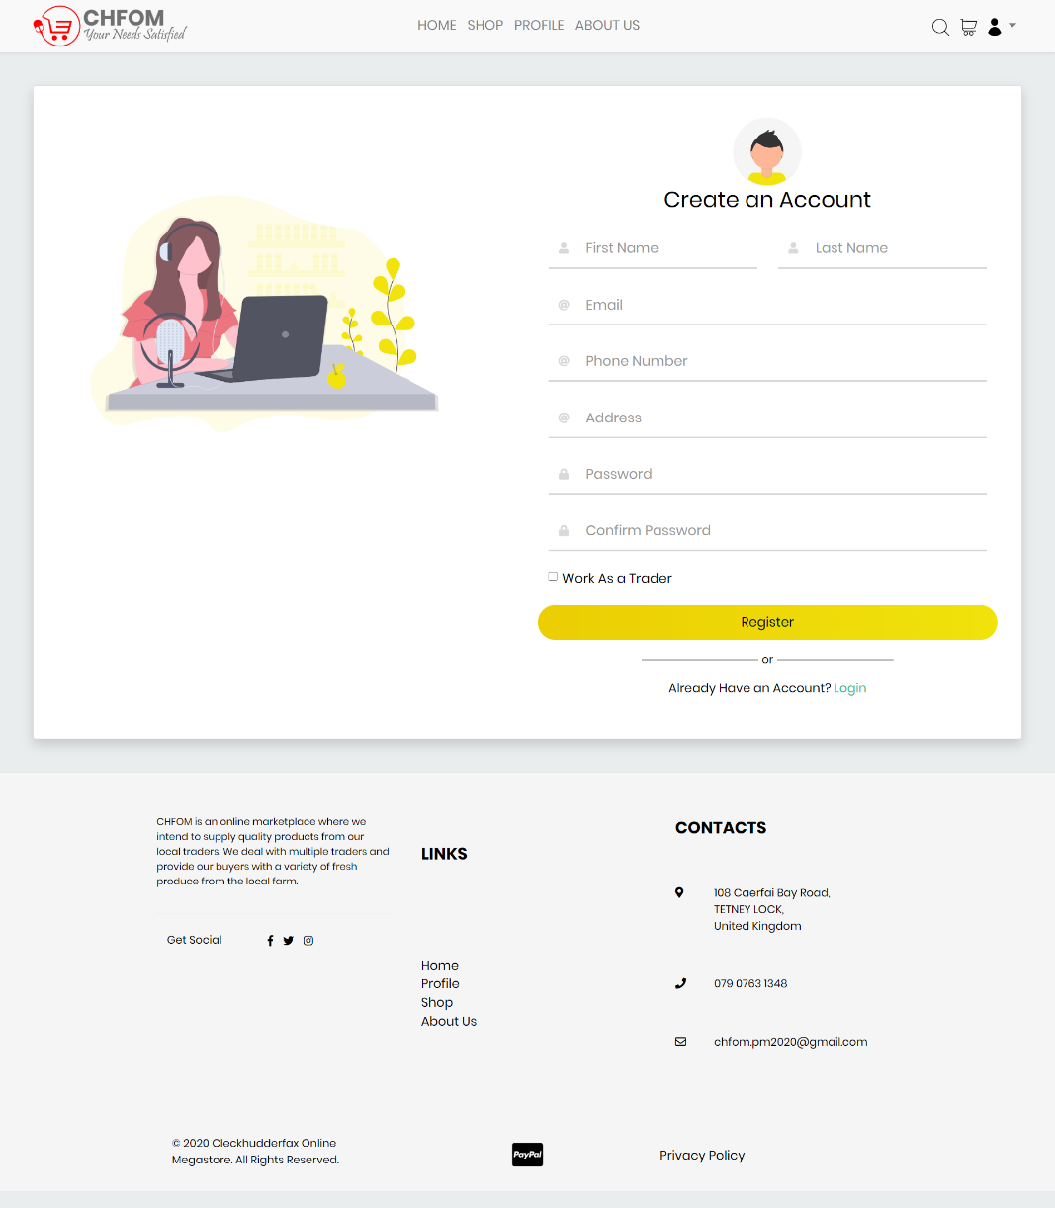

Registration form for the users who do not have an existing account. It requires information such as full name, email address, contact number, address, password, etc. Users can choose the option to work as a trader if they want to register as a trader.

### Account Creation

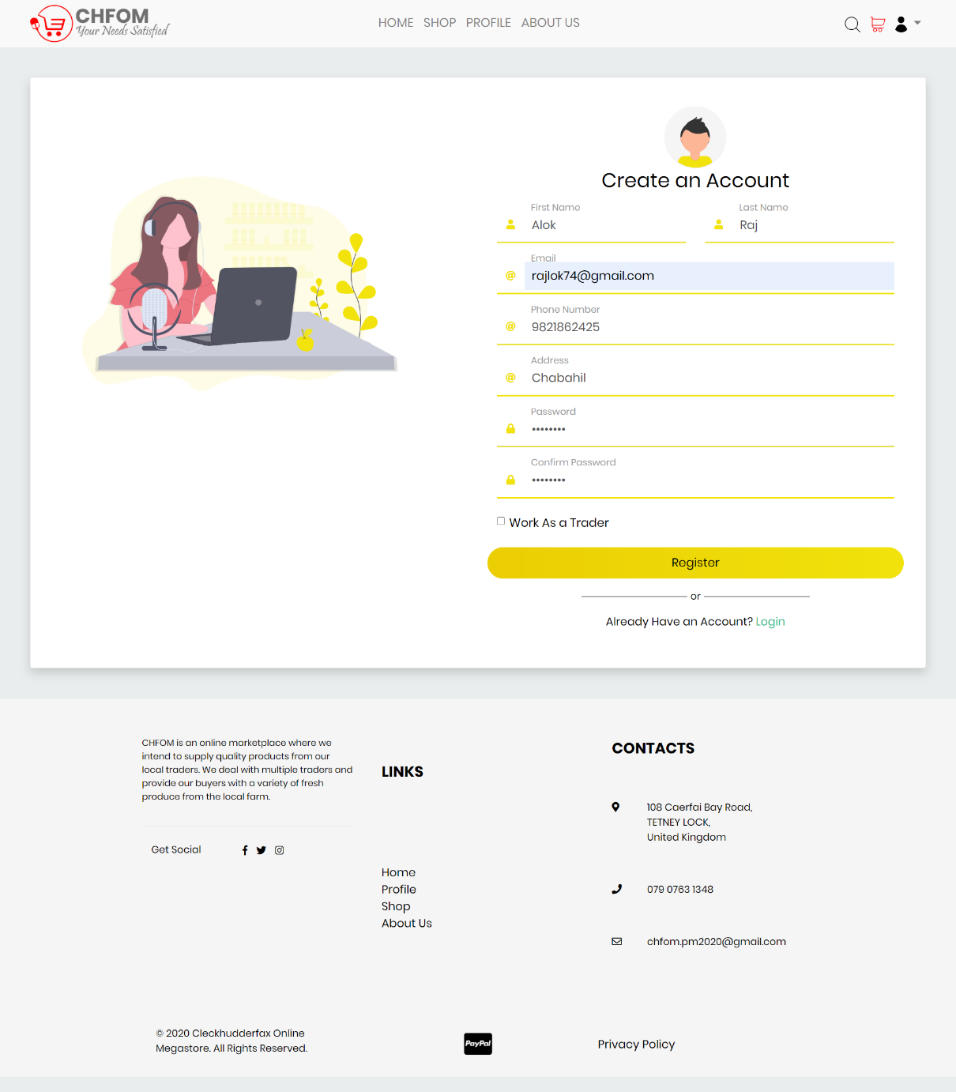

Registration form showing a sample of the details of the new user required for account creation.

### Confirmation Email

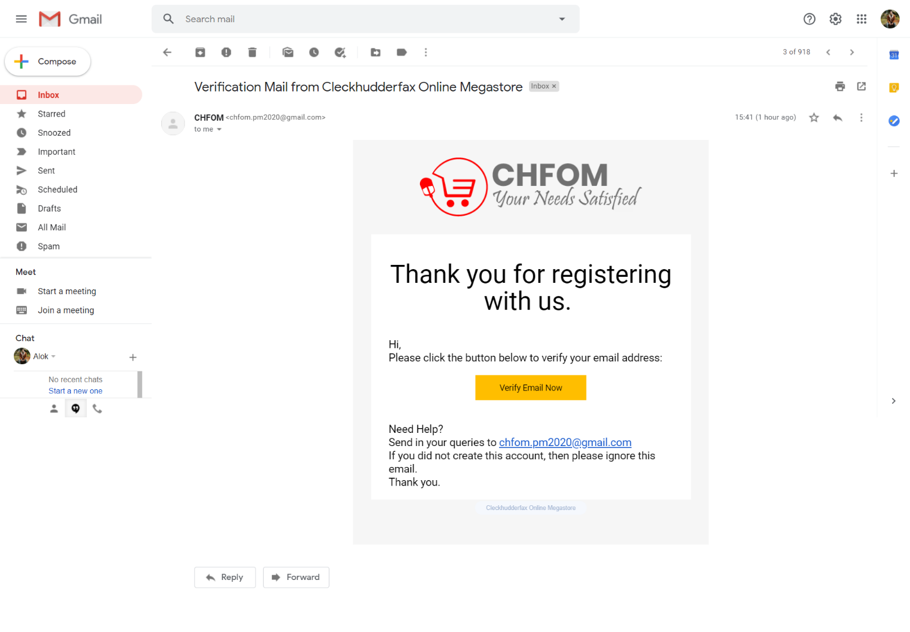

Verification email sent after a user has registered and created an account that provides with a link to verify their email address.

### Form Validation

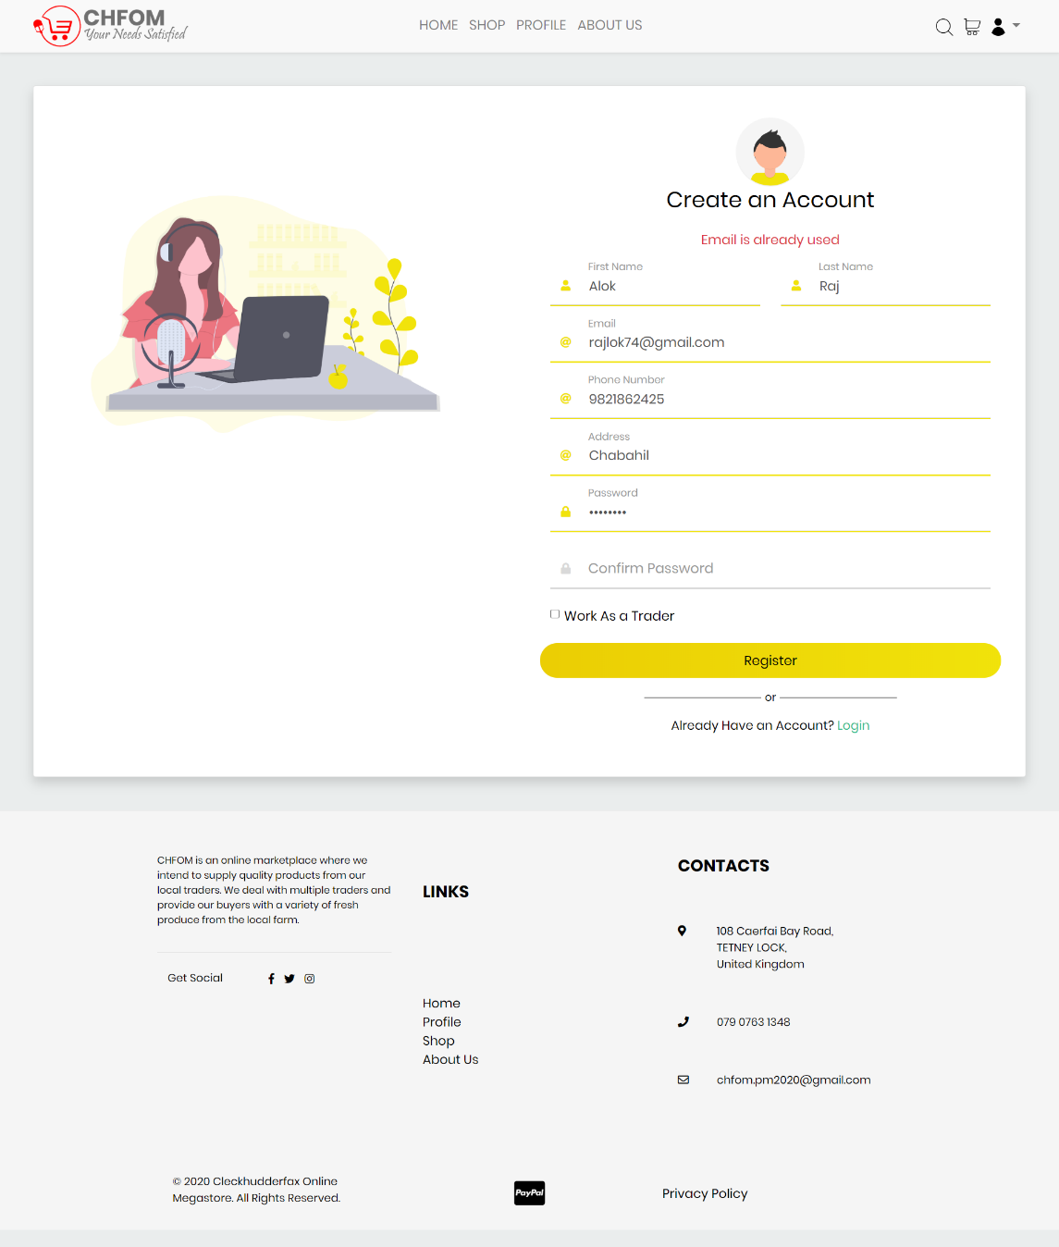

Validation message displayed when a user tries to use existing email address for a new account.

## Login

### Login Form

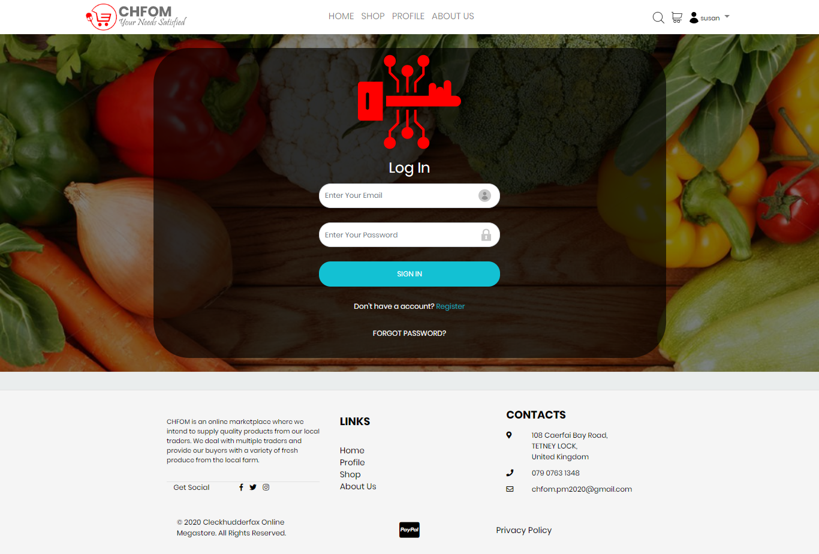

Login form provided for registered users to login with their existing account. It requires user’s email and password.

### Form Validation

##### Login to Continue

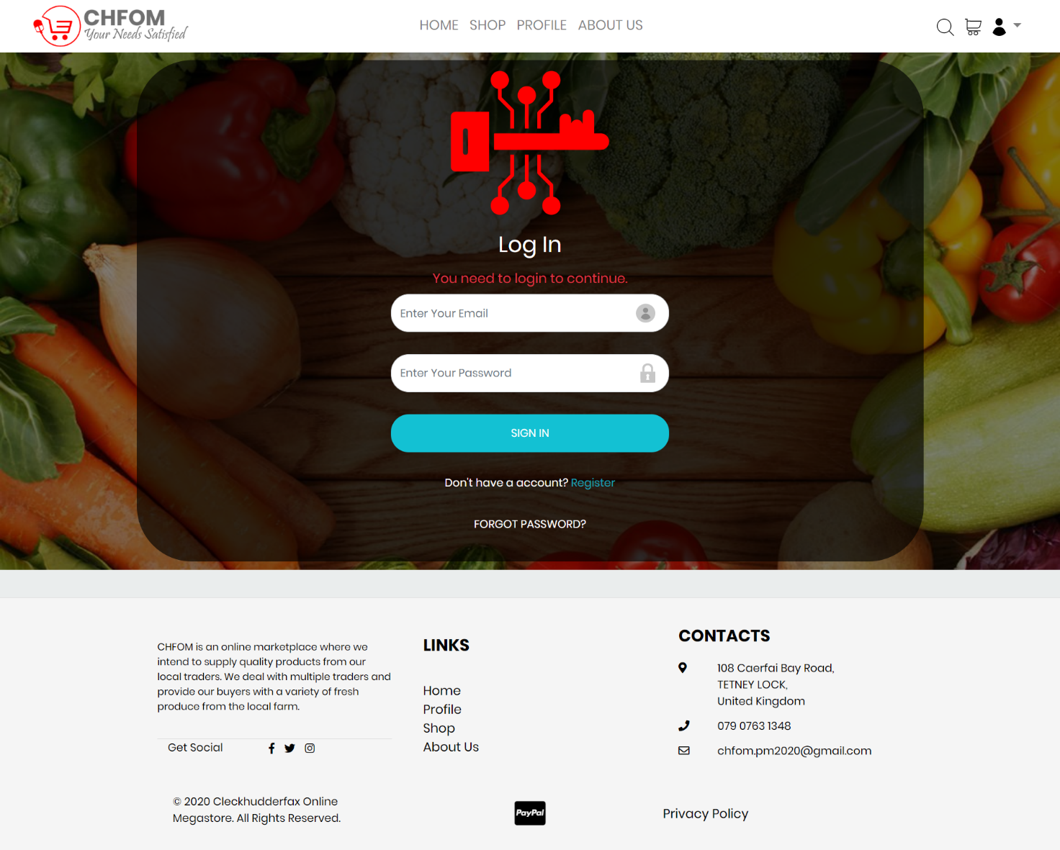

Login page displaying a message to notify the user that they should login to continue.

##### Incorrect Password

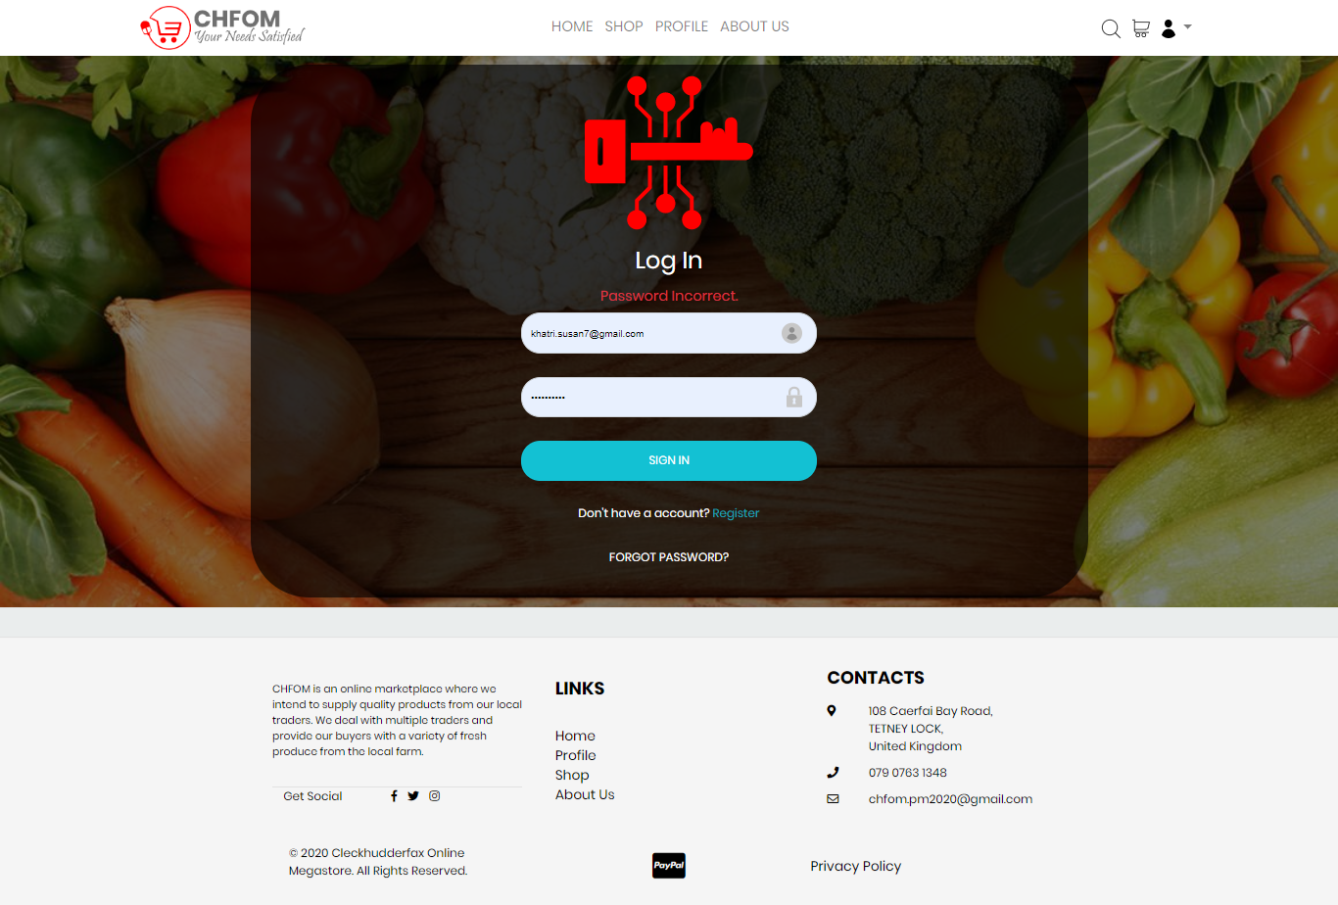

Validation message displayed if a user tries to input incorrect password.

##### Empty Field

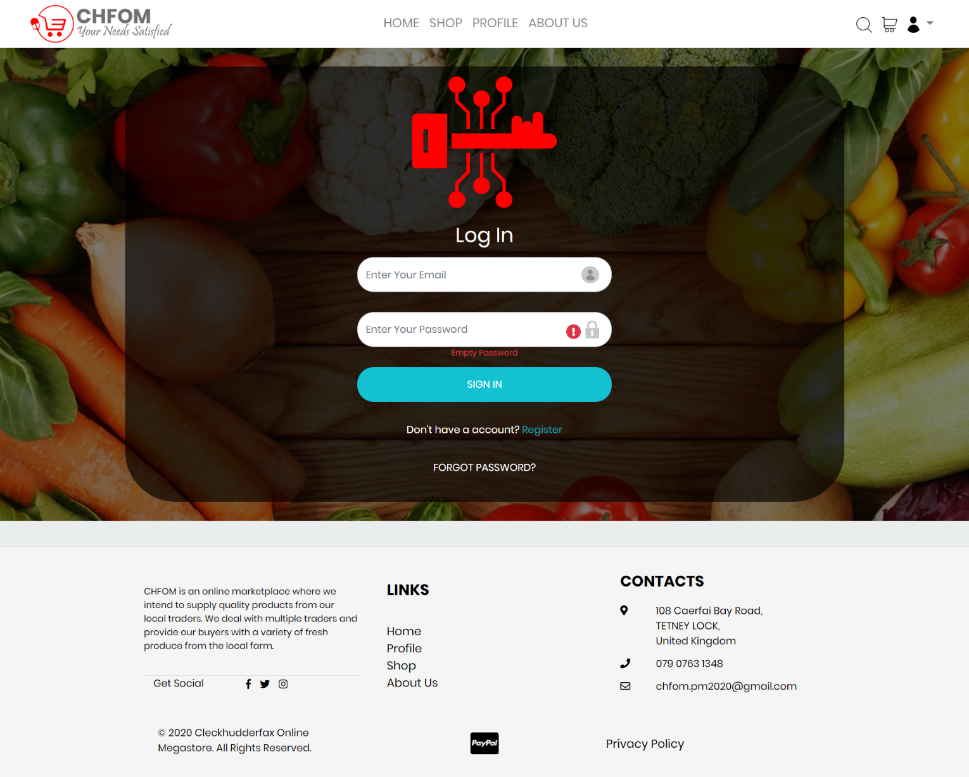

Message displayed user to notify about the empty password field. Password is required to login.

##### Redirecting

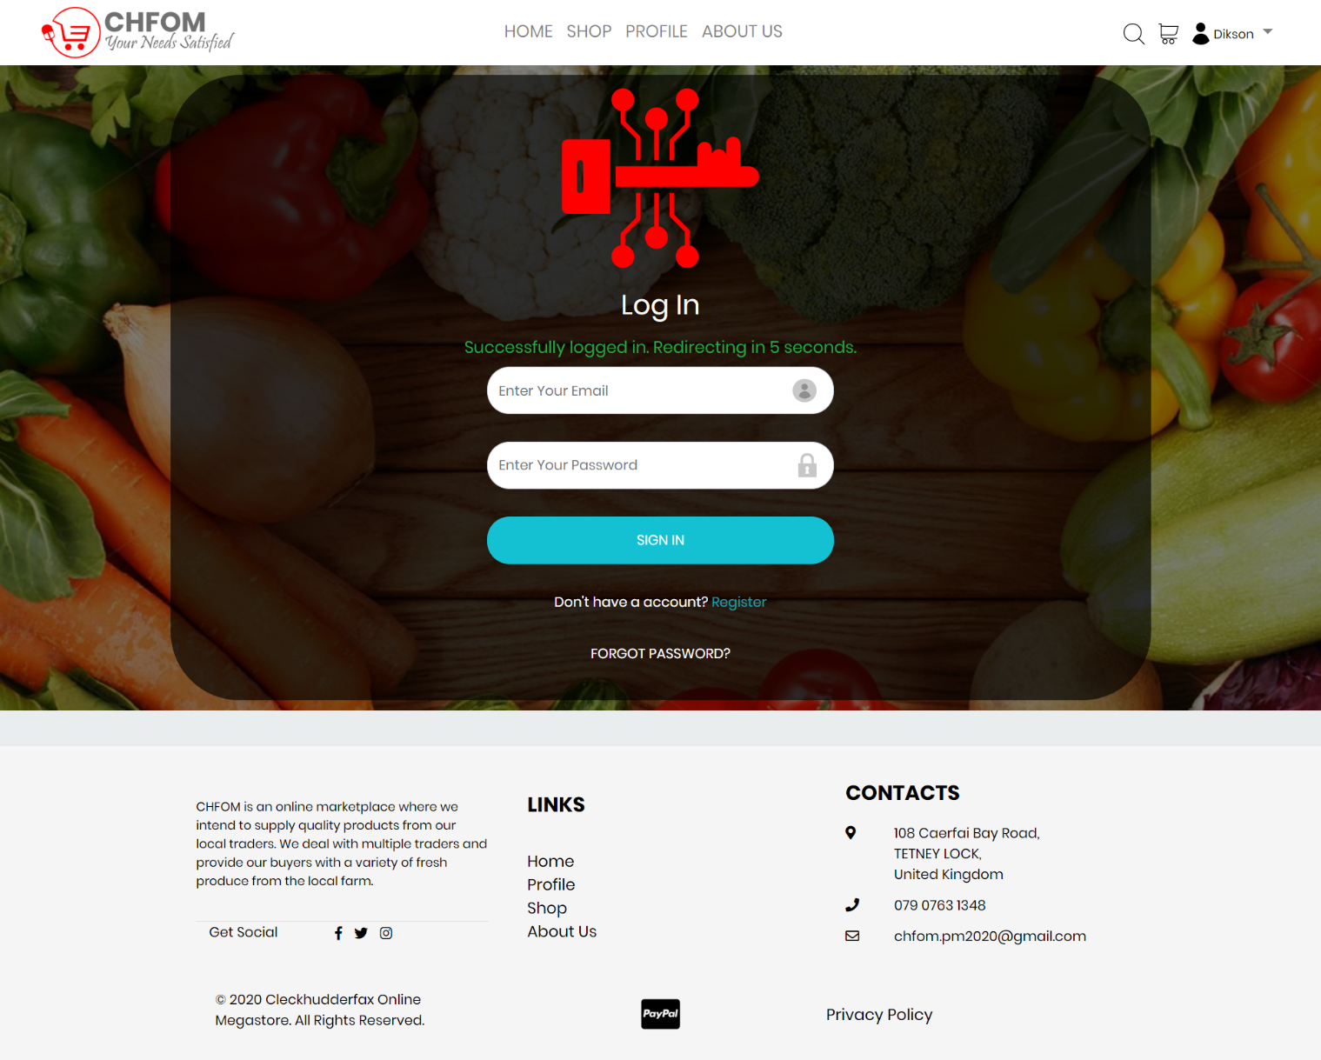

Redirecting message after a successful login with correct credentials.

##### Invalid Email

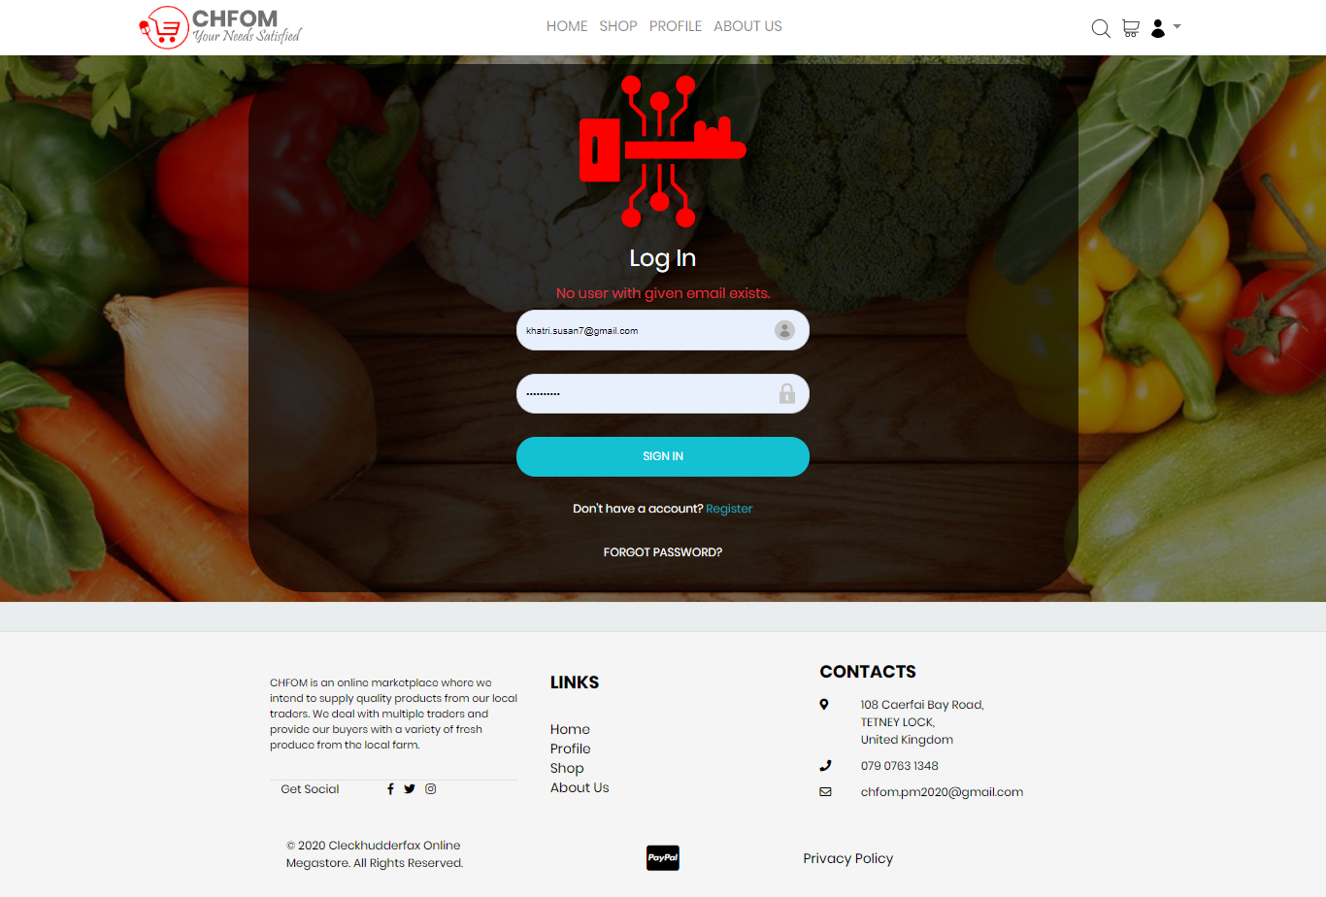

Message to notify user if the email address is invalid.

### Login Success

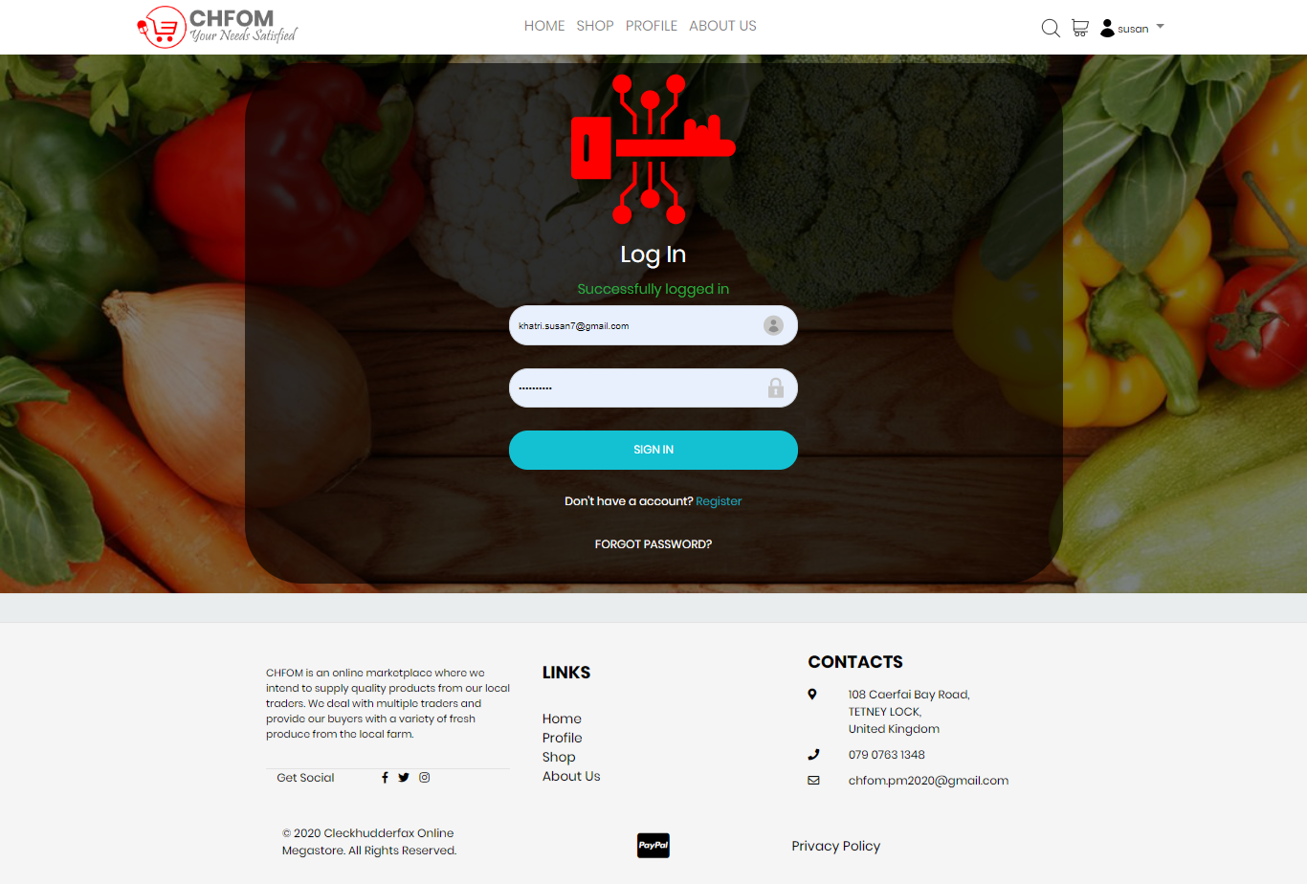

Displayed after a user is successfully logged in.

### Forgot Password

##### Password Reset

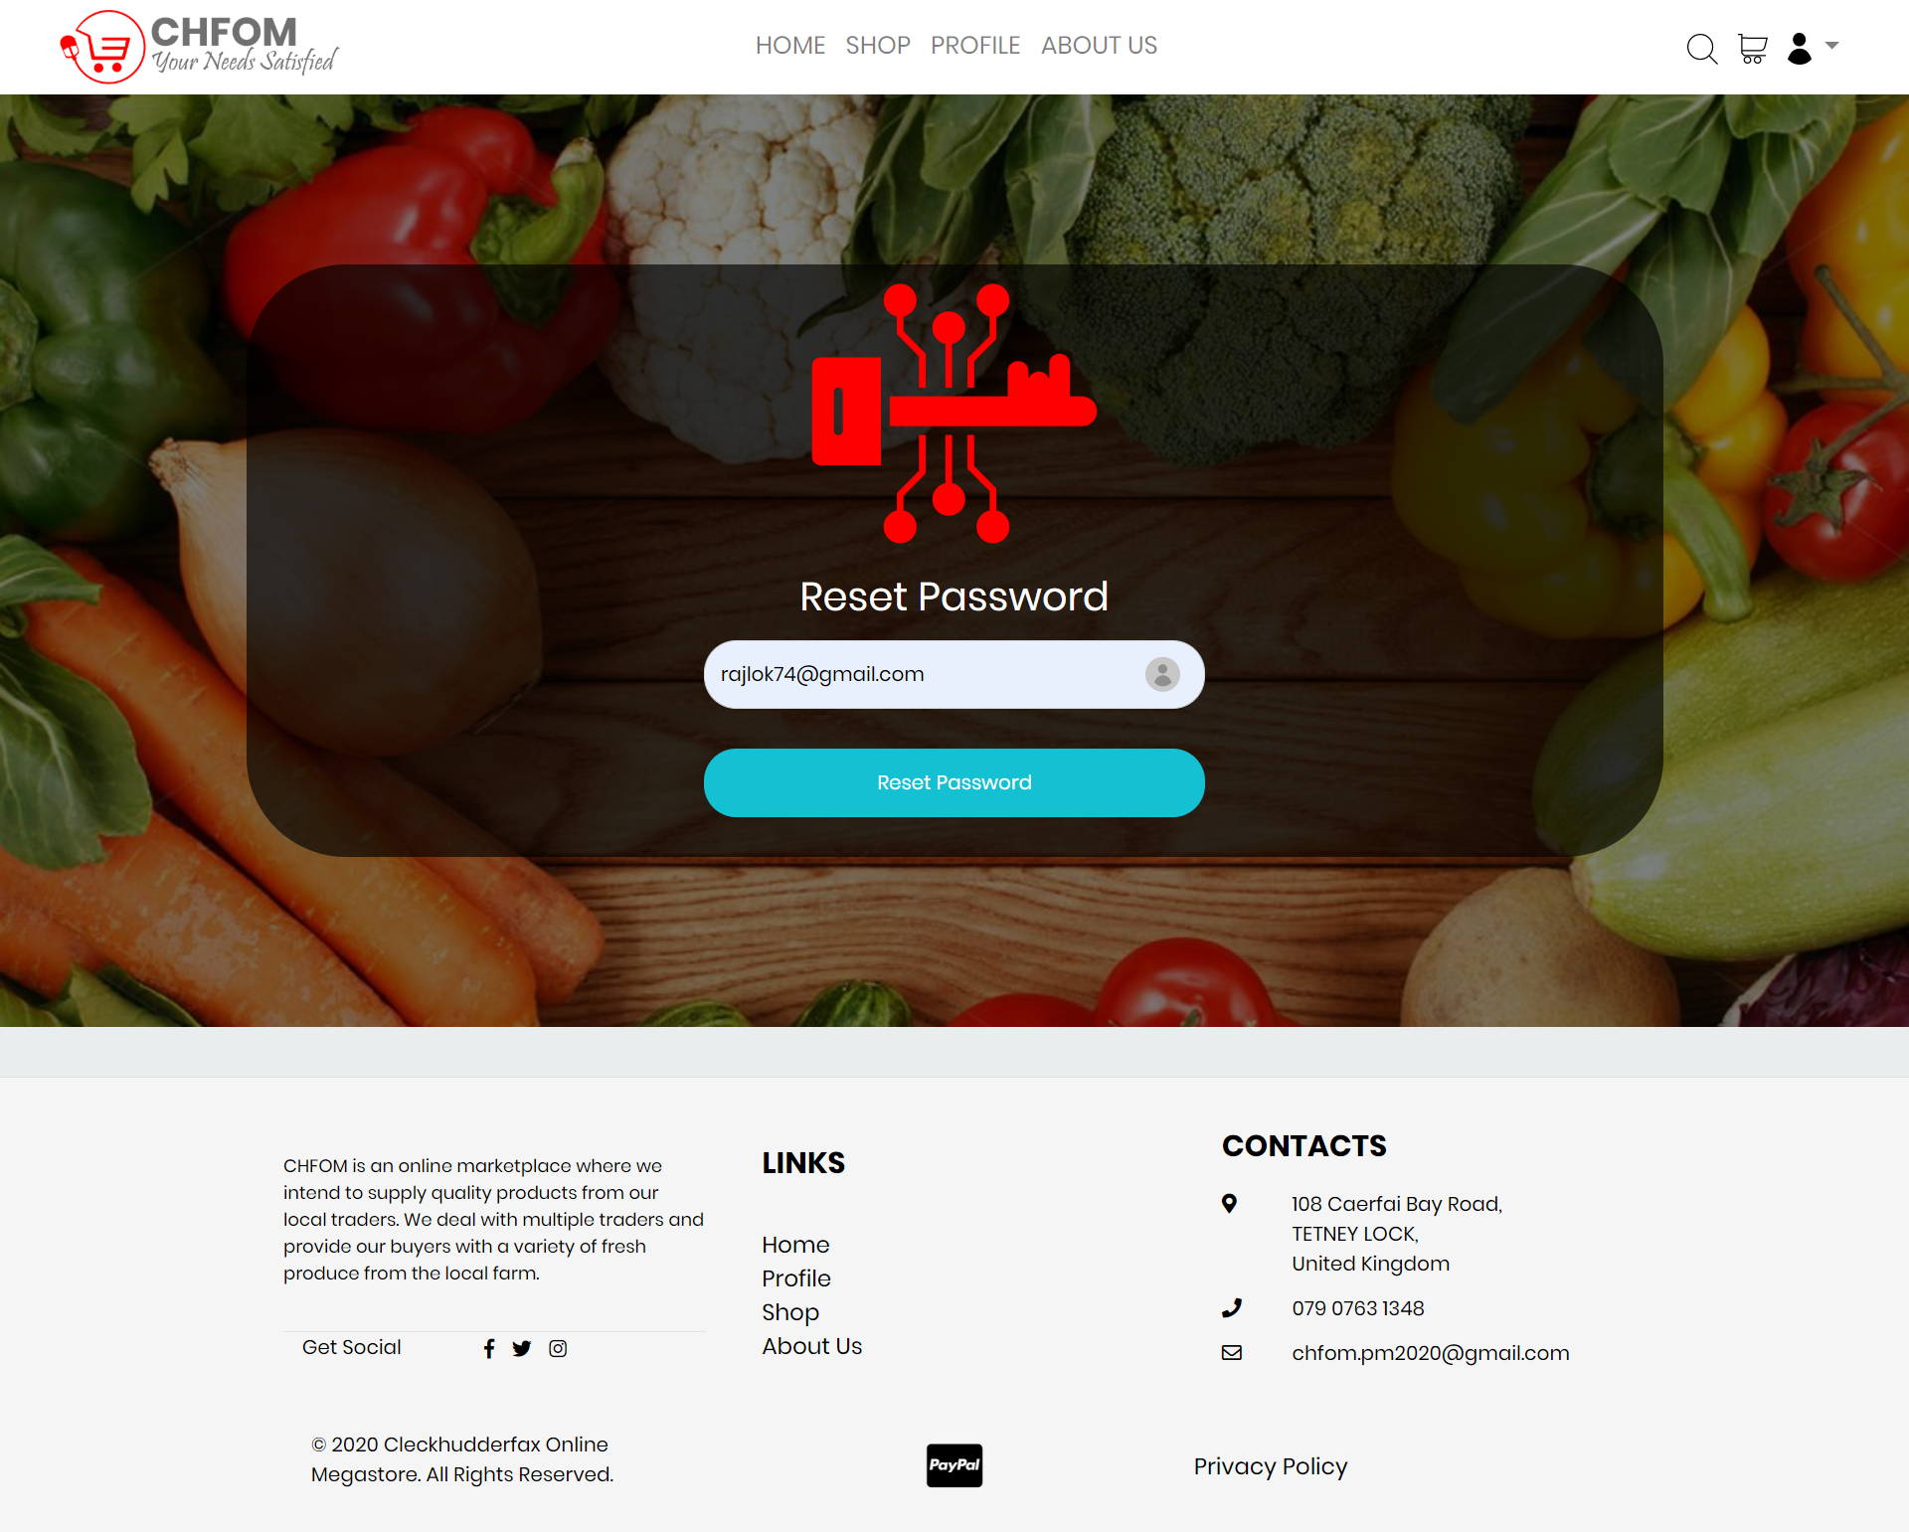

Reset password option for a forgotten password. User needs to provide with a valid email address to reset the password.

##### Password Reset Confirmation Email

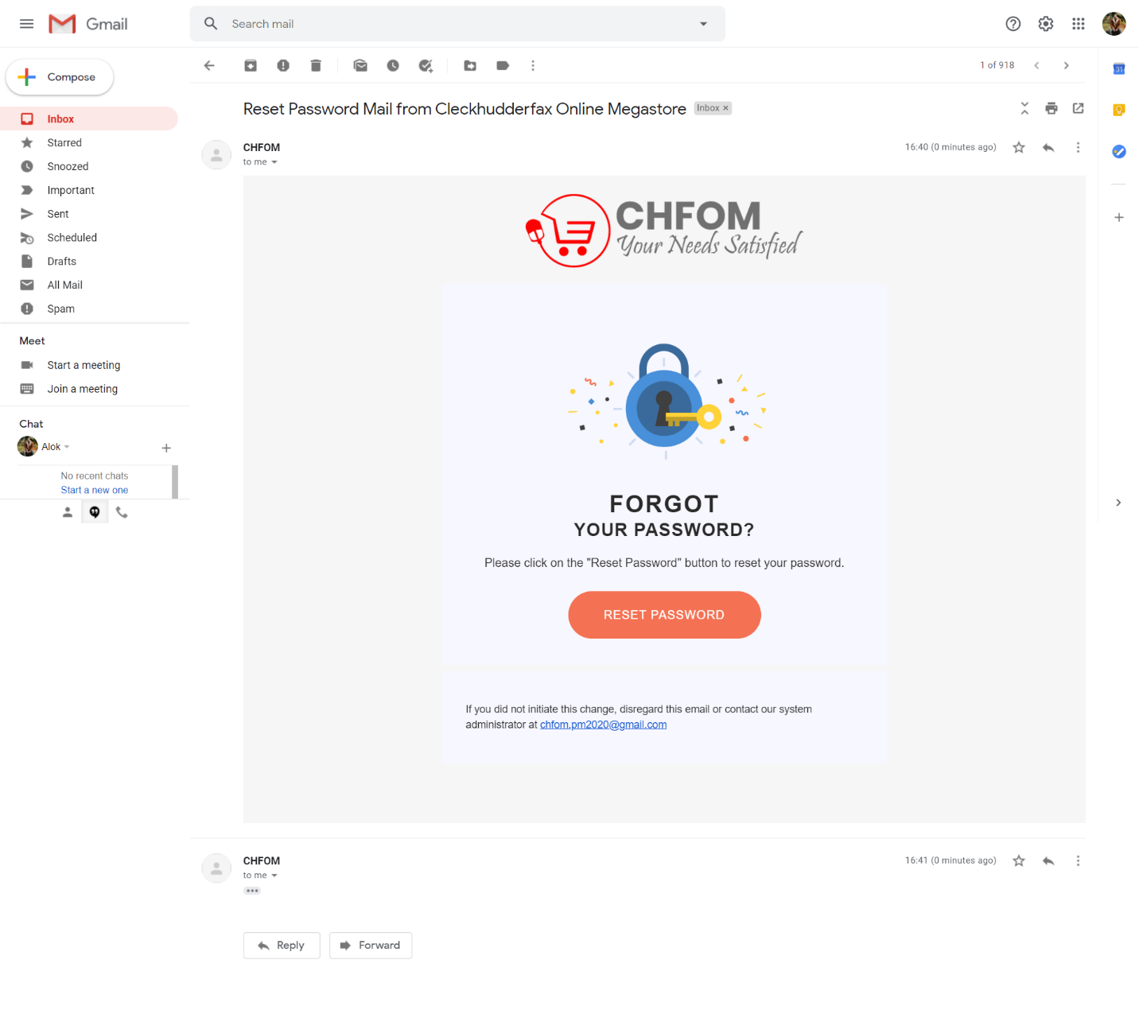

Confirmation email sent to user’s address to reset the password, a new password can be set by following the reset password link.

## Account Management

### Profile

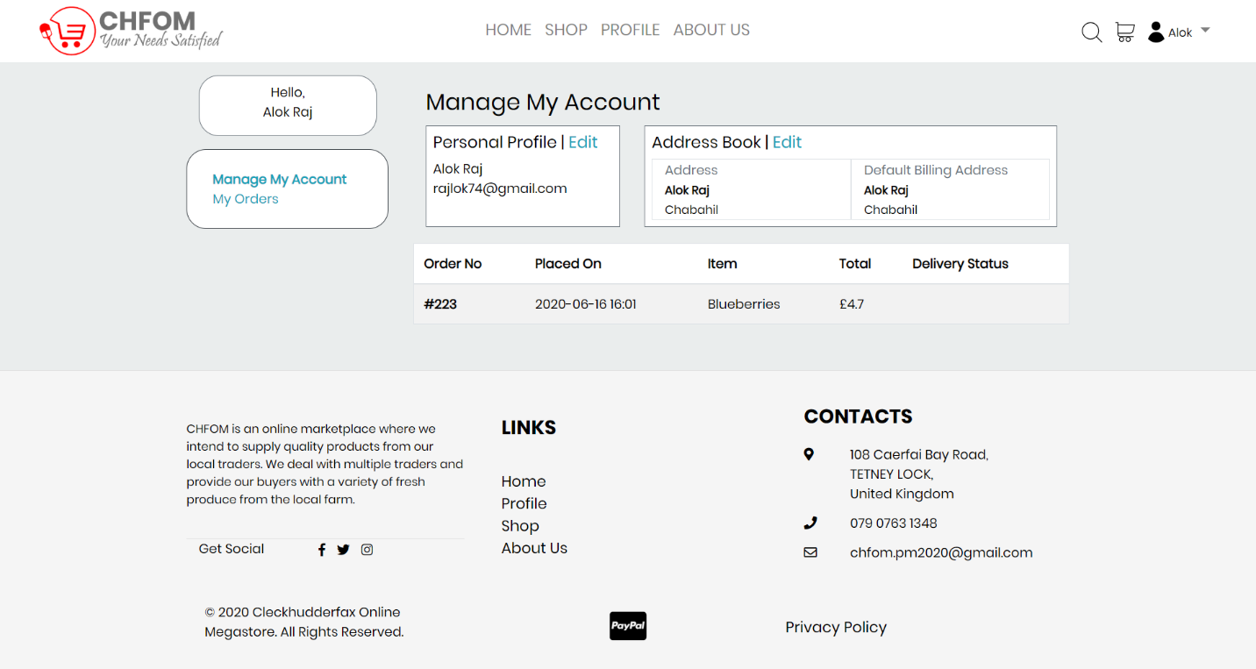

User’s account displaying all the details and information.

### Edit/Update Profile

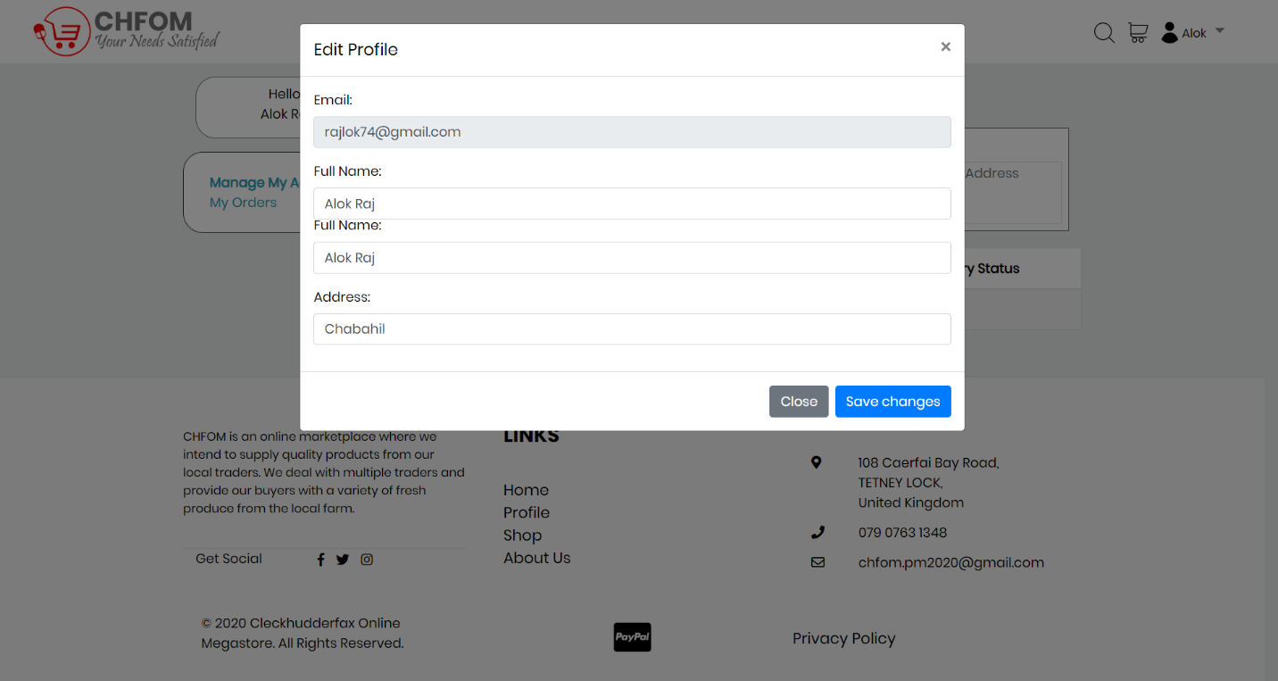

User can edit their profile if they want to make changes to the account with the provided edit option.

Profile Update Success

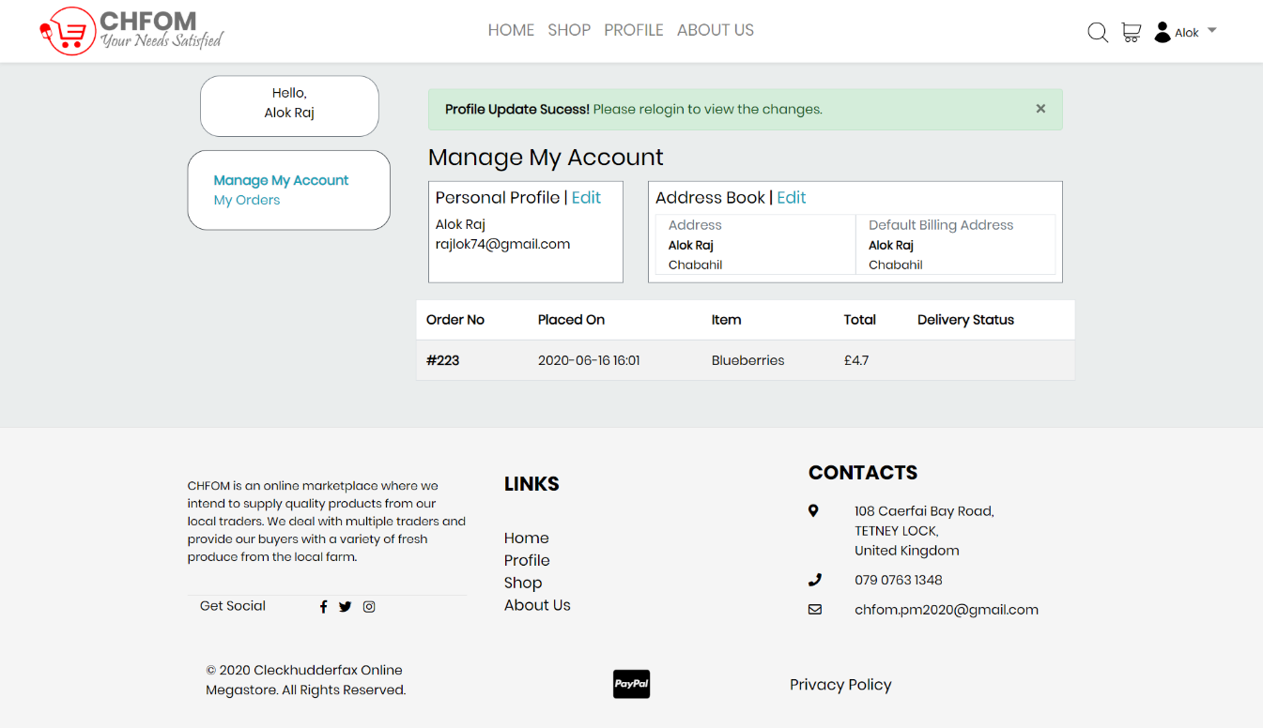

Message displaying user to notify about the successful profile update and to login again to view the changes they made to their account.

### Profile Update Notification Email

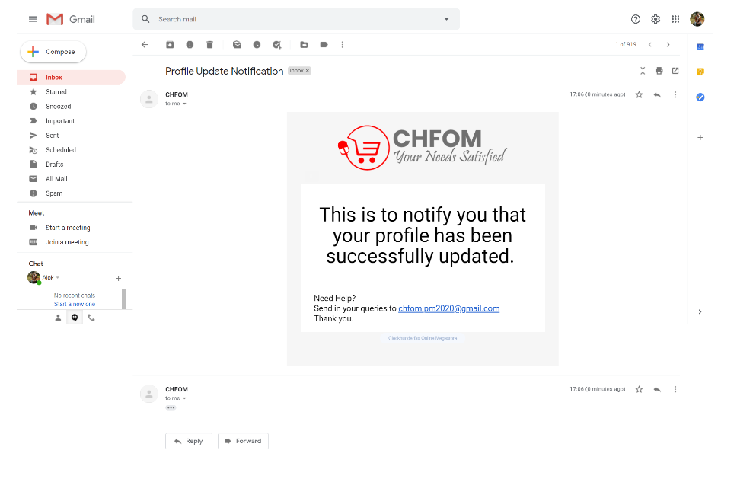

Notification sent to user’s email address after the successful provide update.

## Admin (PHP)

### Trader Details

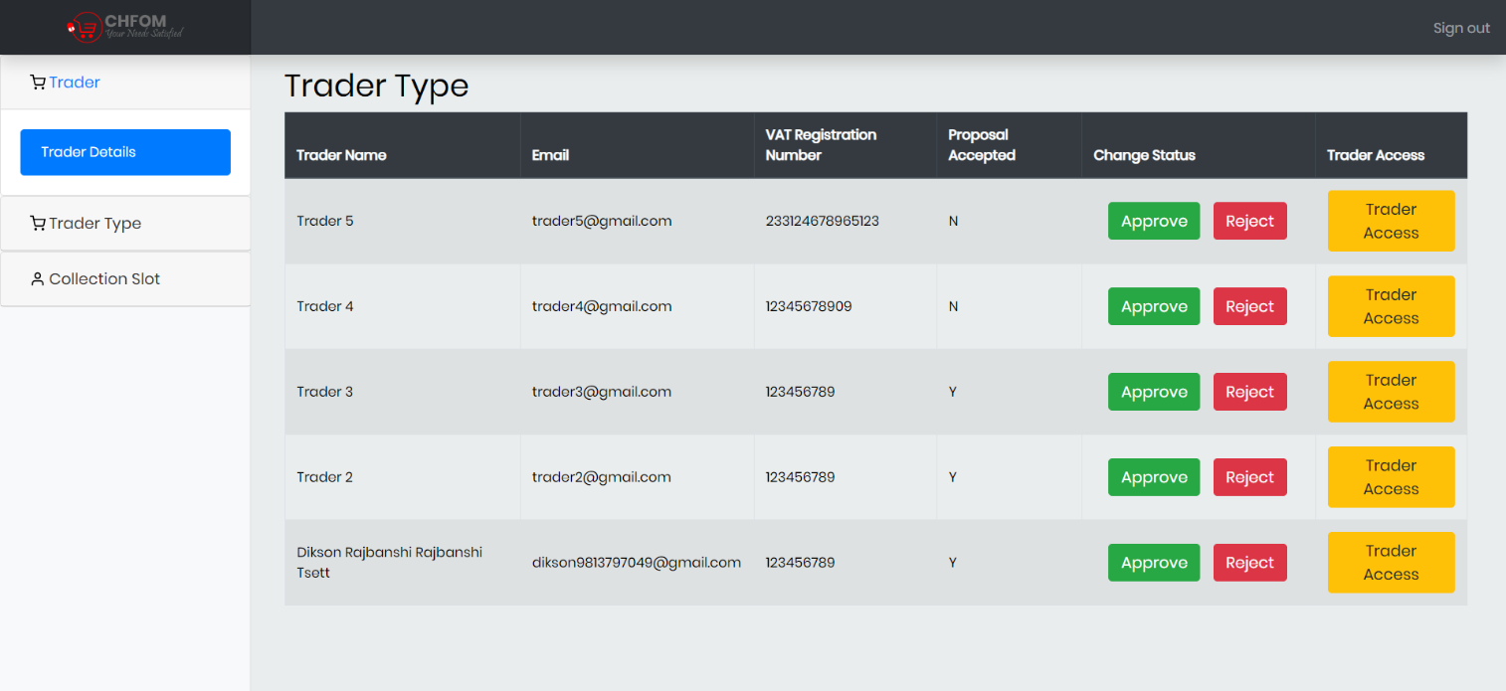

Admin has the access to any trader’s account and have the authority to enable or disable them.

### Trader Status Update

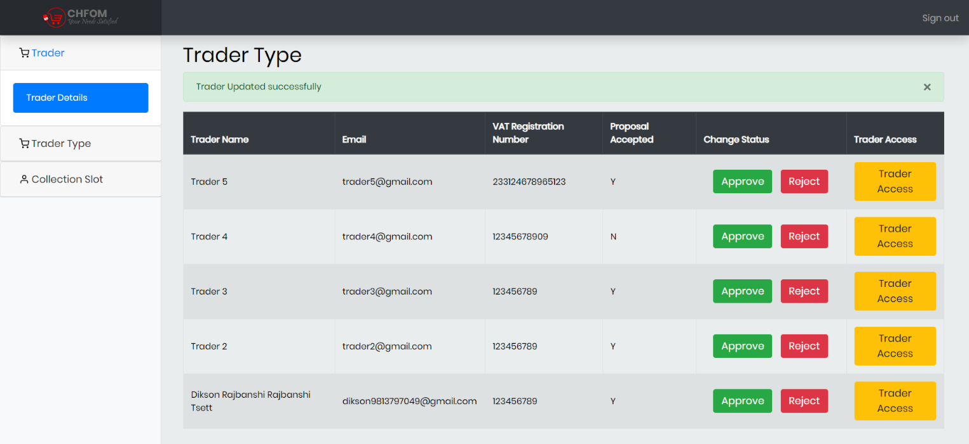

Notification displayed after trader status is updated by admin.

### Trader Type Details

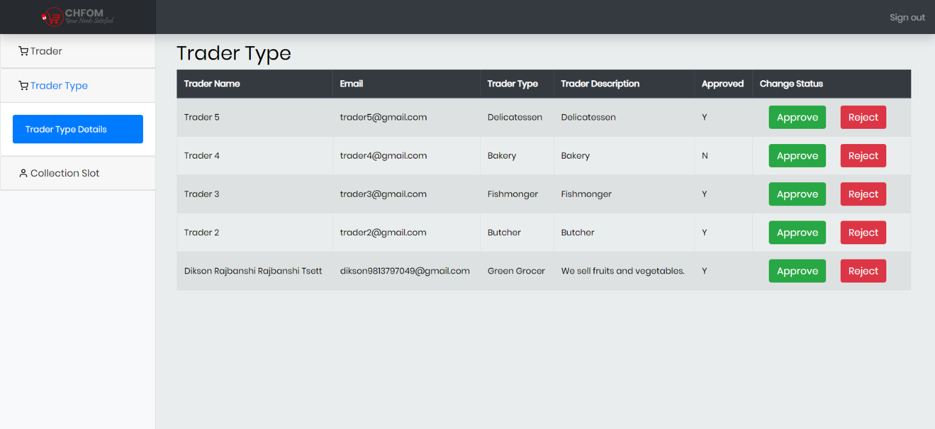

Admin has the authority to update the trader type details.

### Trader Type Status Update

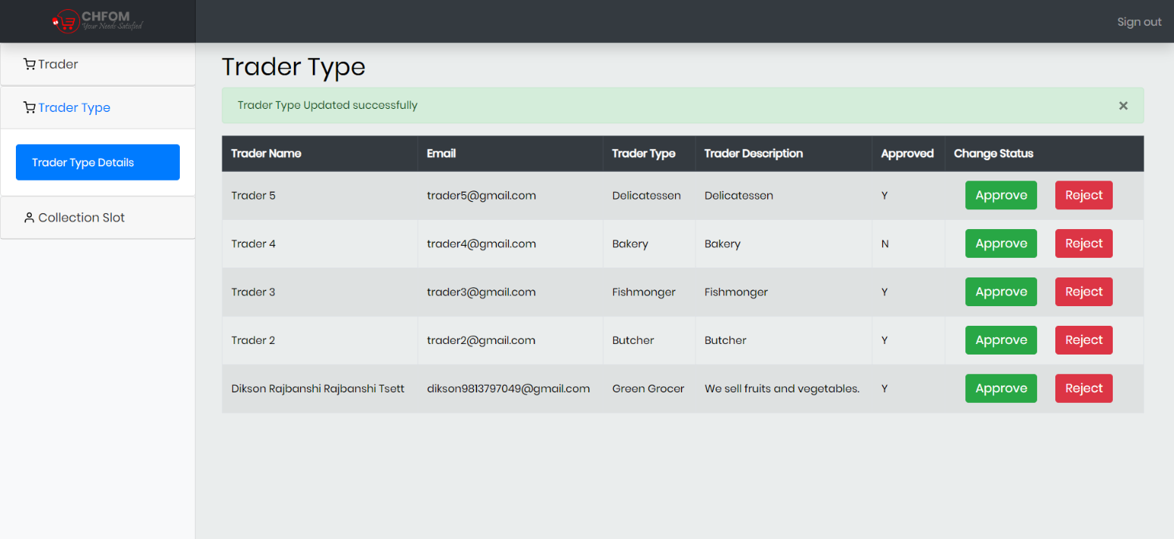

Trader type details successfully updated.

### Collection Slot Details

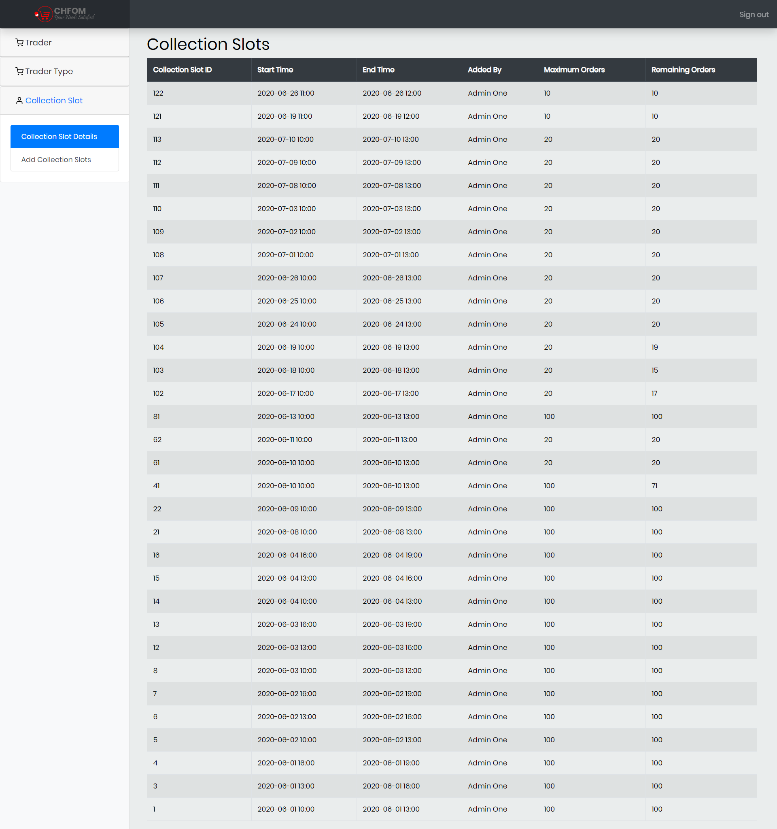

Collection Slot details managed by admin displaying the details like collection slot id, start and end time, admin name and remaining orders.

### Collection Slot

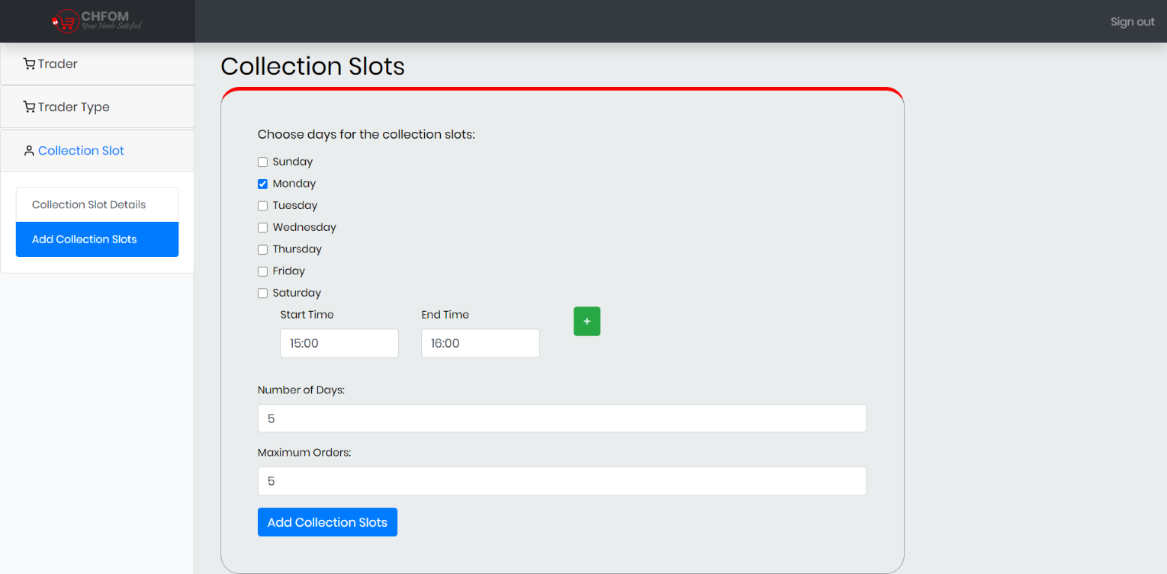

Admin can set a new collection slots using the collection slot generator. The admin will chose the days, time and for how many days the collections slot should be generated for.

### Collection Slot Added

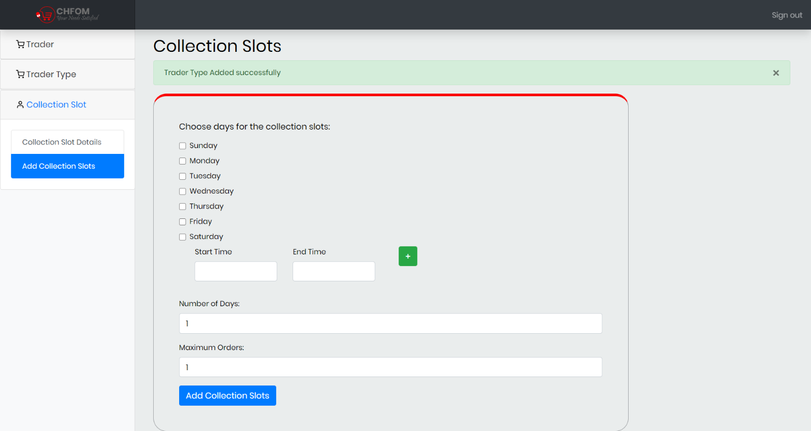

Collection slot added successfully.

## Trader (PHP)

### Add Product

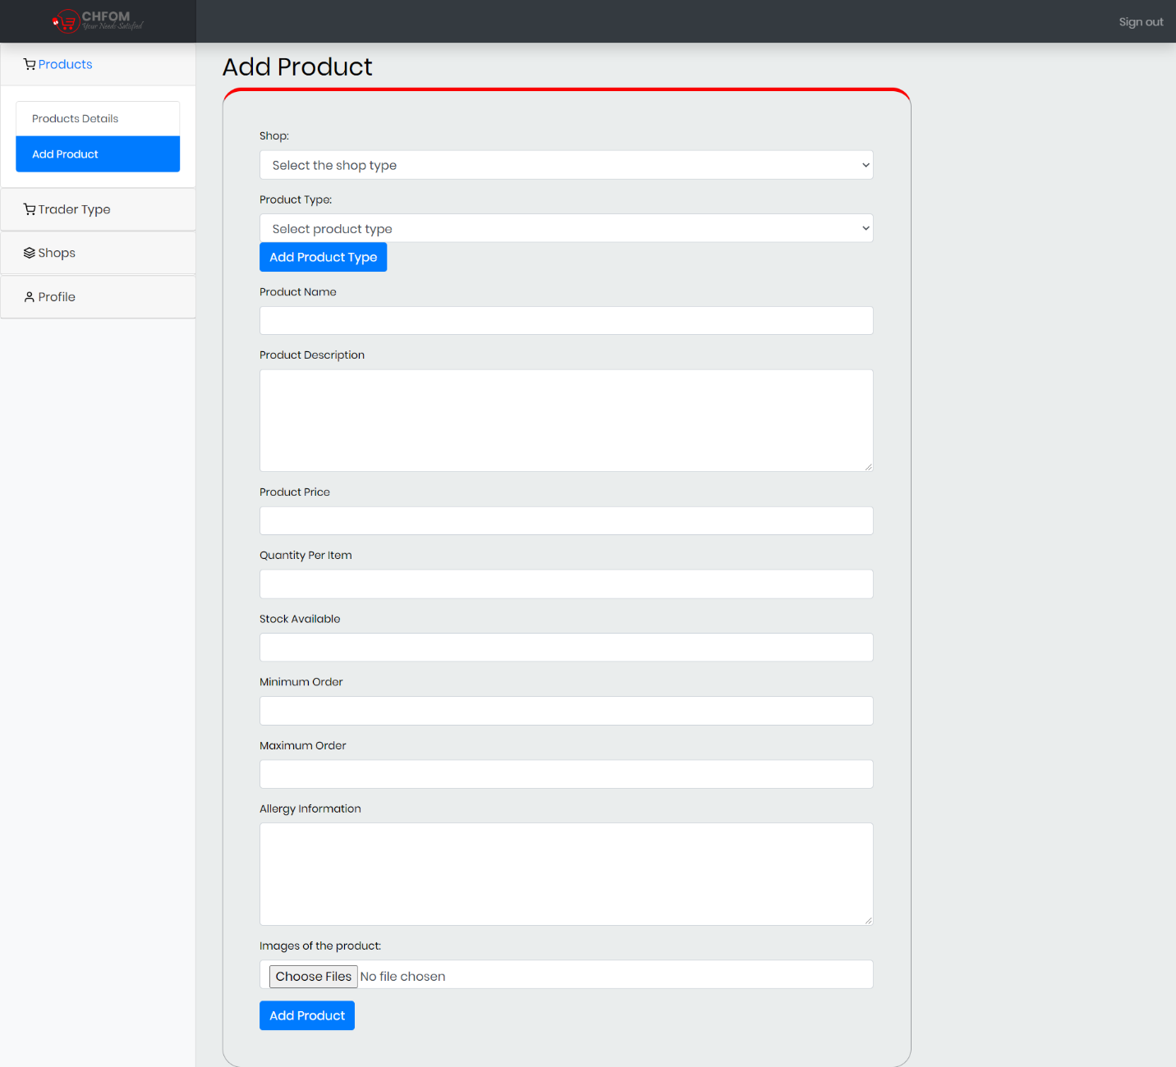

Trader can add products providing all the details such as: shop type, product type, name, description, price, quantity, available stock, minimum/maximum order, allergy information and the product image.

### Product Added

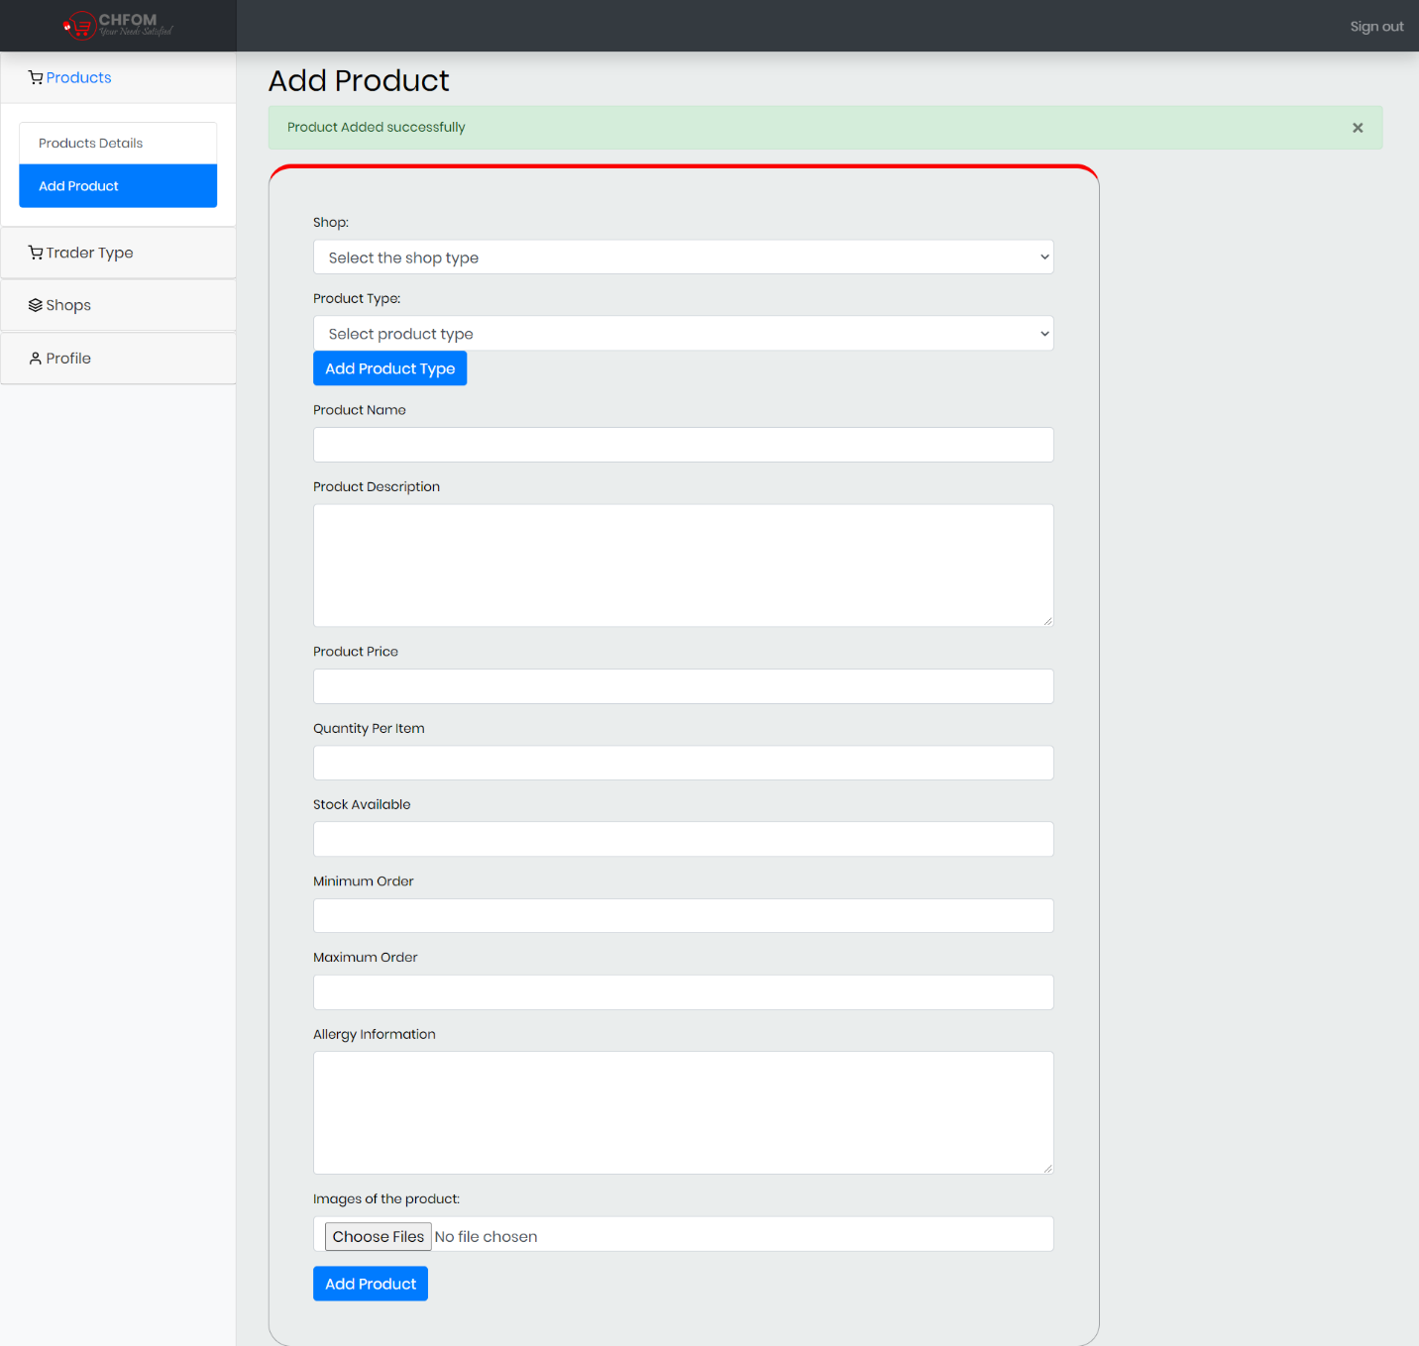

Message notifying the trader that the product has been added successfully.

### Product Details

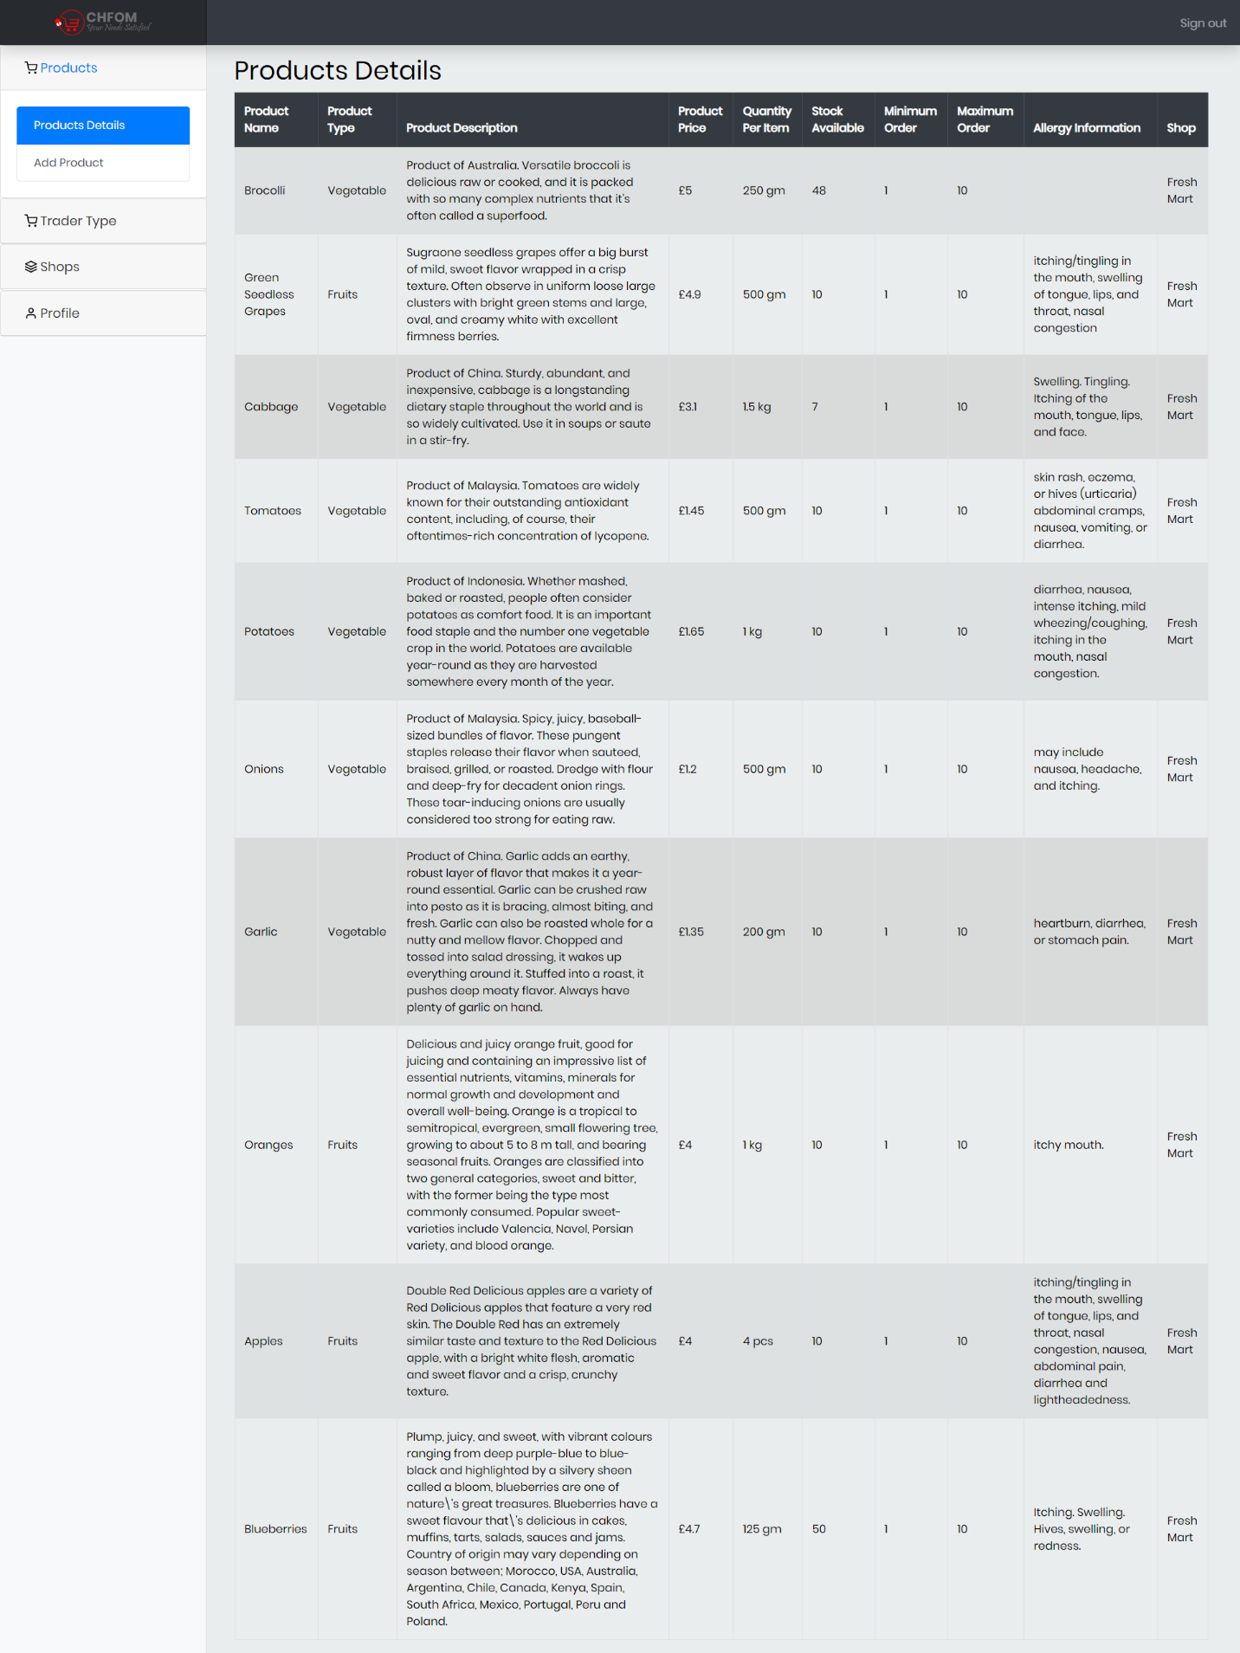

Product Details displaying the status of available products; name, type, description, price, quantity, etc.

### Add Trader Type

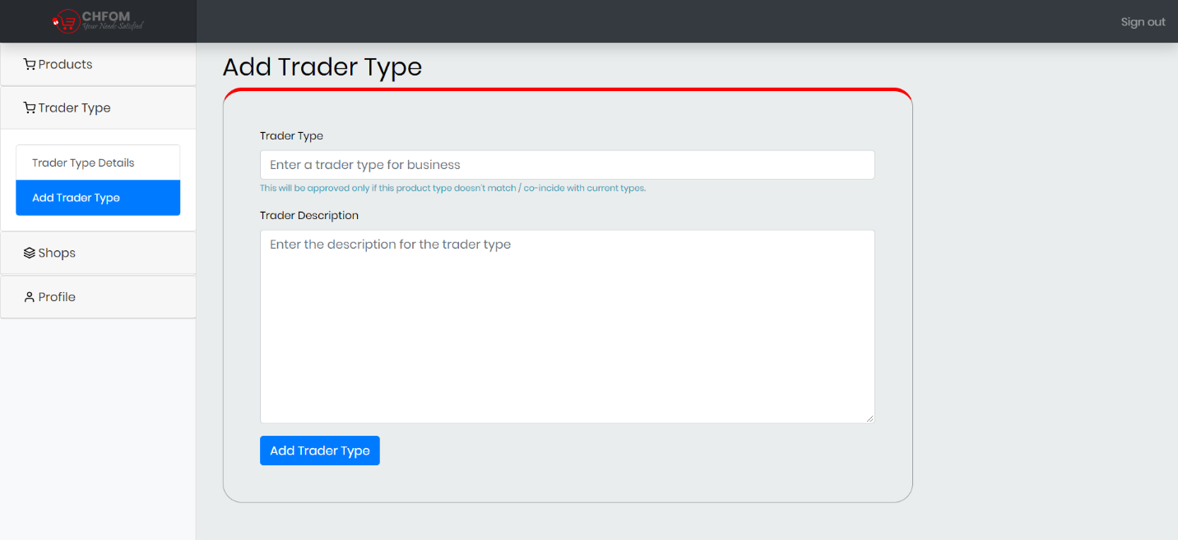

Trader can add trader type for another shop with different product category.

### Trader Type Details

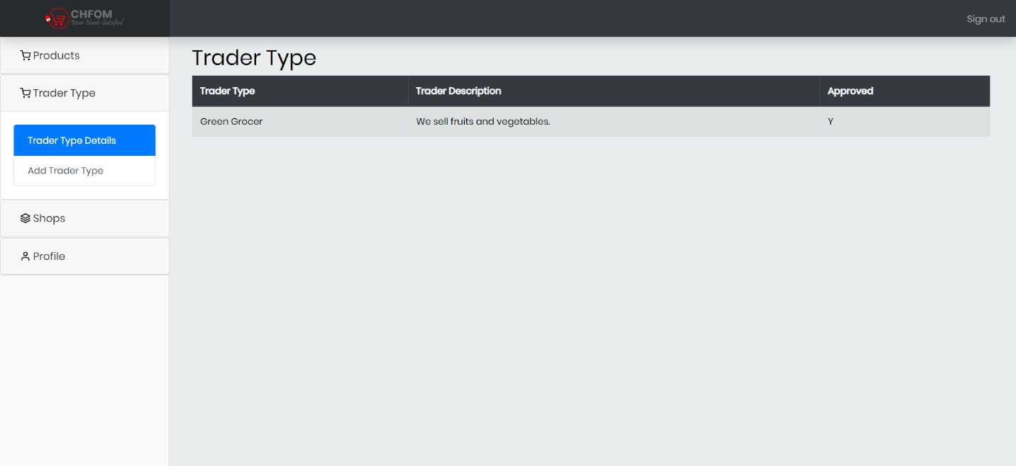

Display of trader type details showing trader type, description, and approval status.

### Add Shop

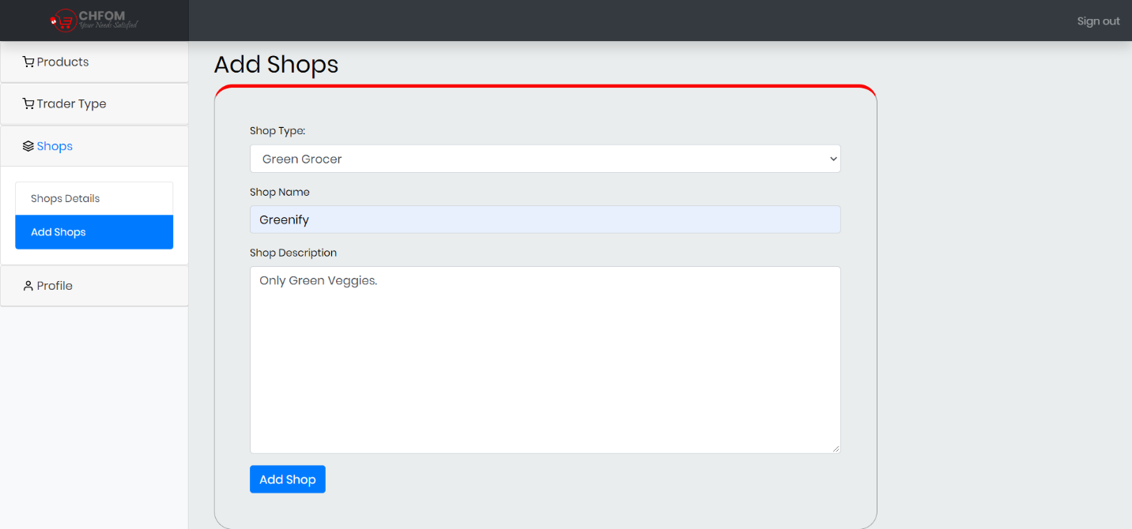

Trader can add new shop for new product category providing the necessary shop details such as shop type, shop name and description.

### Shop Added

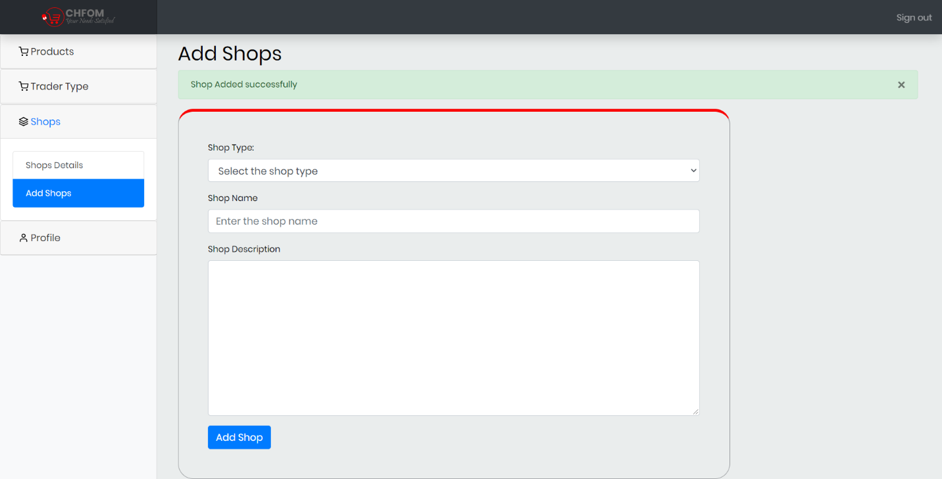

Message notifying the successful addition of shop.

### Shop Details

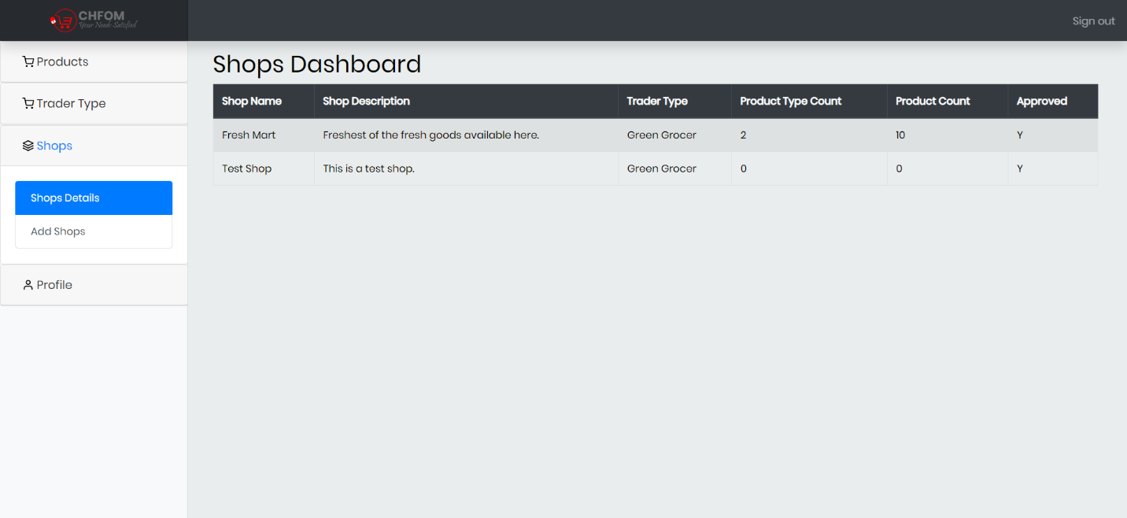

Shop Dashboard displaying the status of the shop with details such as name, description, trader type, product type count and product count.

### Update Profile

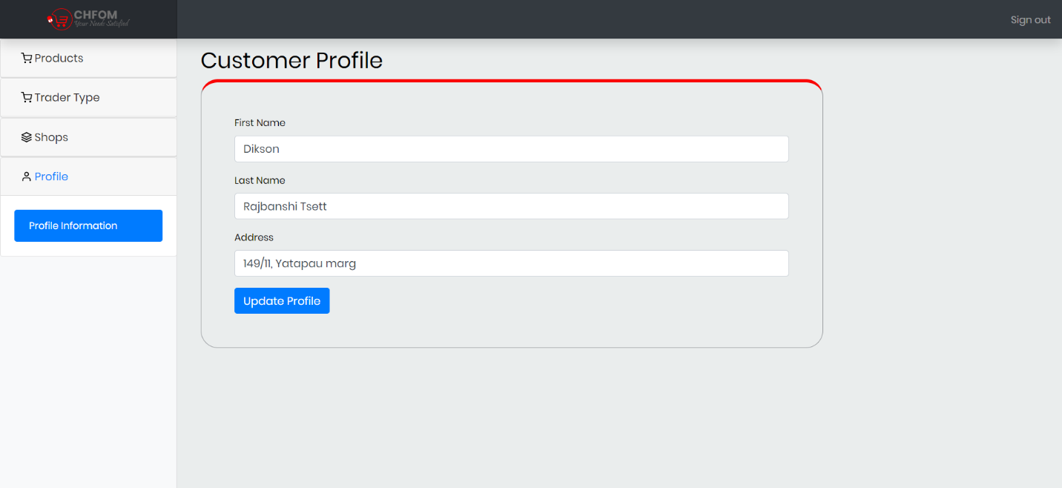

Traders profile information where they can update their profile.

### Profile Update Success

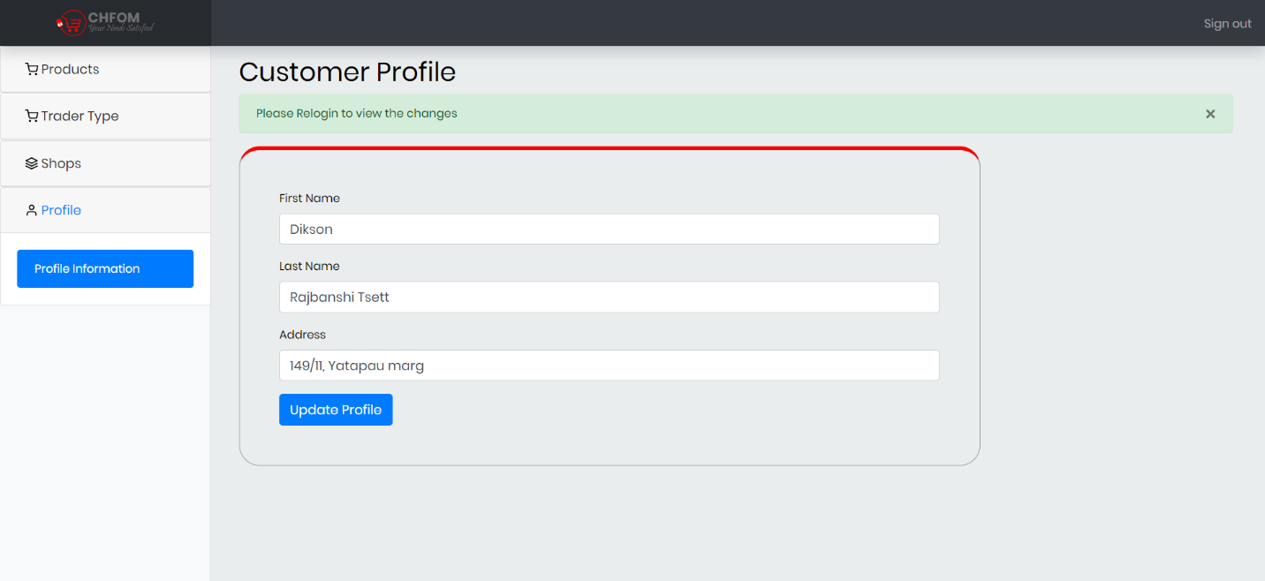

Profile Update success notification message.

## Admin (Oracle)

### Login

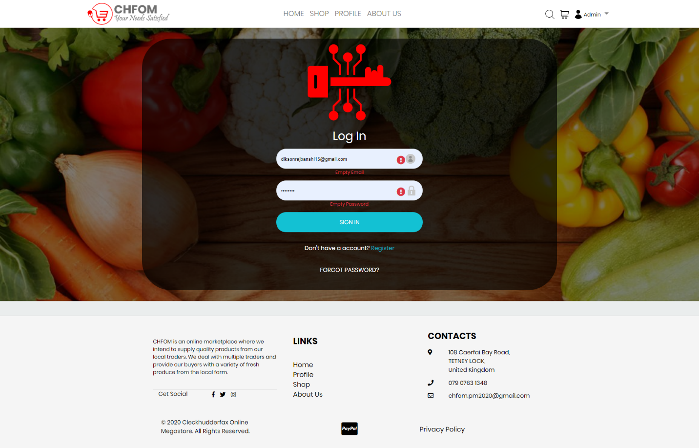

Admin and Trader need to login with valid username and passwords.

### Dashboard

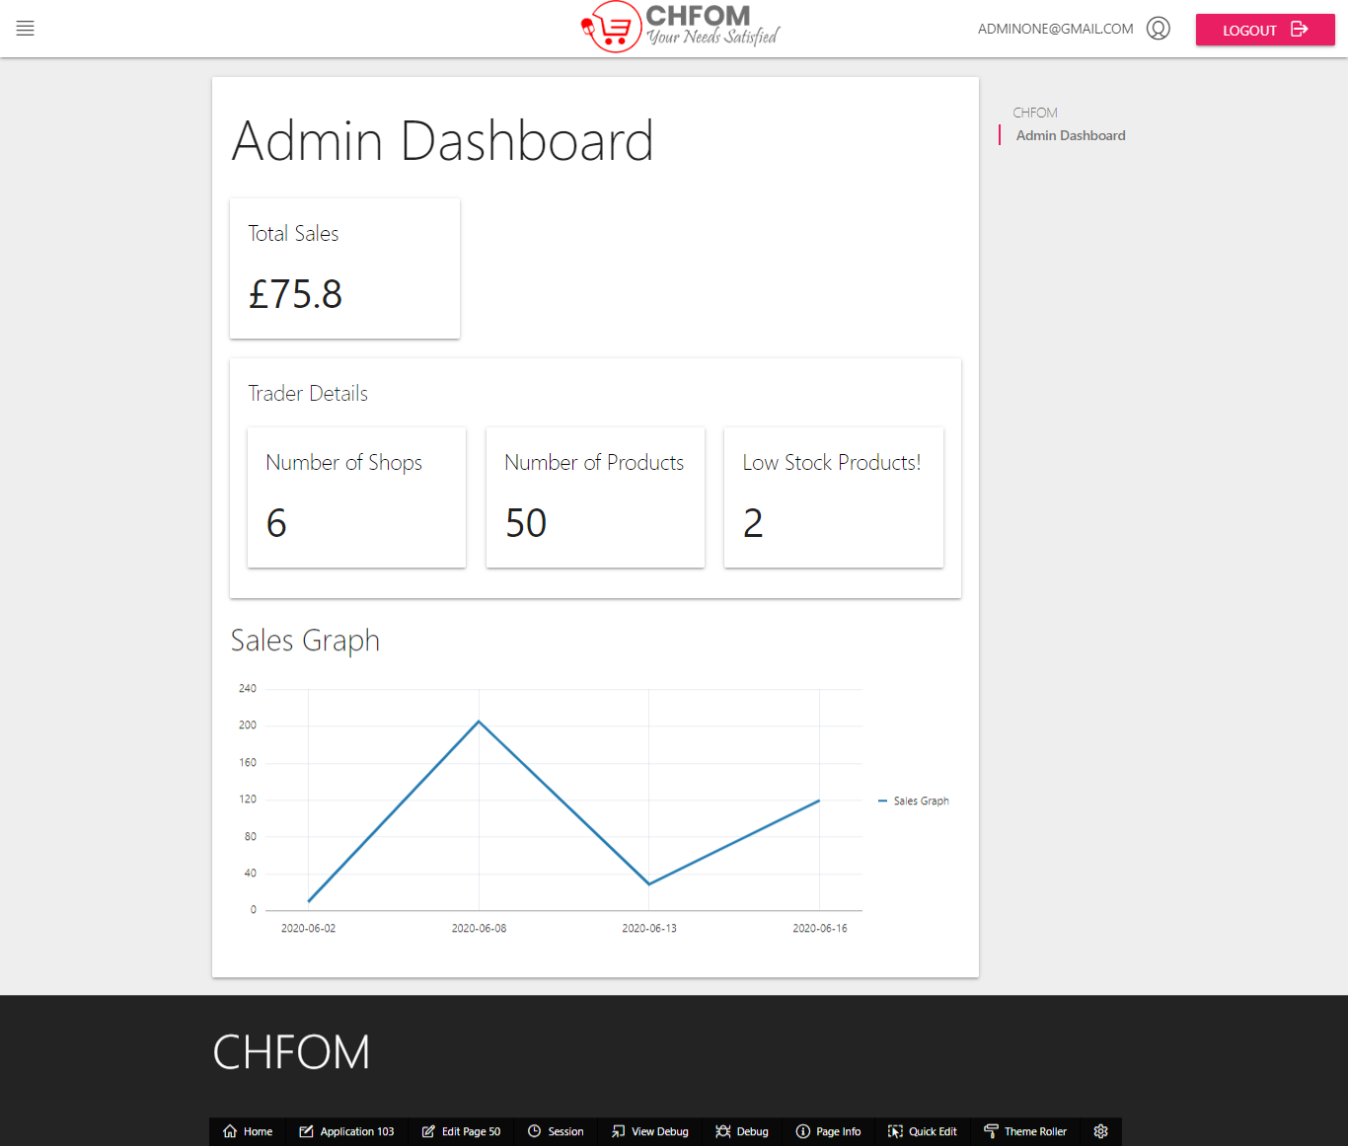

This is admin dashboard. This dashboard showing total sales, trader details; shops, products and low stock products, and sales graph.

### Products

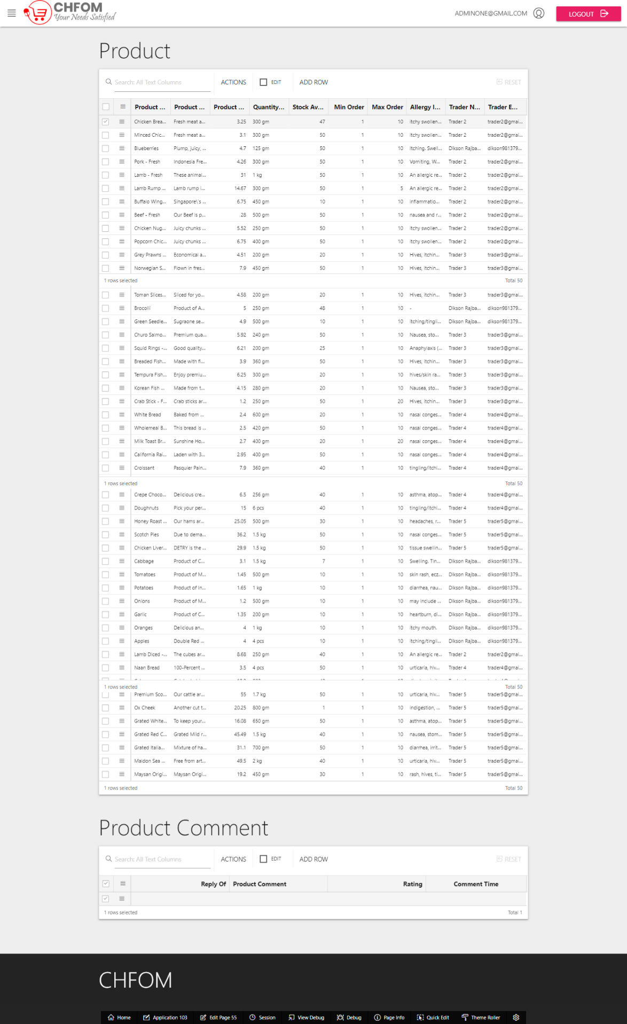

Display of the contents of product and product comment tables which admin can view.

### Trader Details

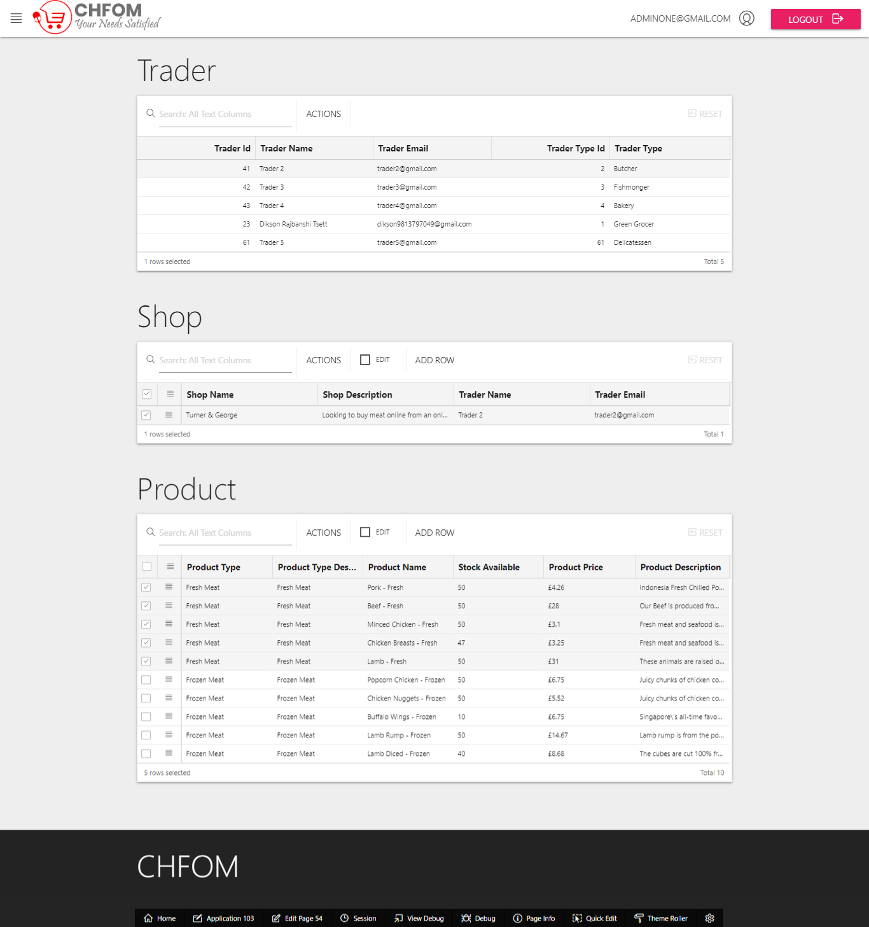

Display of the contents of the trader, shop, and product tables which admin can view.

### Customer Information

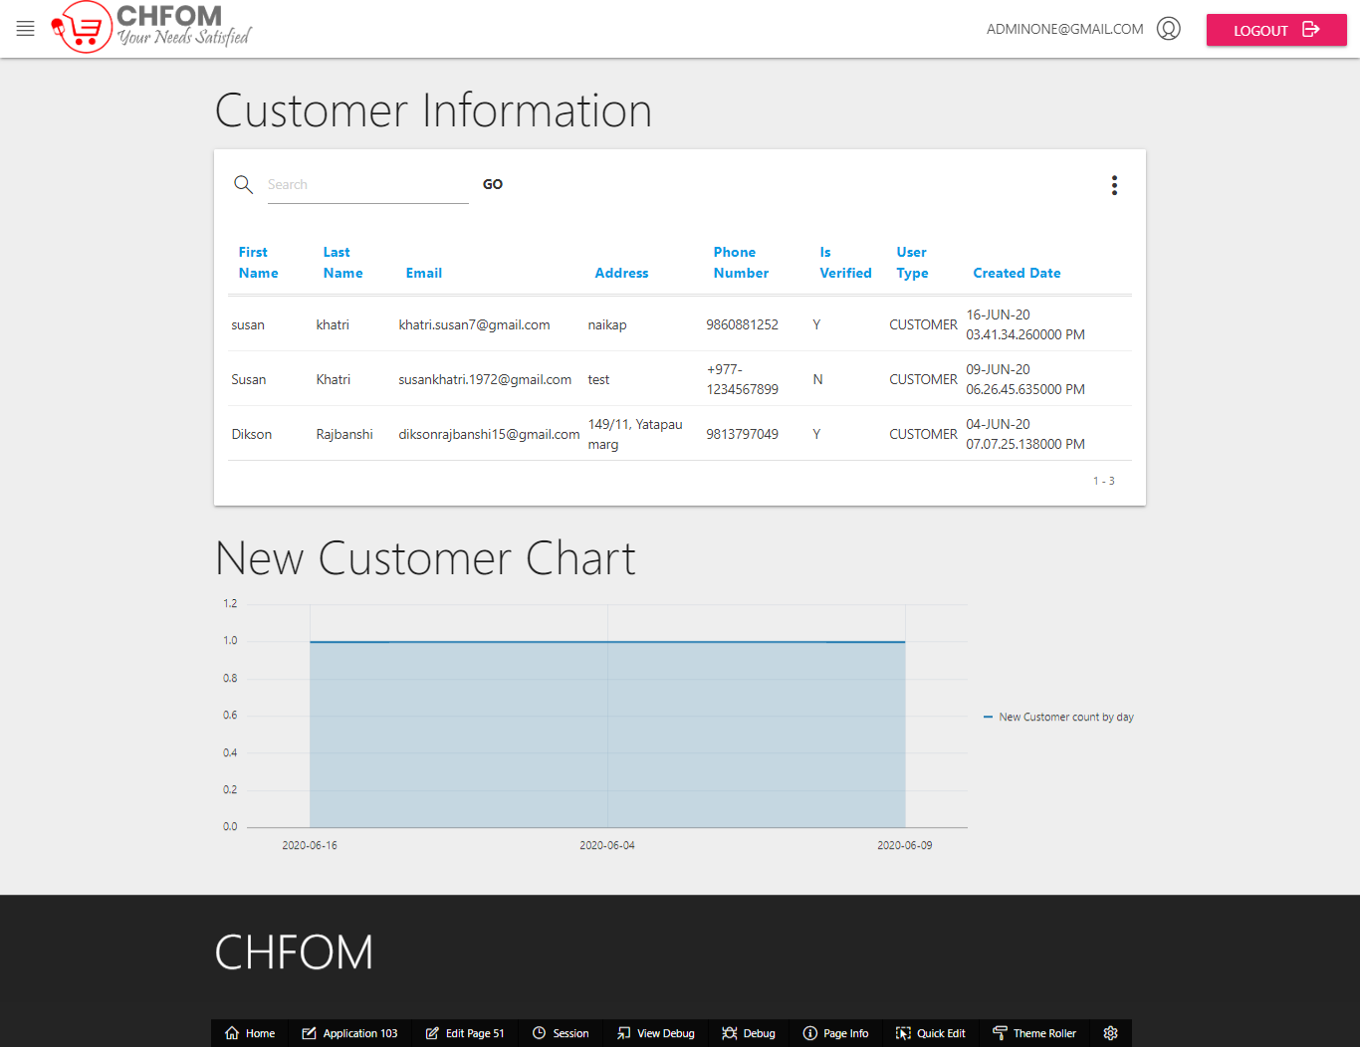

Display of customer information that can be viewed by admin.

### Sales Report

##### Daily

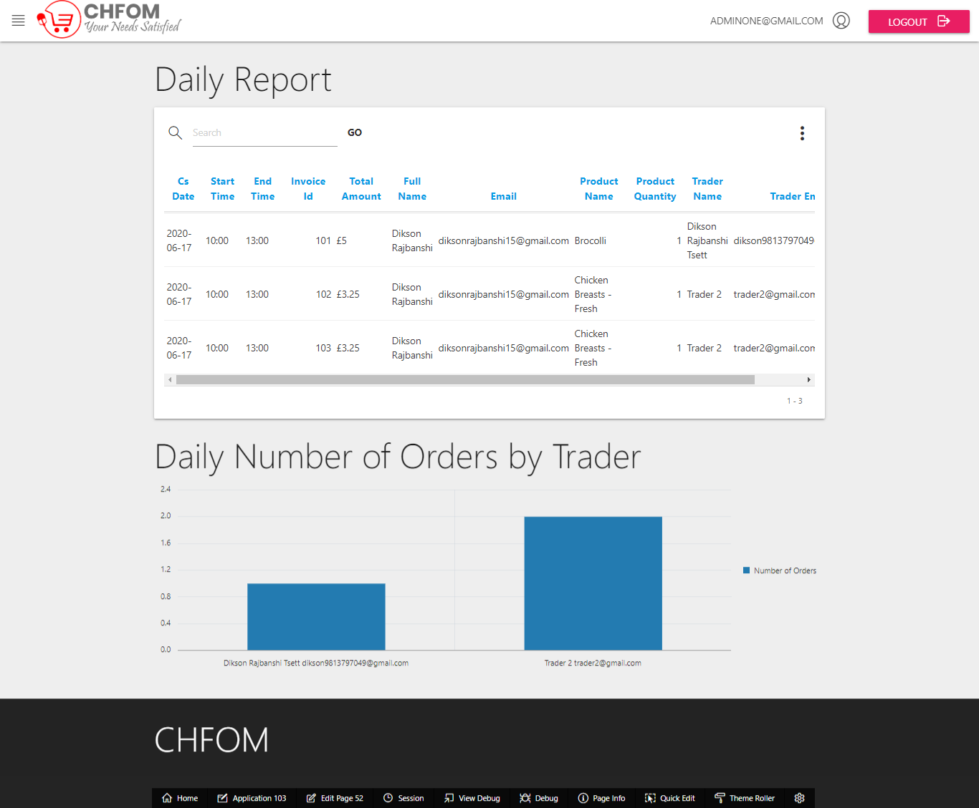

Admin can view sales daily sales report along with the graph of daily number of orders by trader.

##### Monthly Sales Report

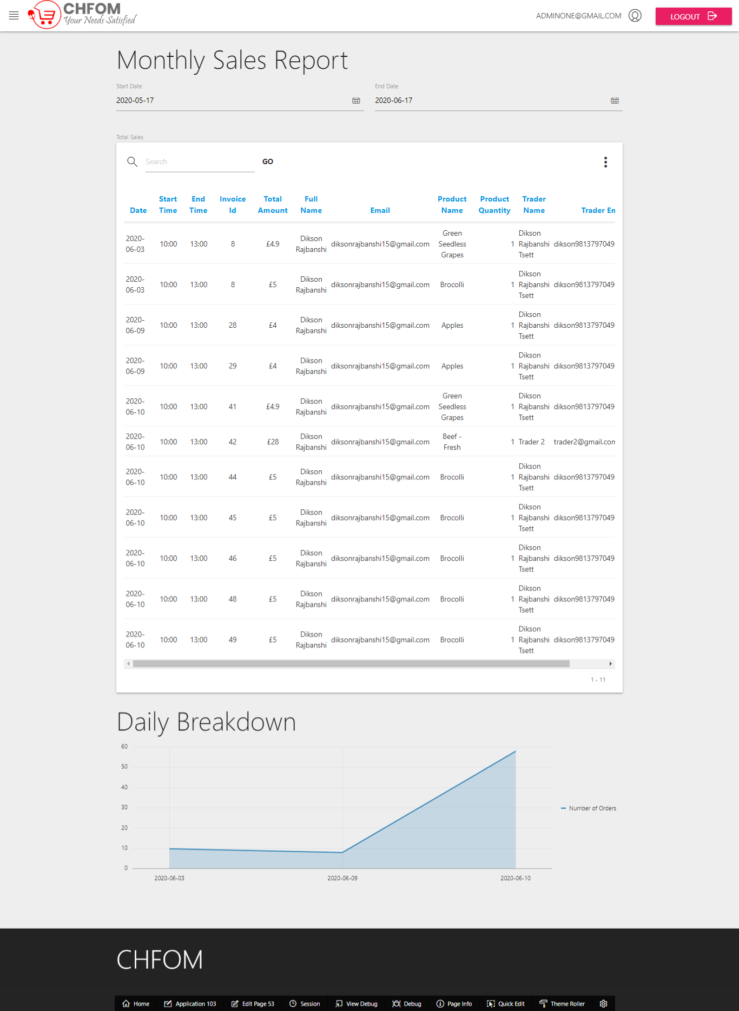

Admin has view monthly sales report and daily breakdown graph.

## Trader (Oracle)

### Dashboard

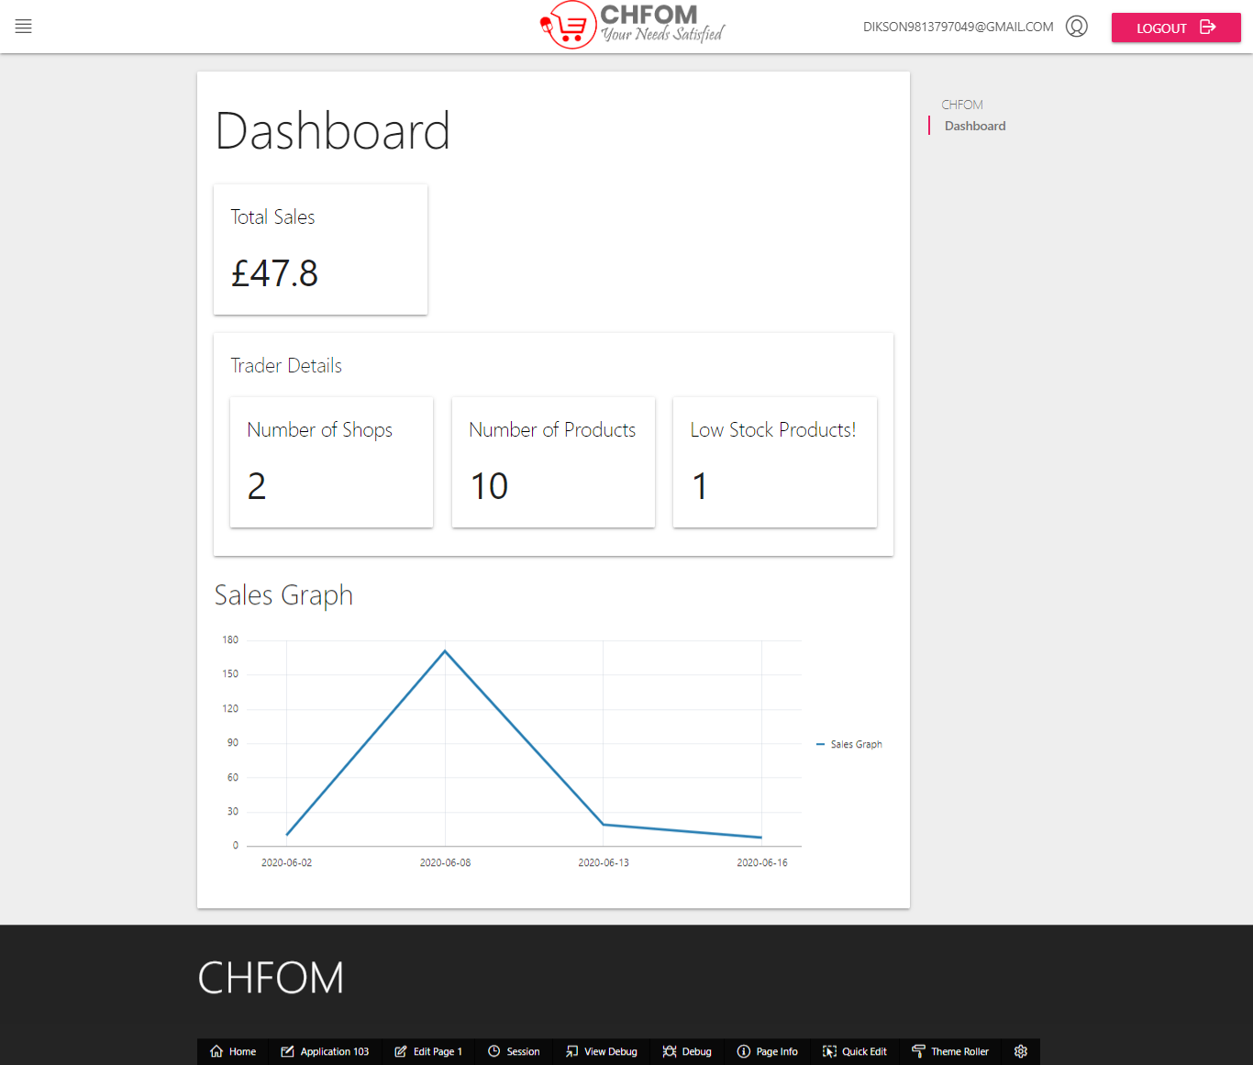

This is trader oracle dashboard where they can view total sales, trader details and sales graph.

### Shop/Product Details

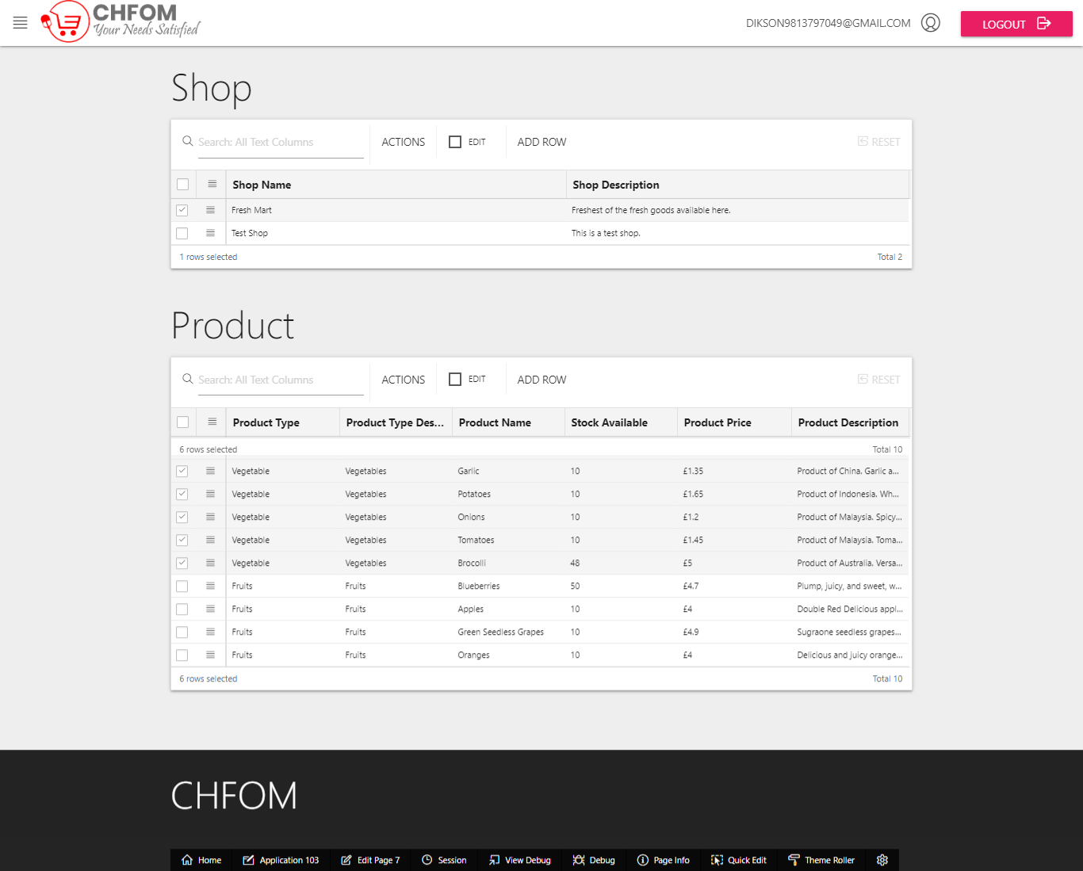

Trader can view shop and product details from shop and product table.

### Product/Product Comment

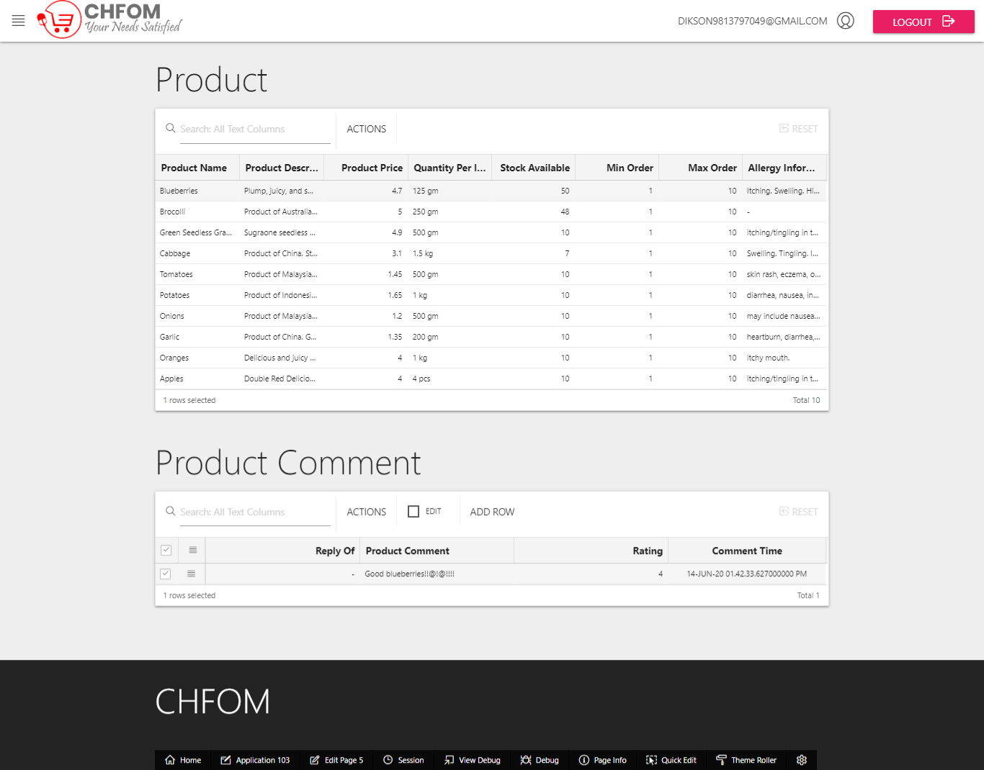

Trader can view product and product comment details from the respective tables.

### Product Type Details

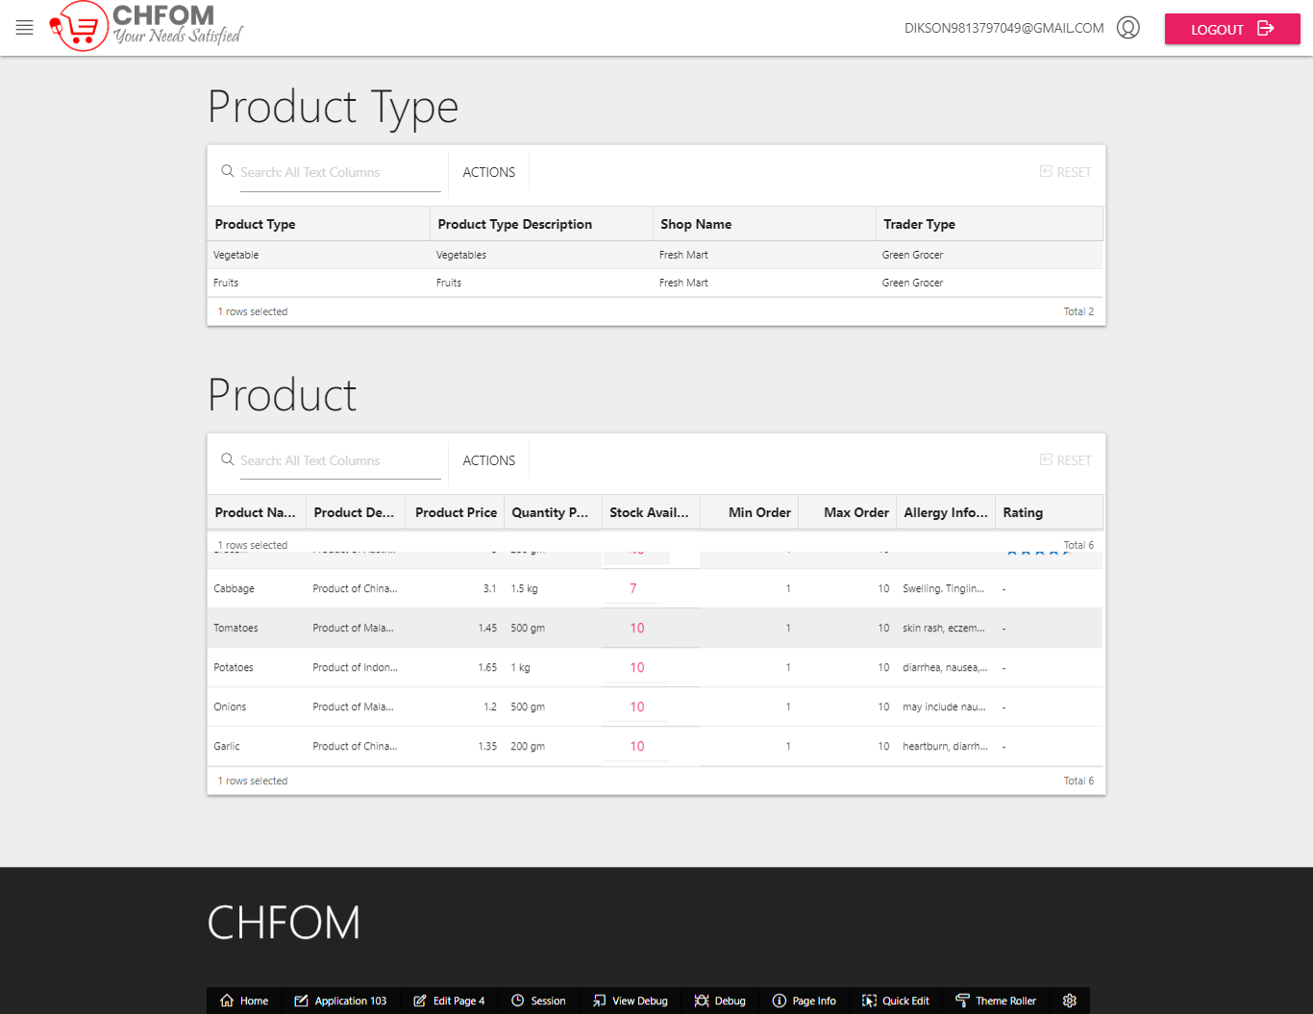

Trader can view product type details.

### Order Details

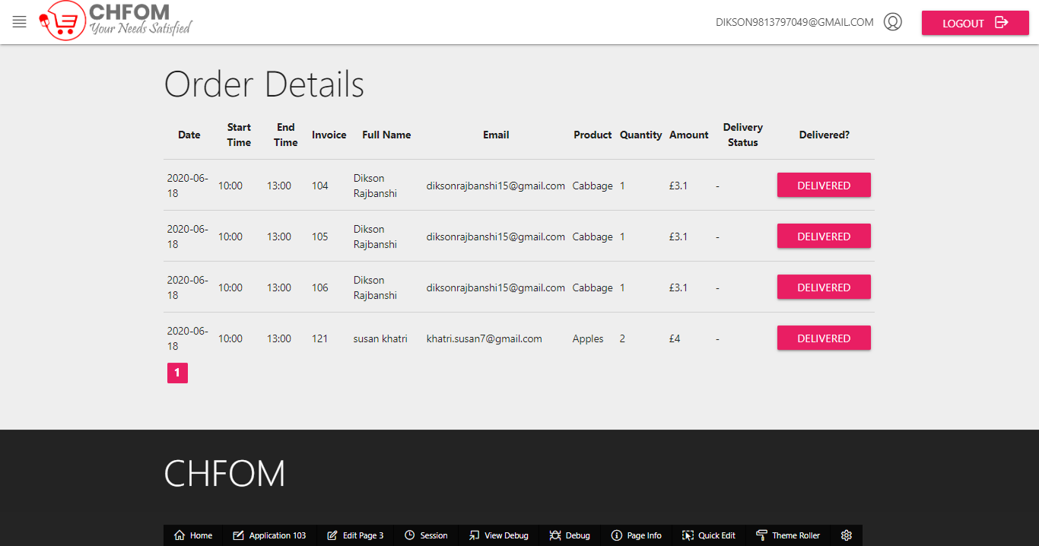

Trader has access to order details for the day containing the details such as date, invoice number, name, delivery status etc. This is used to label the products for making them ready for pickup from the customers.

### Monthly Sales Report

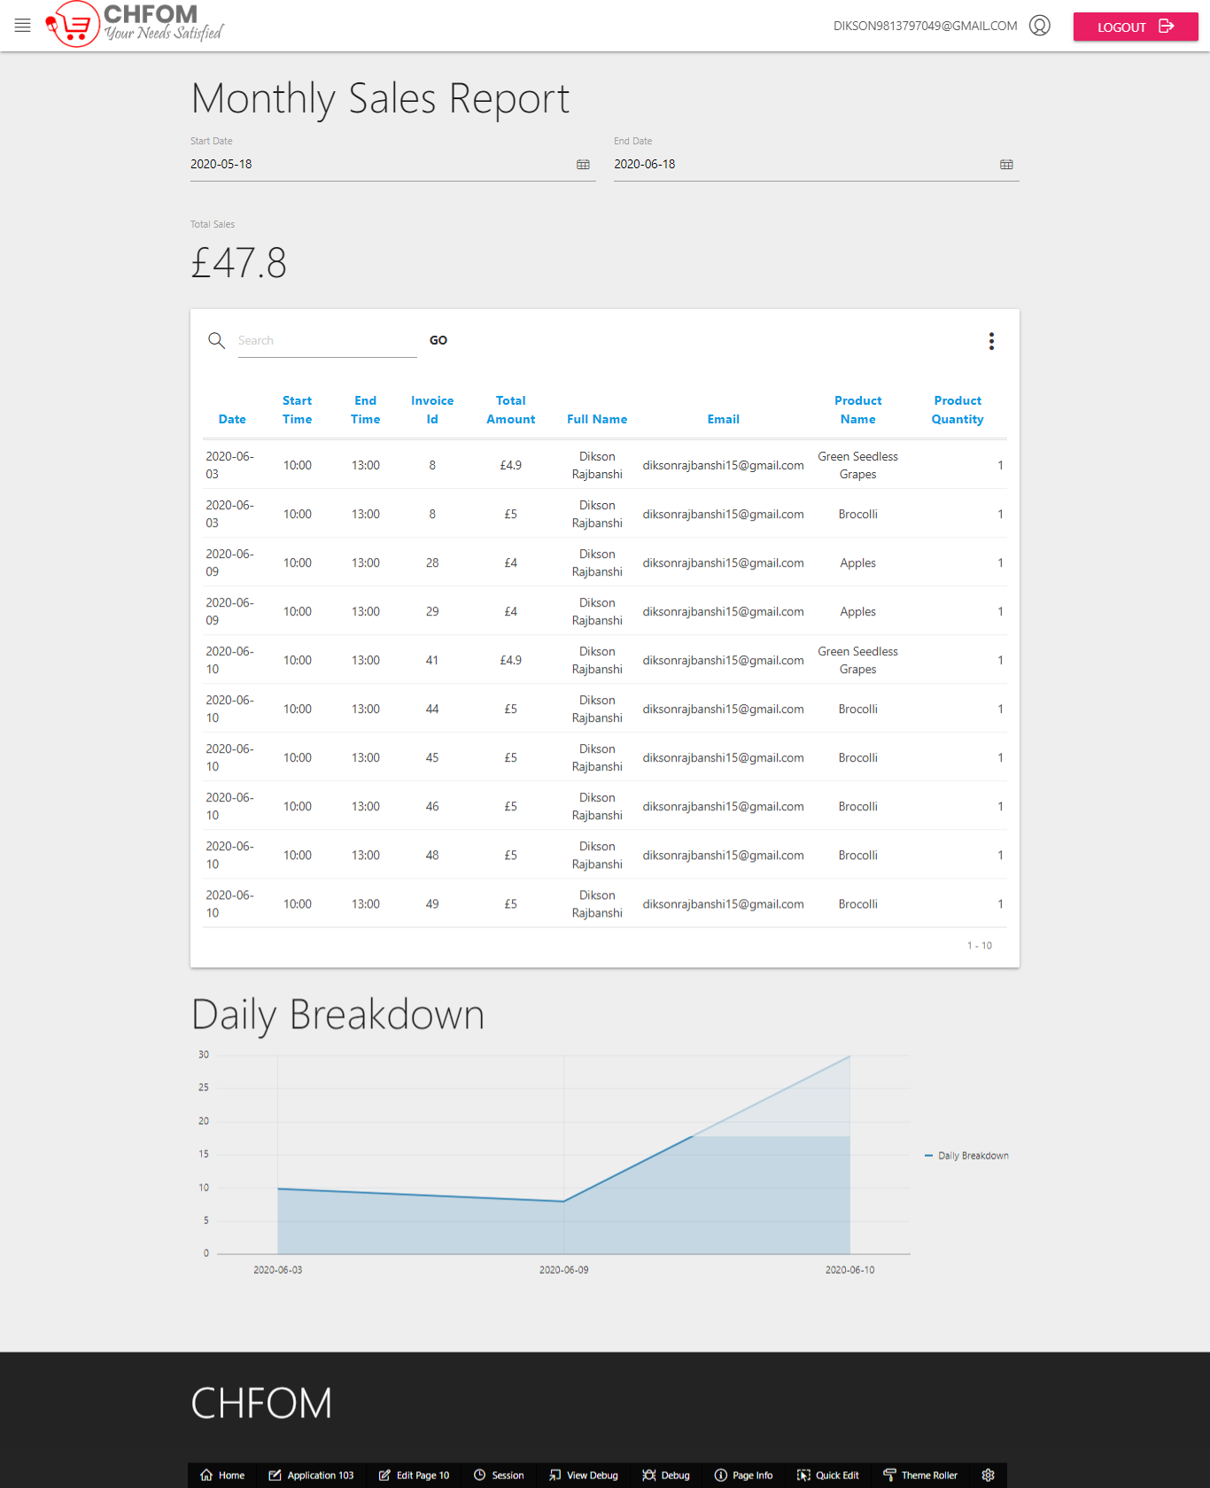

This is monthly sales report. Trader can view this report and details on the monthly sales.

### Monthly Sales Report Chart

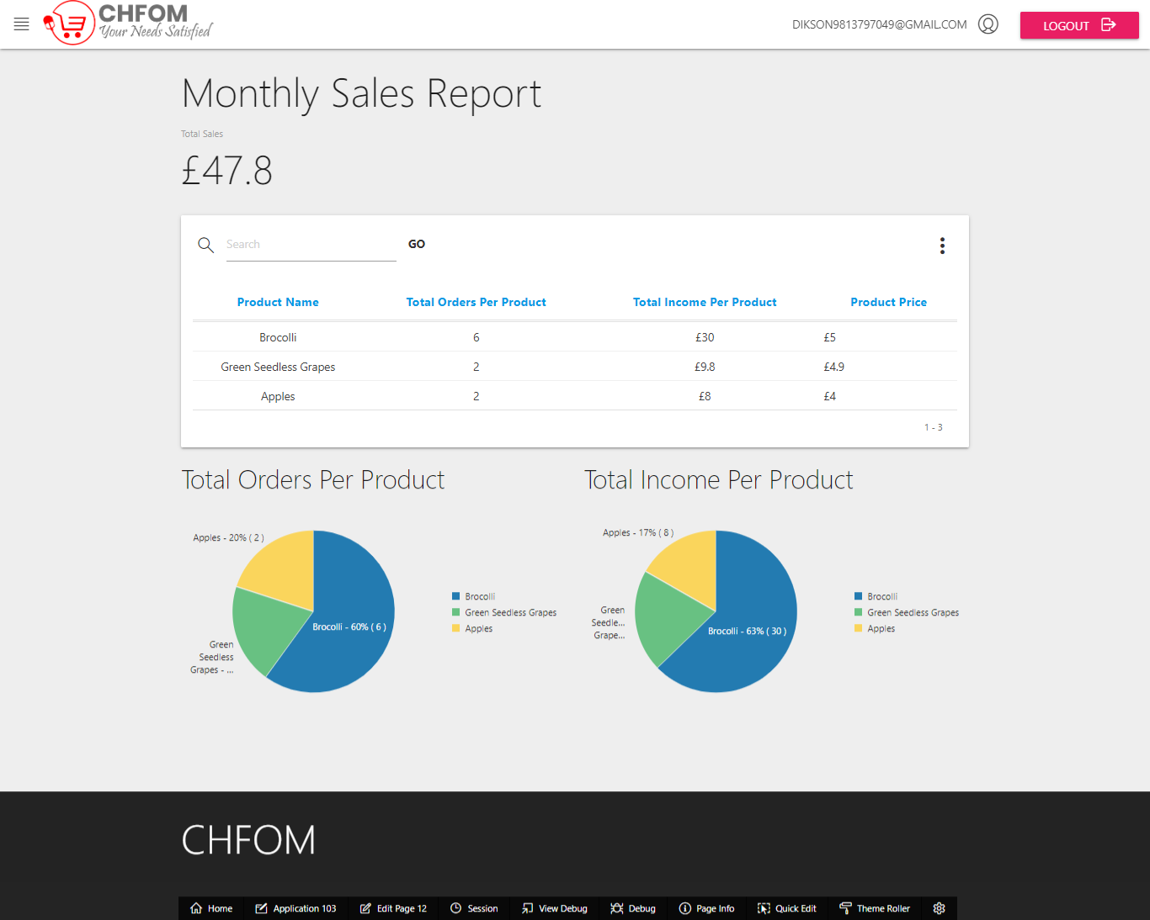

Trader can view monthly sales report chart on total orders per product and total income per product.